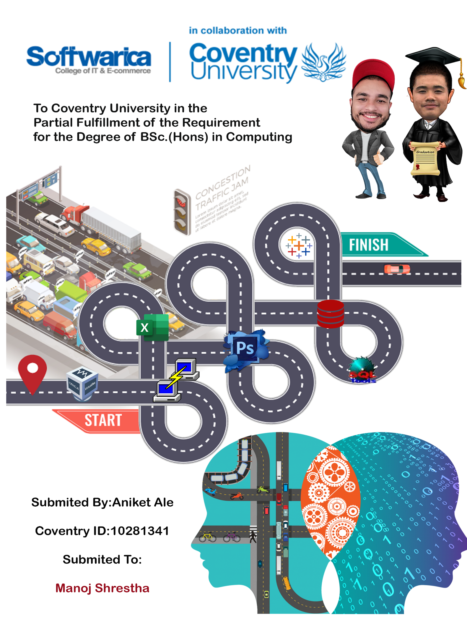

# Acknowledgement:

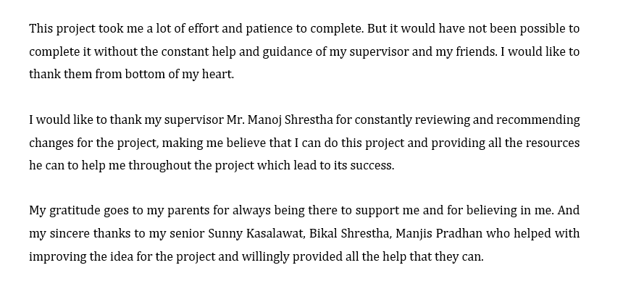

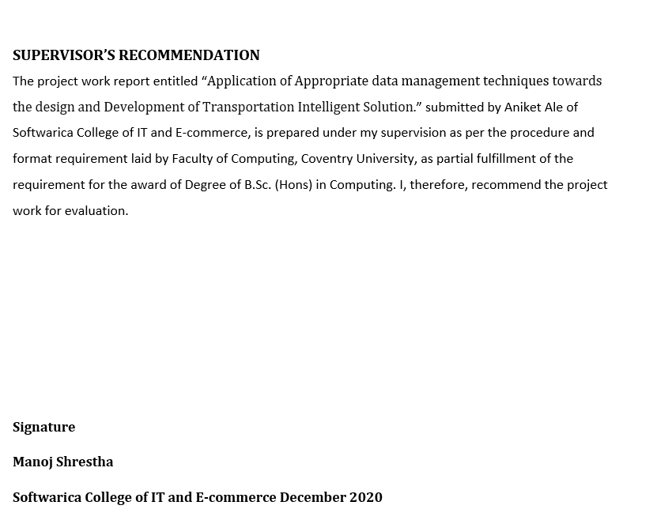

# Abstract

Traffic congestion is now a major issue in transportation management. Traffic congestion has many negative consequences such as accident, increase in travel time. These issues must be addressed so that reliability in road management can be obtained. Finding the trend of traffic congestion by responding to question about where and when how frequently traffic congestion typically takes place can be one efficient solution. This approach would also enable traffic management to find an efficient solution for reducing congestion and accident, as well as for monitoring and estimating congestion and accident.

The main goal of these research is to do visual exploration and support the analysis of transportation data and facilitate in the process of decision making. Visualization of data has the ability to support the study of transportation data as a way of presenting various data types in an understandable form. Different visualization like (bar chart, forecasting, map clustering etc.) has been used in this project. Congestion and accident were also analyze using map clustering. The visualization that have been built makes the analysis, the method of data analysis and interpretation is simpler and allows to gain insight into transportation system which helps data easier to understand and clearable. In order to provide useful business insights, Data warehouse method was used to collect and handle data from different sources.Different role, profiles and privileges were developed to implement a level of security. The system has implemented different auditing techniques so that the activities performed by the workers can be tracked to verify that they do not commit any unethical activities. To comply with GDPR, retention of transportation data for a minimum duration of 5 years was carried out.

Table of Contents

Acknowledgement: 2

Abstract 4

Table of Figures 9

List of Abbreviation 11

Introduction 13

AIM 15

OBJECTIVE 15

Academic Objective: 15

Personal Objective: 16

Technical Objective**:** 16

Justification 17

Research Question 20

Scope 20

Ethical Consideration 21

Literature Review 22

Uber 24

Transport for London (TFL) 26

Tesla 28

Lotus F1 team 29

Rolls-Royce 31

Words as Data? 33

Data as Sentiment? 35

Business Analysis 37

1.Descriptive analytics 37

2. Diagnostic Analytics 37

3.Predictive analytics 38

4.Prescriptive analytics 38

Data Visualization 39

Importance of Visualization 40

How Storytelling Affects the Brain? 41

Law of Large Number 42

Desk Based Research Methodology 44

Development Methodology 45

Data strategy 46

1.Business understanding 46

2.Data understanding 47

3.Data preparation 47

4.Modeling 47

5.Evaluation 47

6.Deployment 47

Tableau 48

Tools 49

Technology 50

Techniques 51

Oracle 11G 52

Business Metrics 53

1.Financial Metrics 53

2. Customer Metrics 53

3. Employee Metrics 54

Dashboard design principles 55

UX design process 56

Understand the user 56

User research 56

Ideation 56

Prototyping 56

Testing and iteration 56

Security 57

Scalability 57

Automatic Storage Management 58

Automatic Memory Management 59

Usability 60

Dashboard Objects 60

Adding interactivity 60

1.Highlights 60

2.URLs 60

3.Filters 60

Adding and configuring fields 61

Filtering and sorting data 61

Adding actions 61

Filter Actions 61

Highlight Actions 61

URL Actions: 61

Performance and Scaling 62

Choosing a data connection 62

Reducing data points 62

Optimize calculations 62

Clean up your workbooks 62

Building accessible dashboards 63

Updating color palettes 64

Providing visual cues 64

User security 65

Password Complexity Function 65

Role 66

Profile 66

Dedicated Tablespace 66

User 66

Implementing Password and Security Features 66

System Security 67

Auditing 67

Data Security 68

Backup 69

Recovery Manager (RMAN): 70

1. Cold or offline backup 71

2. Hot or online backup 71

3. Full Back up 71

4. Whole Backup 71

5. Incremental Backup 71

Virtual Private Catalog: 72

FDA (Flashback data archives) 73

Concurrency Control 74

Enqueue Mechanism 75

Exclusive Lock Mode 75

Database Maintenance 76

Automatic Diagnostic Workflow (ADW) 78

Automation 79

Scheduling 79

Health Monitor 80

Deferred segment 81

Materialized view 82

Extract Transform and Load (ETL) 83

Data warehouse 86

Indexes 87

Partition 88

PL/SQL 88

Dashboard design process 89

Define 89

Prototype 90

Develop 90

Deploy 90

Process 91

Developing Dashboards 91

Challenges 92

User’s concerns 92

Strategies for driving dashboard adoption 92

Devices 93

Effectiveness 97

Testing Dashboards 99

Best case and work case scenario 101

Project Plan 102

Findings 103

High level Dashboard 103

Mid-level Dashboard 104

Low-level Dashboard 105

Future work 107

Conclusion 108

Bibliography 110

Appendix I 118

Appendix II 137

# Table of Figures

Figure 1:key Words 12

Figure 2:Ecosystem of the Project 13

Figure 3:Academic Objective 15

Figure 4:Personal Objective 16

Figure 5:Technical Objective 16

Figure 6:Discussion for appropriate solution 17

Figure 7:Solutions 18

Figure 8:Problem solved 19

Figure 9:Research Question 20

Figure 10: scope 20

Figure 11:Ethical Consideration 21

Figure 12: Progress of transportation over the year 23

Figure 13:Case study of Uber 24

Figure 14: Case study of Transport for London 26

Figure 15:Case study of Tesla 28

Figure 16:Case study of Lotus F1 team 29

Figure 17:Case study of Rolls-Royce 31

Figure 18:Words as Data? 33

Figure 19:Data as Sentiment? 35

Figure 20:Business Analysis 37

Figure 21:Data Visualization 39

Figure 22:Importance of Visualization 40

Figure 23:How Storytelling Affects the Brain? 41

Figure 24:Law of Large Number 42

Figure 25:Desk Base Research Methodology 44

Figure 26:Agile Development Methodology 45

Figure 27:Data strategy 46

Figure 28:Why Tableau? 48

Figure 29: Tools 49

Figure 30:Technology 50

Figure 31:Techniques 51

Figure 32:Oracle 52

Figure 33:Business Metrics 53

Figure 34:Dashboard design principles 55

Figure 35:Scalability 57

Figure 36:Automatic Storage Management 58

Figure 37:Automatic Memory Management 59

Figure 38:Dashboard Objects 60

Figure 39:Building accessible dashboards 63

Figure 40:Updating color palettes 64

Figure 41:User security 65

Figure 42:Auditing 67

Figure 43:Data Security 68

Figure 44:Backup 70

Figure 45:Virtual Private Catalog 72

Figure 46:FDA (Flashback data archives) 73

Figure 47:Concurrency Control 74

Figure 48:Database Maintenance 76

Figure 49:Automatic Diagnostic Workflow (ADW) 78

Figure 50:Automation 79

Figure 51:Health Monitor 80

Figure 52:Deferred segment 81

Figure 53:Materialized view 82

Figure 54:Extract Transform and Load (ETL) 83

Figure 55:ETL Process 85

Figure 56:Data warehouse 86

Figure 57:Indexes 87

Figure 58:Partition 88

Figure 59:Dashboard design process 89

Figure 60:Developing Dashboards 91

Figure 61:Dashboard 1 Tablet Testing 93

Figure 62: Dashboard 1 Phone testing 94

Figure 63:Dashboard 2 Tablet Testing 95

Figure 64:Dashboard 2 Phone testing 95

Figure 65:Dashboard 3 Tablet Testing 96

Figure 66:Dashboard 3 Phone testing 96

Figure 67:Effectiveness 97

Figure 68:Testing Dashboards 99

Figure 69:Best case and work case scenario 101

Figure 70:High level Dashboard 102

Figure 71:Mid-level Dashboard 103

Figure 72:Low-level Dashboard 104

Figure 73:Summary Dashboard 105

Figure 74:Proposal Project Plan 106

Figure 75:Research Project Plan 106

Figure 76:Dashboard Development Project Plan 106

Figure 77:Future work 107

# List of Abbreviation

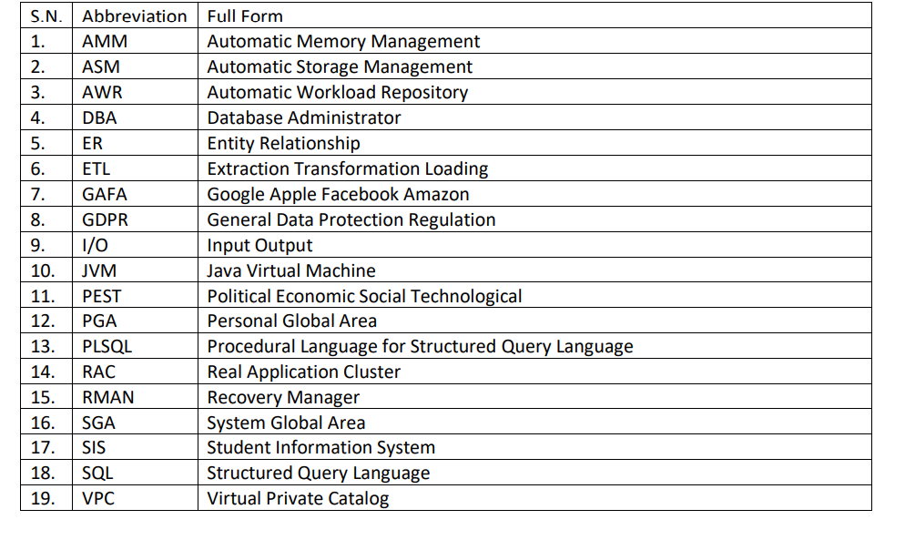

“Without data, you’re just another person with an opinion.”- W. Edwards

**Key Words**

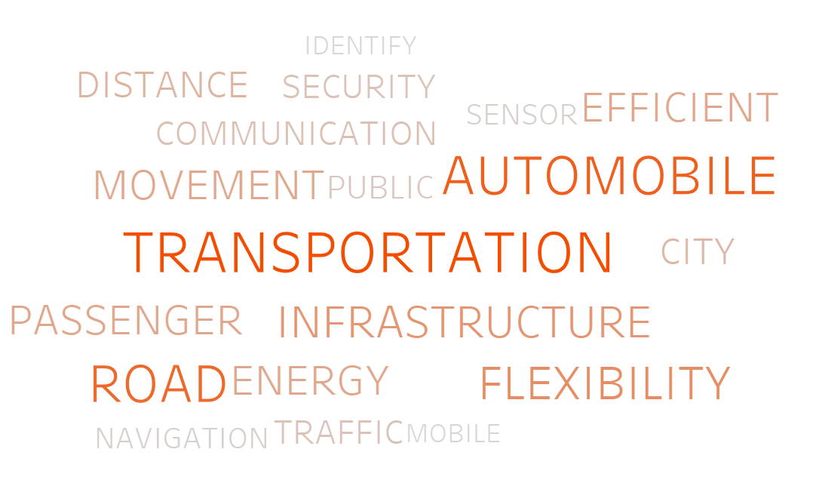

Figure 1:key Words

# Introduction

**“**When something is important enough, you do it even if the odds are not in your favor. -Elon Musk”

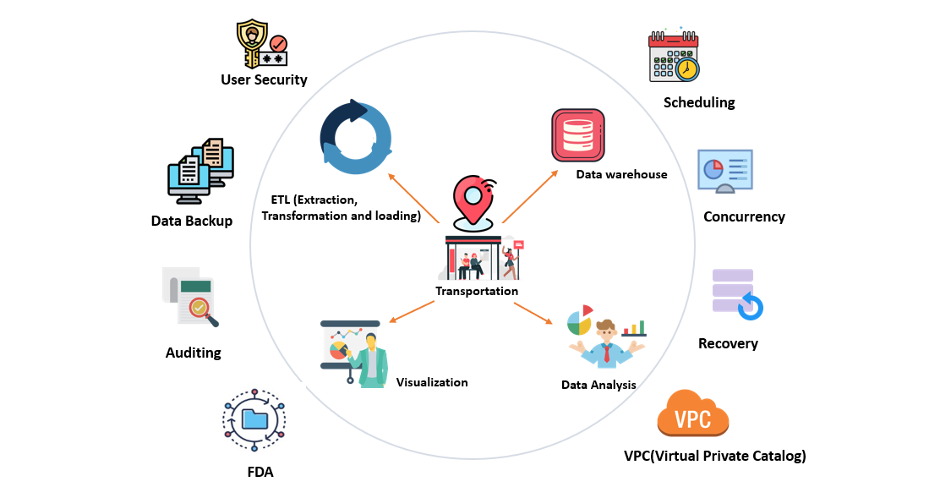

Figure 2:Ecosystem of the Project

Transportation is a fundamental part of human day to day life. Especially the activity of transport is characterized as a specific development of a living being or thing from one point to another point. As a world, we depend on transportation for sharing food and other crucial assets. We require transport for financial, social, educational and political exercises. This research is intended to illustrate how the open transportation can be advance in any places where the city has huge population with less specify transportation.

As People are reliant on transportation nowadays more than 40% of the population spends at least one hours on road each day. These days there are immersion of the transportation due to developing number of vehicles. Growing use of transportation have affected our lives while people need to move quickly between different places. Which result in accidents, traffic congestion and transportation delays. Everyday there is growing number of small vehicles. If it continues, it’ll be troublesome to oversee activity no matter how wide the street is extended.

Traffic congestion is now a major issue in transportation management. Traffic congestion has many negative effects such as increased travel time, accident etc. This issue needs to be addressed so that road management quality can be improved. One of the powerful solutions that can be used is to find patterns of traffic congestion that address the question of how and where how long traffic congestion generally happens, often as traffic congestion. Congestion are repeated incidents that occurred at specific periods of the day in particular road sections. This approach would also enable traffic management to find an efficient solution for reducing congestion and accident, as well as for monitoring and estimating congestion and accident.

In order to provide useful business insights, Data warehouse method is useful to collect and handle data from different sources. Information and data are a necessary aspect of business in order to remain competitive. It is used to track performance of their business generated by business analyst. Data warehouse makes use of numerous methods to improve performance of the system and therefore decreases the cost of execution. It is used to turn information into useful information. It is used in transportation to perform analysis in congestion and accident from different sources. It also benefits to use the ETL (Extraction, Transformation and loading) method to manage the data.

The modern era is the world of innovation where business/trade produces millions of information each second. It is challenging to get it the numerical information where the techniques of visualization have the ability to represent them in images that human can easily understand it. As a matter of fact, human brain process pictures (60 thousand) time faster than text. Human are more used to process image almost (90 percent) of ideas in human brain are visual and more than 90% of human communication is visual. In order to support the decision-making process for transportation, this study aims to examine how visualization techniques can overcome the challenges of transportation. With the help of the information visualization support the study and help in decision-making process. The main idea of this research is visualizing the collected data and to help the study different effects of transportation.

# AIM

Understand and analyze traffic data to discover how the transport sector can develop infrastructures that meet the needs of a 21st century population.

# OBJECTIVE

## Academic Objective:

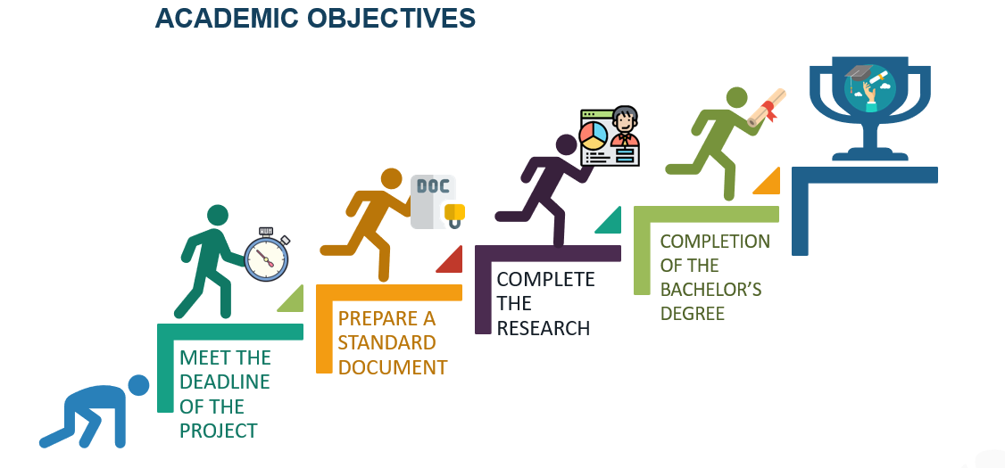

Figure 3:Academic Objective

Personal Objective: 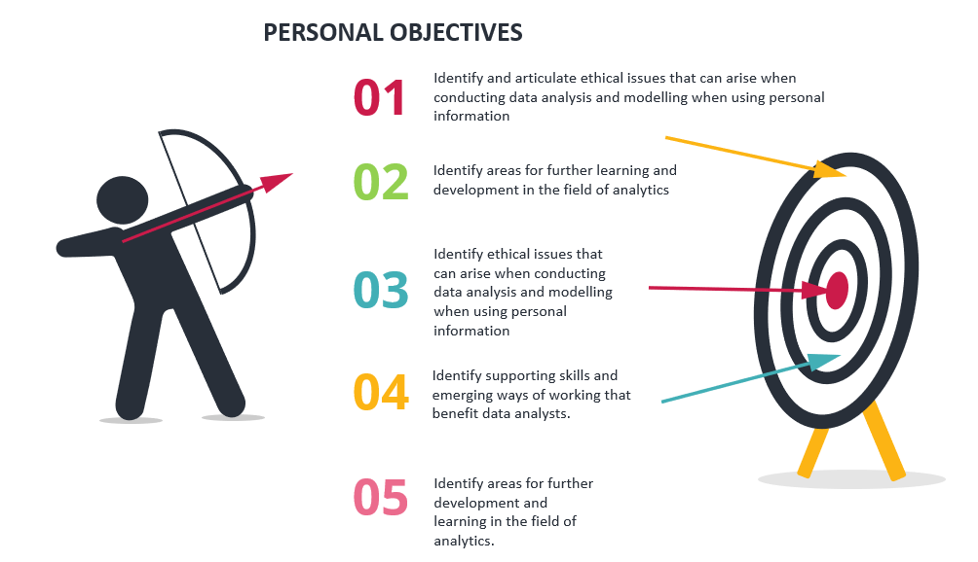

Figure 4:Personal Objective

## Technical Objective**:**

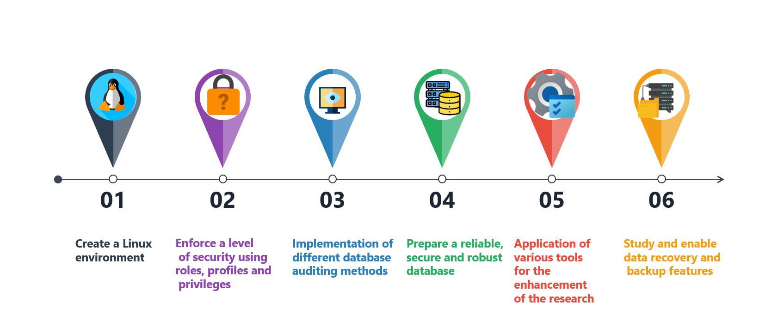

Figure 5:Technical Objective

# Justification

“4.2 Billion hours a year are wasted every year in united states due to sitting in congested traffic/TEDx Talks -Brian Wolshon”

Growing use of transportation have affected our lives while people need to move quickly between different places. Which result in accident, traffic congestion and transportation delays. In order to enhance the decision-making process for transportation simulation user, the study aims to use different data warehouse techniques and examine how visualization techniques can overcome the challenges of transportation through data analysis. The main goal of project is to visual exploration of traffic congestion over the time based on the floating car. Visualizing road traffic congestion will bring way to identify and understand dynamic range of traffic congestion better and intuitive. Thus, the improved transportation system can help make forecasting models and serve as a decision-support system. This system would enable the transportation system to determine which location have most congestion and make pre-decision to help people.

Figure below show employee is having hard time working on spreadsheet. They want to manage the data and be able to create various charts so that we can make and accurate decision. They are looking for better solution.

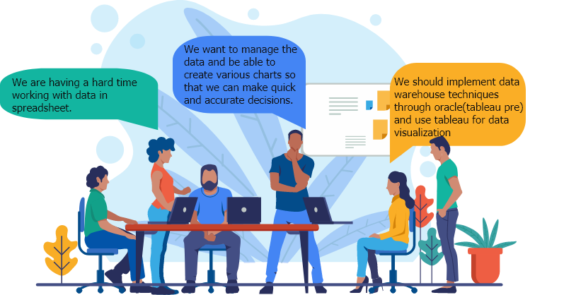

Figure 6:Discussion for appropriate solution

All these features are provided by oracle for most appropriate solution.

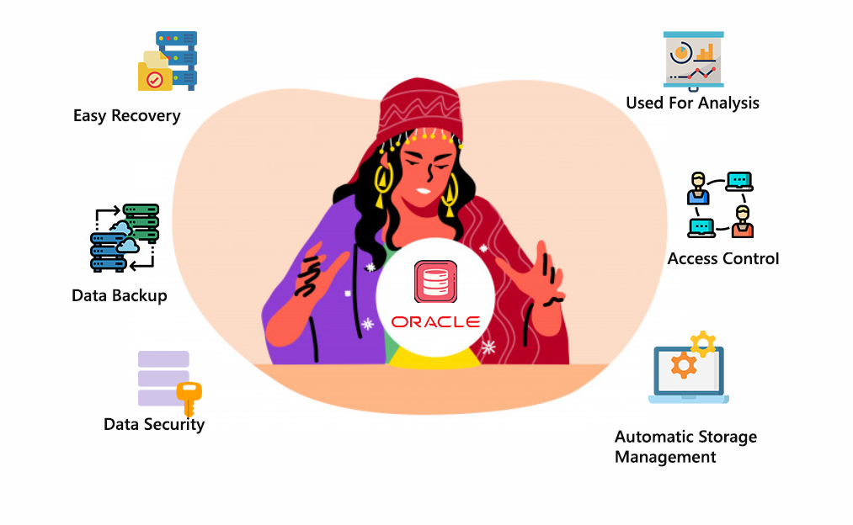

Figure 7:Solutions

Finally, as shown in diagram with the help of visualization it is much easier to analyze the huge amount of transportation data.

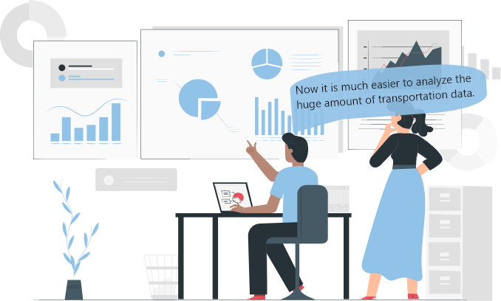

Figure 8:Problem solved

# Research Question

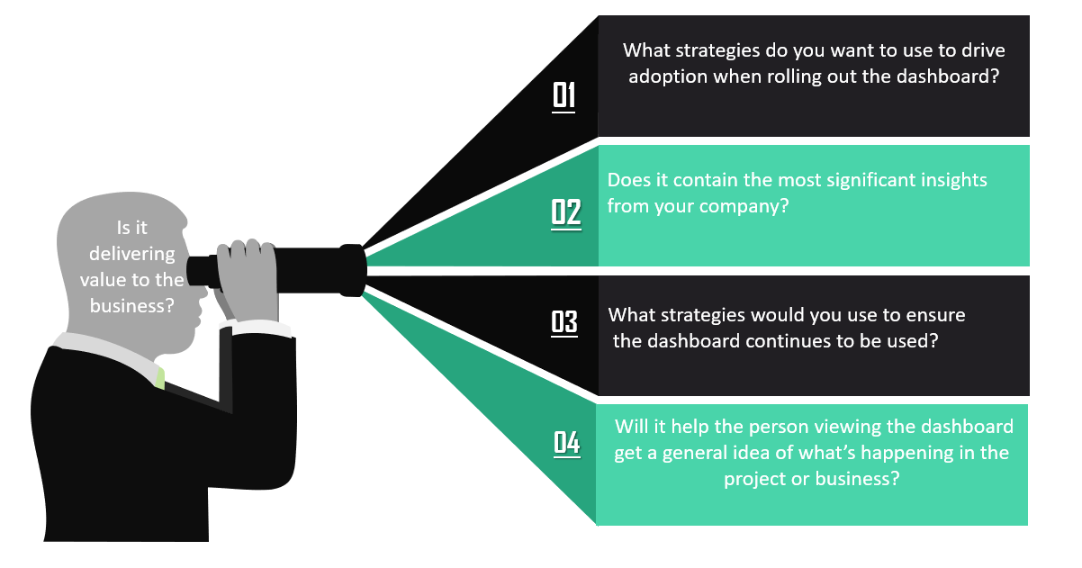

Figure 9:Research Question

# Scope

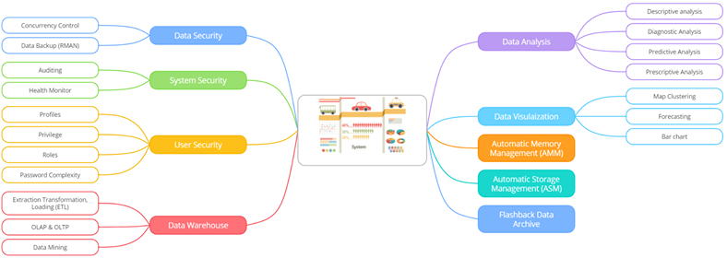

Figure 10: scope

# Ethical Consideration

This project was carried out keeping in mind ethical considerations. The transportation data is extremely valuable and personal data. The work initiative also covers a vast amount of legal issues for decision taking. So, accessing the data of transportation without permission will be immoral. All transportation detail was update so no personal information could be accessed. (EU Data Protection Rules 2020) Ethical consideration thus offers a means of studying how various laws and regulations take place, how ethically any action takes place in many projects steps by steps, also helps in various decisions. 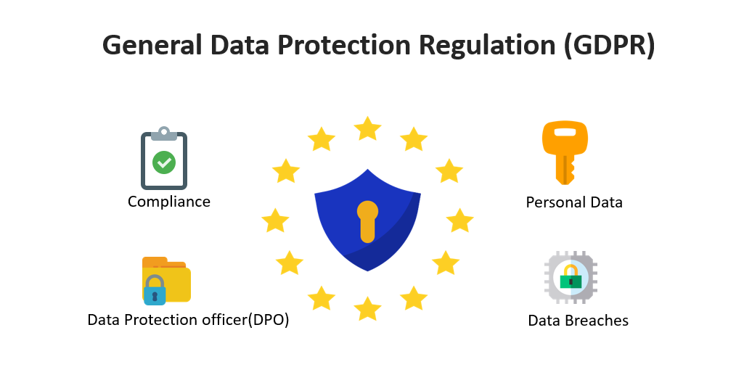

Figure 11:Ethical Consideration

Research papers of respected and checked publishers were also taken into account during the course of the study. Any suspicious papers were skipped. All the author, research papers was acknowledged during the preparation of study by providing appropriate references and citations. Any research study that claimed that author’s permissions was taken into consideration until it could be used was also mentioned and not used until authorization was granted. The ethics of data is about sustainable and responsible use of data. Ethical aspects of research are a primary concern of this project. Data process must be planned as sustainable solutions that support humans in the first place. Data ethics applies to and adheres to the standards and values underlying the laws on human rights and personal data security. In data analysis it’s about fair and true integrity. Principle of data ethics are (Human being at the center, transparency, Individual data control, accountability and equality). This project was done without offending people feelings and ensuing all these principle of data ethics. So, all the ethical values such as privacy, honesty, integrity, approval and many other are strongly required to achieve this project.

# Literature Review

Data visualization will provide the ability understand and discover patterns within transportation data to provide insights in an accessible manner. Working in big data means quality of data is equally important for visualization. “Big data is like teenage sex: everyone talks about it, nobody really knows how to do it, everyone thinks everyone else is doing it, so everyone claims they are doing it.” (Brosi and Bast 2014) It can be characteristics in four different day (Volume, Varity, Velocity and variability) which helps to make right decision and lower the risk.

Early History: Research done by Banafshe Hajinasab, Paul Davidsson, Jonas Lowgren and Jan.A. Persson in university of Malmo (2013 July 15-18 Rio de Janeiro, Brazil). Research aims to examine how visualizations can overcome the obstacles of data analysis in transport simulation. So that it helps improve users to make decision in transportation simulation. (Banafsheh Hajinasab et al. 2013) To achieve goal, they use (multi-agent-based simulation model) for production and transportation called TAPAS. It is a micro level simulation tool aimed at exposing the results of various initiatives, including government rules such as taxation, investment in infrastructure and market strategies. It also acts as decision support system for public sectors and policy makers by forecasting the impact of particular output and transport steps and whether they related to the government’s goals of sustained economic growth. For visualization they have use score cards and map-based visualization. To investigate the visualization technique the main approach used are geographical approach, circular topology and force base drawing algorithms. At last, the visualization tool is created and tested by users to ensure that the model built will meet the user’s needs.

Research on (Visual Exploration od Spatial-Temporal Traffic congestion Patterns using Floating Car data) done by Candra Sari Djiati Kartika in shanghai 2015. (Meng, Sari, and Kartika n.d.) This research aims to show visual investigation of traffic congestion in different time period of shanghai city which is extracted form FCD (Floating Car Data). It is one of the biggest cities of china around 24.28 million people live there. Analysis the traffic congestion based on FCD and predict how long will it take. For analysis two types flow are used Macroscopic flow model and microscopic flow model. They have used trajectories and density mapping of point data visualization technique. I The peak hour for congestion in shanghai city is from 7:00 to 9:00 Am in morning and peak hour in evening is from 17:00 to 18:00 PM. The most less congestion time is from 12:00 to 13:00 PM in afternoon. Congestion last about 15-20 minutes. In addition, FCD is important data-source to collect data of traffic congestion from where extra information can be gain. More advance data analysis and visualization can be done in depth from FCD set. And comparing this data from other methods can extract more improved information about traffic congestion.

Research on (A survey of road traffic congestion measures towards a sustainable and resilient transportation system) done by Nita yoda and Tanzina Afrin in 2020. (Tanzina Afrin and Yodo 2020)

This research shows causes of traffic congestion which recurring and nonrecurring. Traffic congestion details are separate in seven different way brief discussion, speed, federal approaches, travel time, congestion indices, delay and level of services. Seven congestion measures were compared using a real-time tracker dataset. Daily/weekly analysis of congestion were done in road segment. A similar peak congestion period for various measures of congestion was observed from the daily study. In addition, the weekly review revealed a small difference in day to day peak congestion times. In fact, it describes the benefits and drawbacks of every measures are determined, along with the parameters of a good congestion measure. In-depth analysis of the data will be carried bout considering road segment, complexity of road and traffic conditions. This research examines emerging barriers to congestion in traffic measurement approaches and gives new insight into the long-term growth of safe and efficient traffic management system. 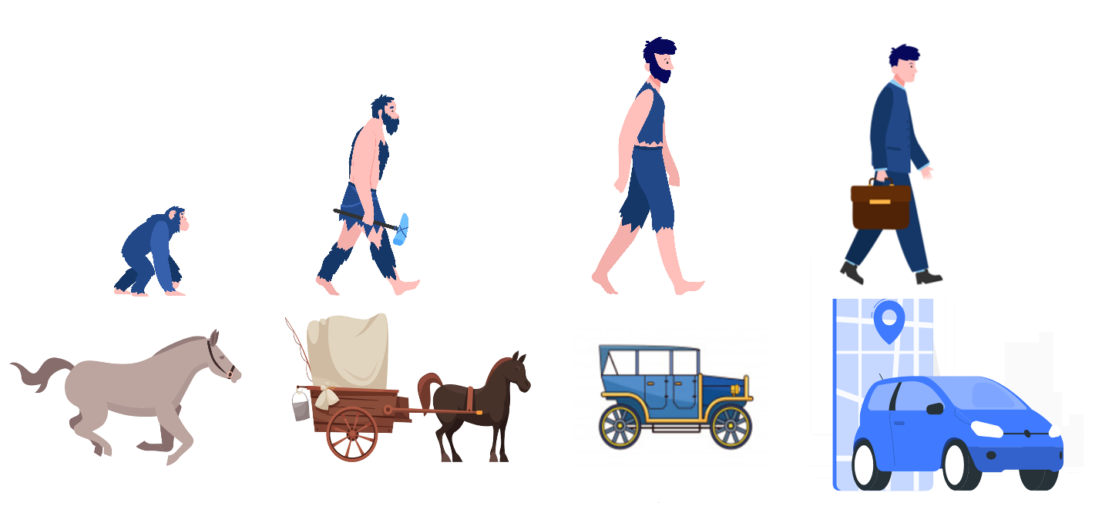

Figure 12: Progress of transportation over the year

## Uber

“According to Uber CEO Travis Kalanick the most successful company is likely to be the one that manages to best use the data available to them to improve the service they provide to customers.” (“Uber Founder Travis Kalanick Resigns as C.E.O.” 2017)Uber is a taxi booking service based on the smartphone app which links users that want to get somewhere with drivers able to give them drive. The entire platform for Uber is related to the basic Big Data theory of crowdsource. Whoever has a car ready to help others can offer them ride. It provides more options those who live in communities when there’s no public transportation and works by pooling journeys to minimize the number of vehicles on our crowded streets.

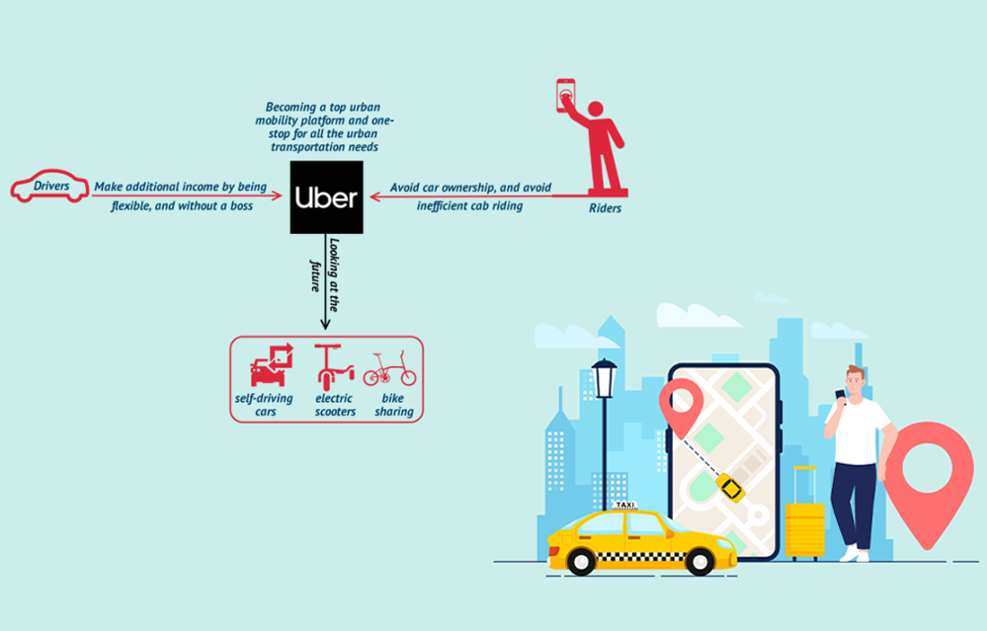

Figure 13:Case study of Uber

Uber stores and track details from every journey taken by its users and use it for market determination, resources distribution and price allocation. The business regularly perform in-depth analyzes of public transportation networks throughout the areas they service, helping them to target coverage on underserved areas by offering access to bus and train connections. (O’Toole and Matherne 2017)Uber has a comprehensive driver database in most of the town they serve, so is a user request a ride they will immediately match you to the most fitting drivers. The organization has built algorithms that track road congestion and travel times in actually time, ensuring that rates can be changed as request for trip increases. Uber use (Big Data-informed pricing and dynamic pricing) common to airline and hotel chains to change price to encounter demand instead of simply raising rates on occasions or on holiday periods, it uses systematic model to forecast real-time demand. Company use service called UberPool to that user can find someone close to them to make similar trip at the same time just so that they can share a trip. Uber relies on a comprehensive rating mechanism so user will rate riders, and vice-versa to create trust between user and driver. “According to Uber’s blog, introducing this service became a no-brainer when their data told them the vast majority of [Uber trips in New York] have a look-a-like trip – a trip that starts near, ends near and is happening around the same time as another trip”. (Uber Revenue and Usage Statistics 2017) Certain programs trailed or are due to be implemented in the past include Uber Chopper, providing wealth helicopter trips, Uber Rush for delivery package service and Uber Fresh for food deliveries. Uber keeps the data always at the heart whatever it does which means it applies less to short-term performance, and more to the long-term growth based upon data.

## Transport for London (TFL)

TfL operates a network of taxis, buses, footpaths, cycle paths, cycle hire bikes and ship used by thousands of people daily. London population is increasing at a stunning pace. According to analytics of TfL Lauren Sager Weinstein “The population is currently 8.6 million and is expected to grow to 10 million very quickly. We have to understand how [customers] behave and how to manage their transport needs.” (How TfL Uses ‘Big Data’ to Plan Transport Services 2019)

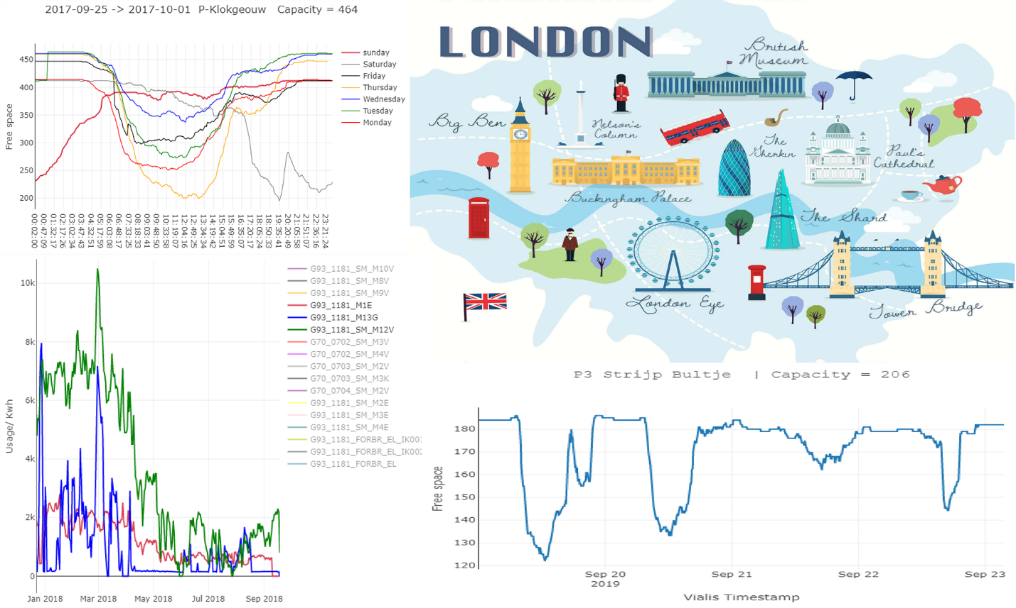

Figure 14: Case study of Transport for London

TfL has two objectives for analyzing and collecting data it is providing information to customers and planning services. From the research Weinstein says that passengers expect us to offer decent facilities and affordable and they want us to be creative and innovation to fulfill those needs. TfL use three main ways for data analysis: Providing personalized travel information, mapping customer journey, managing unexpected events. This business collects huge number of data through survey, traffic signal, ticketing system, Media and sensors attach to the vehicle. Smartcard ticketing program which has made it possible to obtain a large amount of data regarding the particular journey. (Big Data in Practice 2016) Traveler top up card by money and they can access train bus by simple touch point. Smartcard ticketing program produce around 19 million taps a day which can be useful for research/analysis. The obstacles on London transport are still there, one of most demanding was during the 2012 Olympic and Paralympic Games. At the busiest day of games on 7th august, approximately over 4.5 million travelers are transported. Given the large number of travelers TFL’s was able to sustain the transportation during the match. (Delaney 2016)

TfL digital media help to manage huge number of travelers. TfL increases awareness of the busier network at the beginning of January 2012, with the consequence that all passenger visits the platform to gain public transport status. The website lets travelers make the right decision earlier and encourages to shift the travel pattern. With the support of the geographic information system, the websites had to take extremely complex data to preserve and forecast the travel trends during the matches. Geographic information system compiled and visualized the TfL data in a straightforward and easy way to make it easily understood. The site even manages the Denial of Service (DoS) threat well and will make it run during London 2012 Olympic and Paralympic game until September. TfL shows recognizing what you’re doing is crucial to efficient use of the data. It therefore helps to have a form emphasis on your particular priorities and obstacles and to concentrate on collecting the data that allows them to be achieved.

## Tesla

Tesla builds up toward autonomy through the use of consumer-owned cars to collect the critical information. The humans have experience of sleeping on the road while driving long distance. Tesla “Full Self Driving” innovation will reduce the amount of annual death caused by car in the US, a record 40000. (O’Kane 2018)

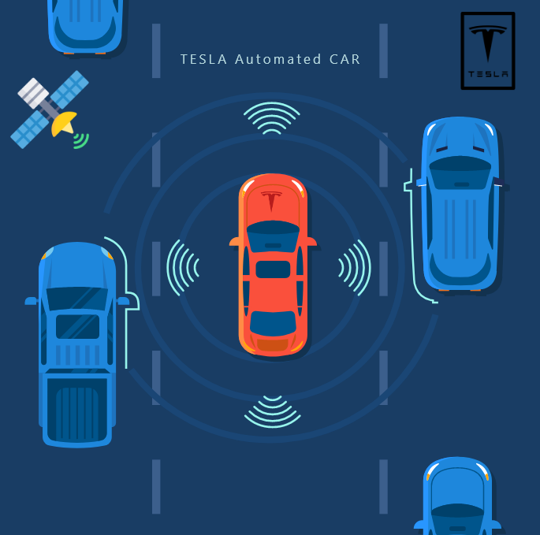

Figure 15:Case study of Tesla

Through its new semi- autonomous devices tesla gathers real-world data form millions of vehicles on the road. Analyst from Morgan Stanley (Adam Joan’s) claims that data from autonomous would be more valuable to Tesla than Model 3. Tesla establishes autonomy through the use of customer- owned vehicles to collect all relevant data. The business has tens of millions of drivers, including those who use Autopilot each day on the streets, and tesla in compliance with its personal data, it gathers information on about whether the system works properly. “Musk said that [Tesla was collecting](https://www.tesla.com/blog/master-plan-part-deux/) just over 3 million miles [of data] per day.” (Faiz Siddiqui 2019) You can find complete IOT implementation in self-driving vehicles, highly sensitive digitally powered brakes all within 16 feet, forward-facing radar and camera vision up to 250 meters away. All these features are accessible via the internet system and with GPS devices as well. As the number of users increases tesla collect the huge amount of data which can be helpful for future progress.

## Lotus F1 team

LotusF1 team big data is an essential key to success of Motorsport teams. It generates terabytes of data during race in real-time and looks for any adjustment that could win a race.

“Thomas Mayer COO of the Lotus F1 team Formula One has always been on the cutting edge of technological development so it was natural that data analysis would become a big thing for us. It saves us time and money: instead of having to rely on trial and error, we have real data.” (WTF1 2019)

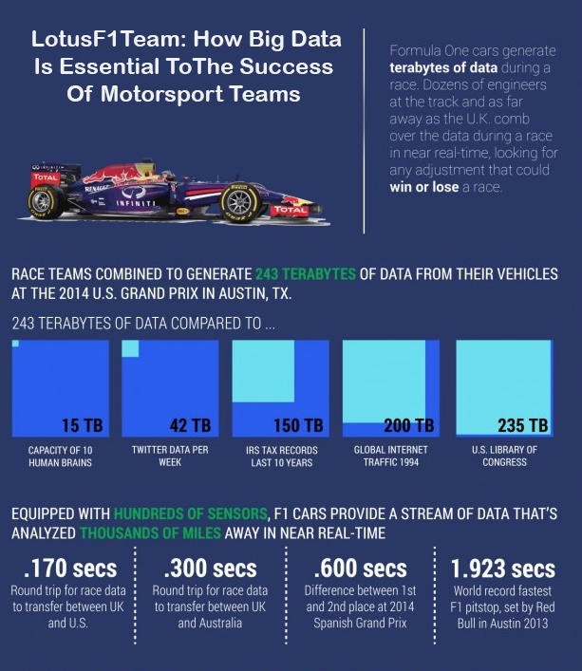

Figure 16:Case study of Lotus F1 team

Formula one cars carry some 140 different sensors and that they constantly send around 10 mb data per laptop to the pits? In total, 20-30 MB of data is collected per lap. Looking at 2cars running from Friday until Sunday and including collected as well as computed data, it sums up to an amazing 30 GB of data for an entire race weekend. It collects information on hundreds of channels, in particular different movement, speeds, pressures and temperature. 4 engineers monitor each car’s weekends. One focuses on the engine, one on the transmission, another one on electronics and system and the fourth engineer keeps an eye on handling and driving dynamics. They constantly analyses and interpret the data, convert the drivers’ feedback into numbers and provide the race engineers with a solid basis for their decisions and setup changes. During races they have a close look on certain crucial data channels and can immediately alert the race engineers about anything out of the ordinary. (Meet the Boss 2015) For example, a drop of pressure in a type including a puncture or high engine temperature. With all this information it undoubtedly helps team members such as Lotus F1 go with grip mostly with changes and make sure that fans get what they want (fast and furious).

## Rolls-Royce

Rolls-Royce produces huge engines which 500 plus airline and much more than 150 military use it. It is extraordinarily high-tech business, in which errors and failures might cost billions and live of people. The information/data gathered by Rolls-Royce allows them to develop more durable products, manage products effectively and provide quality customer support.

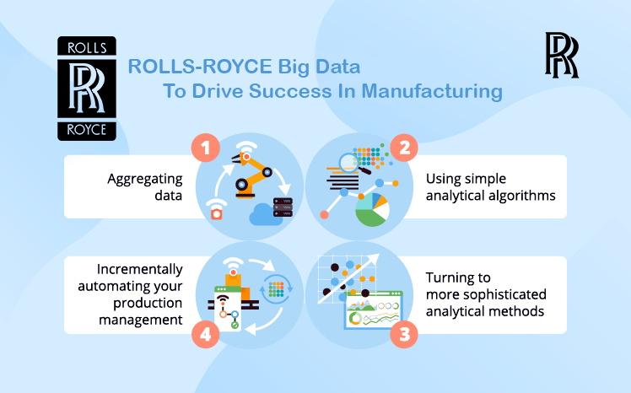

Figure 17:Case study of Rolls-Royce

Rolls-Royce has used the Big Data strategies in three major aspects of its operations: support for design, manufacturing and after sales. It continuously improves engine health monitoring system and at the same time working with the customers to understand the experiences and how it can improve engine of tomorrow. It supports the intelligent engine by looking at everyday new technologies and application for it it’s always looking at new data streams possible ways to apply data that’s outside of Rolls-Royce to help with intelligent. It is more responsible to the changes needs of customers in a fast-changing technology world. It mainly focuses on developing hardware and software algorithms to collect data which generated by the propulsion system, to collect data, which is generated by the propulsion system, transferred to a close service called “Mind sphere”. And it uses this data for design purposes, so analyzing the income data and telling the other development teams how they might be able to improve their designs, or for condition monitoring development purposes. Customer can benefit from monitoring and analytics services by allowing Rolls-Royce to reduce their maintenance times by providing advanced warning when faults are being detected, well before they become a costly fault to repair, and by providing them optimization on how they can use the system without them needing to actually do anything. “As Stein puts it: Rolls-Royce, like many successful industrials, is having to become more and more digitally aware. The digitization of Rolls-Royce is not up for debate; the question is not whether it will happen but how fast it will happen. I think of Big Data as the encroachment of digital technology into what historically have been mechanical or electronic industries. It forms a big part of our present but is going to form an even bigger part of our future.”

## Words as Data?

Everyday day data make our services work better for us. Like it helps to say right words and help to make wright decision. (For example: How does it feels like when you like someone in tinder likes you back??) Isn’t it amazing? This happens mostly to guys when you like someone at first and likes you back and list goes on and on thousands, millions. Well nobody knows the exact number. Do you know how to figure it out? Is it possible to crack the system? Then how? Which kind of people are going to like back? What kind of person not interest you? How did you draw to conclusion?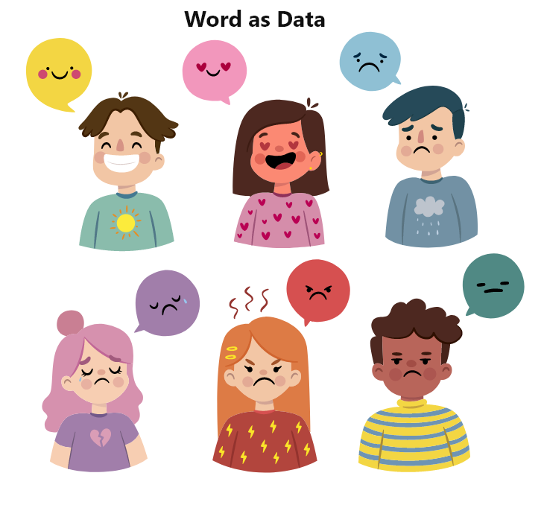

Figure 18:Words as Data?

Well there are several data points of earlier and of potentials/expectations and at that moment you make the choices. Did you learn to bicycle or swim? Doesn’t it feel great to swim/cycle which once you have learnt it? Its great isn’t it? But was it easy to learn it? At first you don’t know how to balance it, how to keep yourself up float, guider or helper will tell you guideline you should follow the instruction. But then you forget to follow the instruction and practicing it again and again initially you will learn it. So, I must follow the instruction in order to keep balance in bicycle. (The Telegraph 2018) There are several bad/negative rewards of falling then there’s eventually encouraging/positive reward and between small encouraging reward when balance yourself, in your mind sub consciously you’re gathering a lot of data then connection those all data you figure out how to bicycle or any games that’s how to learn everything isn’t it? So, the decision we made depends on positive and negative rewards.

## Data as Sentiment?

Today big company like Amazon, Tinder, Facebook, Netflix, YouTube gather big data to make the decision. How they do it? How does Netflix decide which series do you like? How does Amazon decide what you like what you wear? How does tinder know you like that person? How does Instagram already know whom to follow or not? How does Facebook know (person that you meet in bus) then suddenly appears in your friend suggestion list? How does Facebook know you better that you parents? Isn’t it fascinating? (Gwynn Guilford 2015)

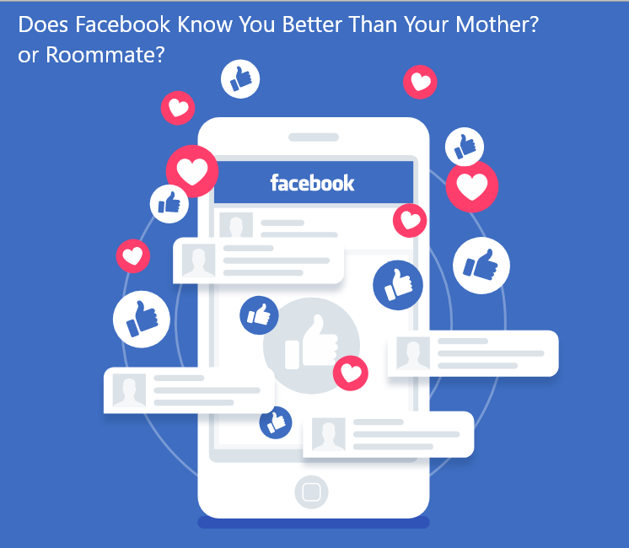

Figure 19:Data as Sentiment?

Next time you take that Facebook quiz you might want to think twice before you click Facebook is constantly collecting your personal data from your location your likes to your relationship status this personal information is an advertiser stream the internet used to be run by people you know people like Open University professors with open-toed sandals and socks and groovy beards right now it's not it's big businesses and they're making millions and billions and it's very difficult for us as individuals to really protect ourselves and our rights online at face value a Facebook app such as a quiz to find out if you're more of a dog or a cat person might seem harmless and entertaining it's in one click you could be allowing access to a personal data stored on Facebook that could be your name your photos age birthday friends everything you have posted on your timeline and everything you have ever. (Shashank Gupta 2018)  candy crush are examples of popular games developed to integrate with Facebook Wireless 2000 Titus uses digital habits apps that share the social networks platform are also able to Hoover up all the data about its users data which we are willingly giving away every time we sign into an app using Facebook or play a personality quiz well access to your personal data may help developers to improve their services a Cambridge analytical scandal shows that your personal data is also at risk of falling into the wrong hands some people think you know this was a data breach or a hack it wasn't a data breach were hack this is how Facebook was designed to work.

## Business Analysis

Business analysis is the process of allowing change by identifying needs and proposing strategies that provide value to the stakeholders. As the role of business analysis, we find and identify solutions that optimize the value that a company provides to its investors. Business analysis perform across all levels of the organization and can engage in everything from developing strategy, creating the business architecture, identifying the priorities and criteria for initiatives and project, or encouraging quality improvement in its technology and process to take a leadership role. There are four type of analytics can be divided into three main categories: prescriptive analysis, diagnostic analysis, descriptive analysis and predictive analysis. 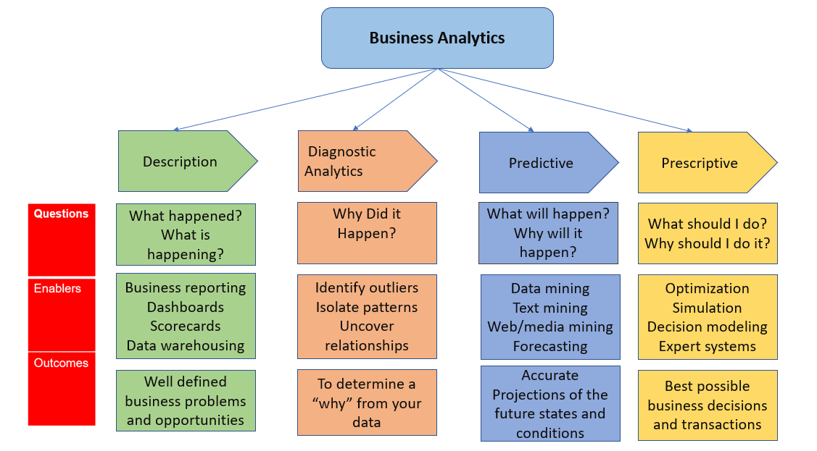

Figure 20:Business Analysis

### 1.Descriptive analytics

Descriptive analytics summarizes or defines the existing data of a business in order to have an image of what has happened previously/history or is currently happening. It helps to recognize weaknesses and strength as well as provide customer profiles. Business analysis use description analysis to make available data more relevant to the member of organizations.

### 2. Diagnostic Analytics

“Diagnostic analytics is used to determine why something happened in the past”. (Anushka Mehta 2017) It is classified by strategies like correlations, drill-down, data mining and data discovery. It is used to identify main cause of the problem. It is used in evaluating the aspects and events that led to the result. It often utilizes probabilities, distribution and likelihoods of result for the analysis.

### 3.Predictive analytics

Predictive analytics uses mathematical models and machine learning methods to predict the probability of future events. It focuses on the finding of descriptive analytics to formulate algorithms that extract the probability of selected outcomes. It uses research algorithms and mathematical models, allowing for a higher degree of predictive precision that business intelligence alone can achieve. Sentiment analysis is common application of predictive analytics.

### 4.Prescriptive analytics

Prescriptive analytics reaches above predictive analytics, offering suggestions for next best steps and enabling future event management to achieve better results. It depends upon the solid feedback system and on continuous iterative testing and analysis to keep learning extra relationships among different performance and results. (Team ASM IBMR 2020) It is a specific recommendation until next best steps that can be implemented to specific business objectives in real time.

## Data Visualization

We call stay in visual world. Yet why is visual so powerful? It’s about the way our brains get and transmit information. Visualization is any method for generating diagrams, images, waterfall chart and bar chart etc. Visualization by visual images is effective means of communication. The modern era is the world of innovation where business/trade produces millions of information each second. It is challenging to get it the numerical information where the techniques of visualization have the ability to represent them in images that human can easily understand it. (Rouse 2017) As a matter of fact, human brain process pictures (60 thousand) time faster than text. Human are more used to process image almost (90 percent) of ideas in human brain are visual and more than 90% of human communication is visual. Moreover, a variety of the businesses use the different visualization methods to show their information/data to their clients. For project, tableau is free tool/software used for visualization and helps to understand data. (Visualizations That Really Work 2016) The combination of data/information technology in transportation sector millions of data are created. As human can process images faster than text therefore user’s data is represented in detailed chart as it results in making right and faster decision determined by data.

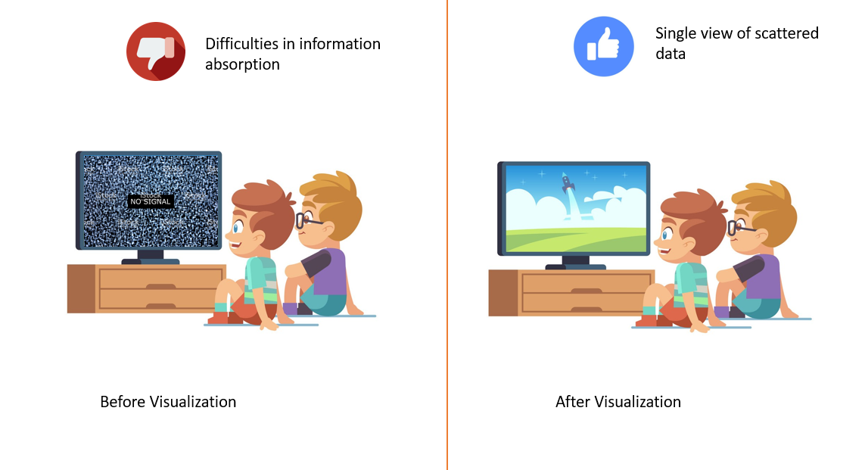

Figure 21:Data Visualization

## Importance of Visualization

“As Johnny Ive, the great Apple designer, said, we spend most of our time getting design out of the way.” (Unwin 2020) It's got to get out of the away, because it's about the relationship with the viewer and how they reason about the content.

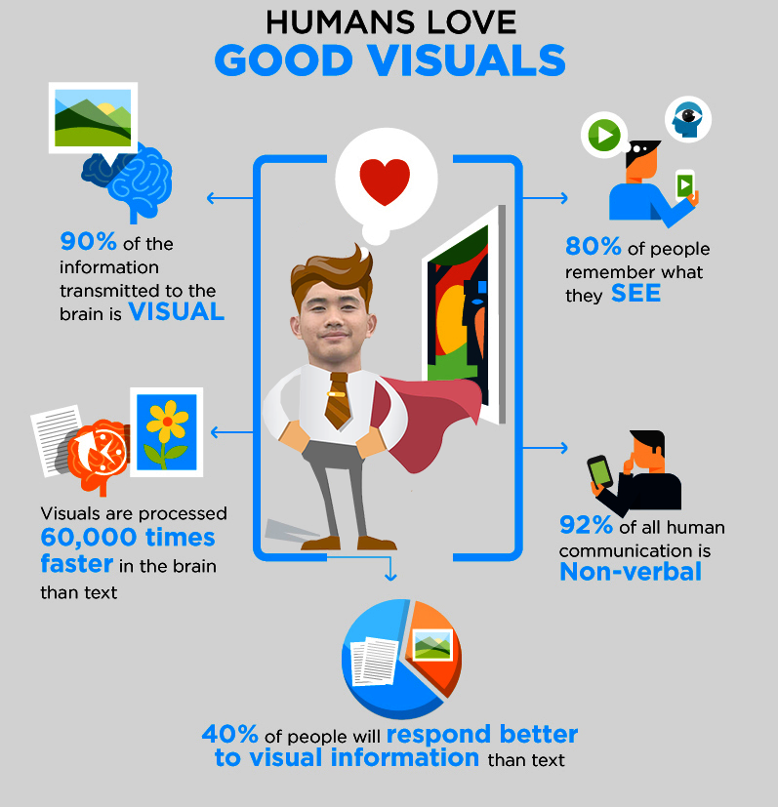

Figure 22:Importance of Visualization

Data visualization it’s actually a very linear process of decision making that you can do based on some few basic principles. Three things should inform your design always. One is you, as the designer. We evolved to see things and make snap decisions. “A tiger that’s coming to eat you. We have to be able to recognize those patterns right away and make snap decisions on them in order to survive. You can communicate a lot of information very quickly, because we all have brains that are designed to recognize patterns this way.” (Heitzman 2019) Data is just a clue to the end truth. Successful visualization tells a story. Before Data Visualization it (Difficulties in information absorption, scattered data, multiple stakeholders dependency). After data visualization (Better information absorption, actionable insights, singular view scattered data).

## How Storytelling Affects the Brain?

Story with which you and me can relate which is something interesting same applies to the data. Story about data is you have to present fact about the data in a story way like it is told to others. So, it is interesting which seek the attention of audience. The characteristics of good story telling is flow, interesting and message. To create a good data story first we need to know who our audience is. The audience whom I’m telling story they are not much from technical background rather they are businesspeople who want to understand things in high level. (Micheál Heffernan 2017)

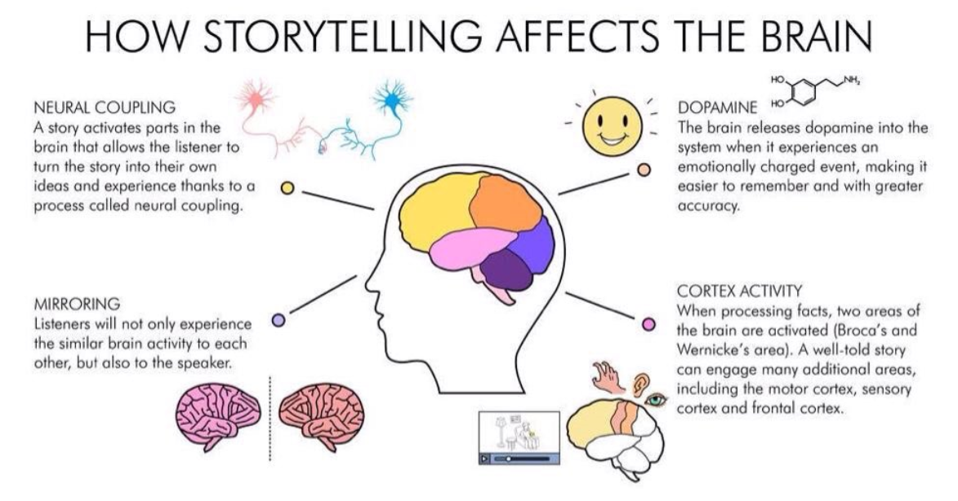

Figure 23:How Storytelling Affects the Brain?

In that case, I should not tell them about technique stuff what I should tell them is about how these things are beneficial to the business. On the other hand, if my audience is someone who wants detail of how something is working, how stable the model is then I should create my story in different way. (Martinez-Conde et al. 2019) You should be very clear on what is your purpose of study. Next thing is identifying the purpose of study which means what is the thing that I want to tell the audience. Drafting the story is another thing where what are the main part of your story and what is the question and answer of story. Then it has to be reviewed and structured.

## Law of Large Number

The law of large numbers was first discussed by a time mathematician Gerolamo Cardano in the 1500s and he decided that results get better and more consistent over time with a large data set so in other words think about casinos and how casinos operate you might have one or two players that win a large amount but over a long period of play time with a long number of players a huge amount of players the house always wins and that's how casinos work so it doesn't matter if one or two players win which means the casino loses overtime through a large number of data they will always win. (Webb 2019)



Figure 24:Law of Large Number

In trading basically the way you apply the law of large numbers to your trading is that you will actually be statistically better and have a better performing portfolio the more trades you make that adhere to your setups so if you have a good trading strategy with a good win ratio you don't even actually need a good win ratio what's really most important is your risk reward ratio so if you are always making more than you're losing and you only need a couple of winners to recover any losses that you make you can actually lose most of the time but win. overall, with a large number of data sets so it's actually better for you to take more trades as many trades as you can that fit within to your system because

managing your risk that's what casinos do and that's what you should do as long as you manage your risk and keep your losses smaller than your winners you can actually win trades less than fifty percent of the time and still consistently make money now think about when you apply that to a trading strategy that is having a set percent 80% 90% success ratio now you're doing really well so the ones that fit your setups don't take traits that don't fit your setups and most important controlling your risk you'll be able to do just fine check out. (Creating Future Wealth 2019)

The best sales advice of all time what does it say it says that while insurance companies don't know who will die each day, they prosper through statistics by knowing how many people will die each

day it's called the law of large numbers the idea is to stay in touch with and coddle every prospect you lose if you can't be number one be number two over time just like insurance companies the numbers will start working for you eventually.

## Desk Based Research Methodology

Desk based research or secondary research is a research technique that includes accessing already available data. To maximize the overall productivity of research, current data is collated and summarized. Steps to conduct secondary research is “identify the topic of research, identify research sources, collect existing data, combine and compare, analyze data”. Some example of desk base research is (Data available on the internet, public libraries, commercial information sources and educational institutions). Data from internet, public libraries and educational institutions has been mainly used for this project which is most cost-effective compare to primary research. In addition, it helps to achieve a wider knowledge of the subject.

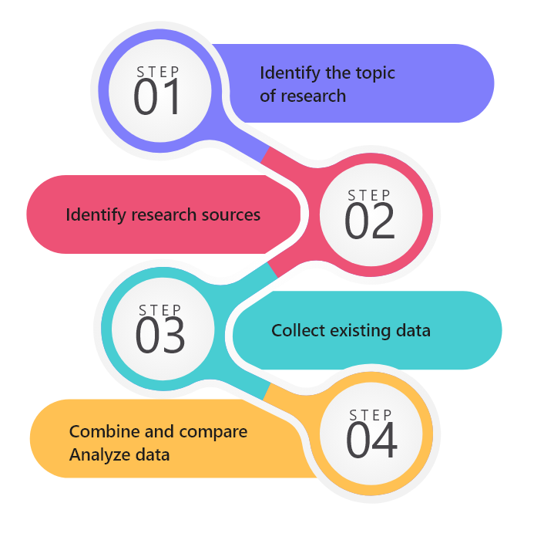

Figure 25:Desk Base Research Methodology

## Development Methodology

As the methodology for development, this project uses an agile methodology. Agile methodology is a specific approach to project management that is used in the development of software. It is an approach that encourages constant iteration of design and testing during the project lifecycle. It is one of the easiest and most efficient process to transform business vision. Using Agile methodology there is regular chances to look at the product and make improvements. Agile methodology has been used as a development technique, using this technique I have developed many applications. The main advantage of using this methodology is it is possible to correct a mistake in the middle of a project. In addition, it facilities flexible responses to modification.

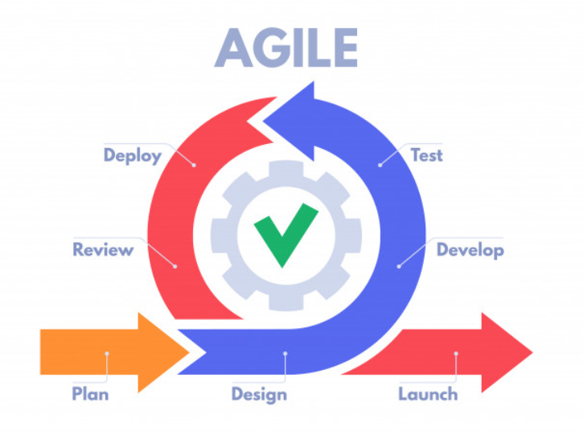

Figure 26:Agile Development Methodology

## Data strategy

CRISP-DM methodology provides general procedures for generic mapping to advance business model. Its task is divided in four division which are: phase, specialized task, generic task and process instances which help in data mining project. It shows cross-reference between output and tasks. It covers the stages of a project, their corresponding task, and the connection among these tasks. (Crisp DM Methodology - Smart Vision Europe 2020) These are the phase if CRISP-DM reference model.

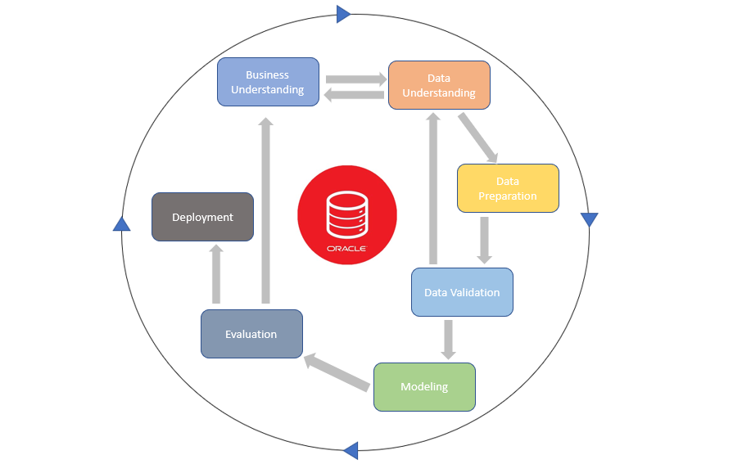

Figure 27:Data strategy

### 1.Business understanding

The first step focuses on identifying project priorities and criteria form a commerce point of view, then turn this information into a description of (data mining problems) and a tentative strategy for achieving the aims.

### 2.Data understanding

Data understanding process begins with the initial data collection and continues with activities that allow you to familiarize yourself with the data/information, collect data if required data is not available, explore its initial insights into the data, and finding interesting(subsets) to establish hypotheses about secret knowledge or verify data quality.

### 3.Data preparation

This phase certainly covers all the activities needed to build the ultimate dataset for the primary raw data. We do it for our modeling and analysis. Its activities are likely to be carried out several times and in no specified order. For modeling tool task include collection of list, record and attribute, and transformation and cleaning of data.

### 4.Modeling

Modeling is also called juicy part of data strategy process where we find the solution to our problems by carrying out statistical analysis and modeling. It has different modeling idea/techniques which are selected and implemented in this step, and their limits are optimized to optimal values. There are typically several methods for the same type of problem in data mining. Some methods have specific necessity on the procedure of information/data.

### 5.Evaluation

In this phase, you have developed a model or models at this point of the project, which appears to be high quality for a data analysis prospect. Before moving to the final implementation of the data strategy, it is important to thoroughly analyze it and review the steps taken to construct it, in order to be confident that the model meets the business goals properly. The main goal is to assess whether there are any critical business problems that have not been properly addressed. A decision regarding the use of the data mining results should be reached at the end of the phase. (Rodrigues 2020)

### 6.Deployment

Deployment modeling generally isn’t the conclusion of the project/plan. Although the main aim of the model is to increases idea of the data, the idea acquired will necessity to be structured and available in such a way that it can be used by the client. It also includes implementing “real” models within the decision-making processes of an organization. The deployment phase can be as simple as producing a report or as difficult as applying a repeatable data mining method across the (enterprise), depending on then requirements. It several cases, customers carry of the deployment phases not the data analyst. Even if the analyst carries out the implementation effort, however, it is crucial for the client to know in advance what steps need to be complete in order to essentially make use of the generated models.

### Tableau



Figure 28:Why Tableau?

Tableau is a popular/powerful and faster growing tool which is used in the business intelligence for the data visualization. It helps to simplify raw data into the format that is very easily understandable. (Rungta 2020) With Tableau, data analysis is very fast, and the created visualization take the form of worksheets and dashboard. The information/data that is generated using tableau can be understood at any level of organization by the professional. The reason to use tableau are it is first ultimate skill for data science, apply for any business, user friendly, tableau is easy to connect to different data sources, fast and easy, leverage the power of data, you don’t need to do any coding, communication is huge and it makes easier to explain your data reports to your boss.

# Tools

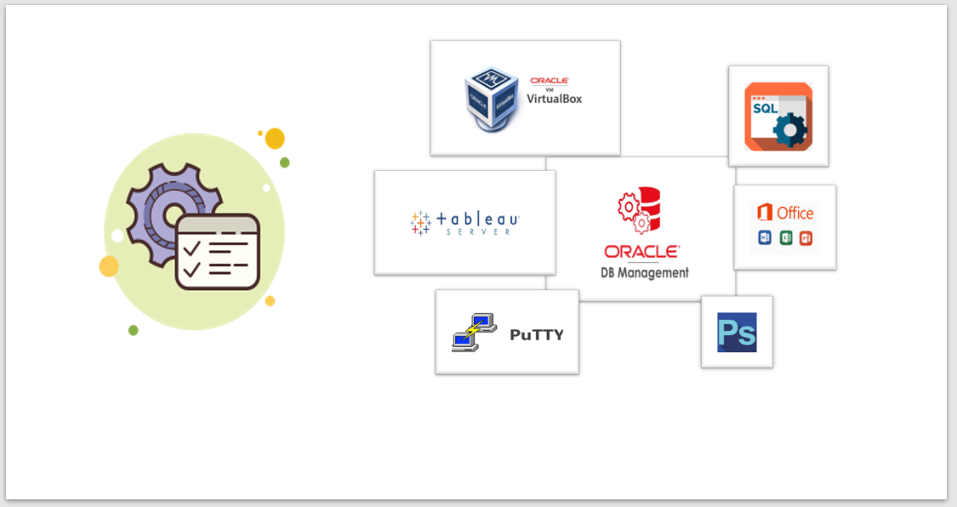

Figure 29: Tools

# Technology

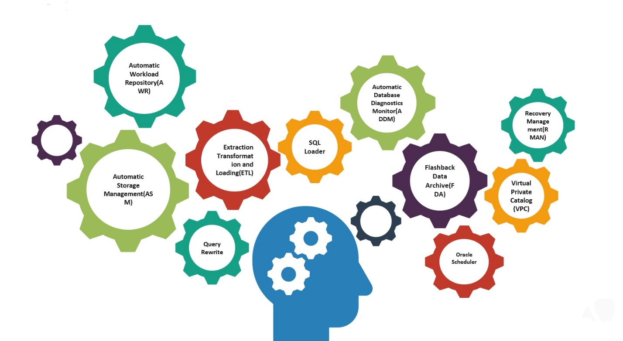

Figure 30:Technology

# Techniques

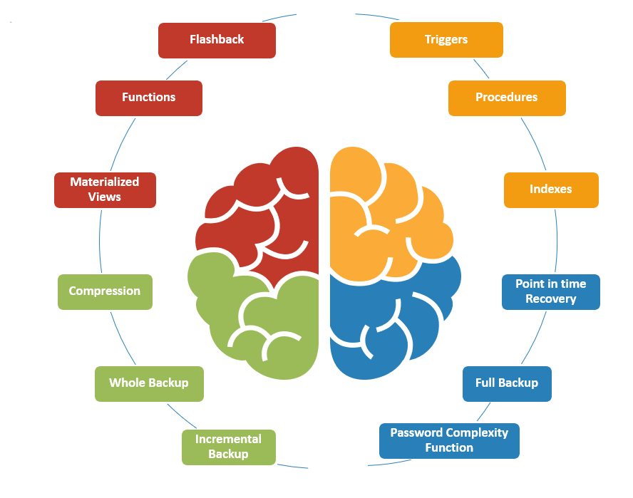

Figure 31:Techniques

Oracle 11G****

Figure 32:Oracle

“Great [achievers](https://www.awakenthegreatnesswithin.com/action-makes-all-the-difference/) are driven, not so much by the pursuit of success but by the fear of failure.” Larry Ellison (“Larry Ellison” 2020)

Oracle Database is a set of unit-treated data. The reason of any database is to store and recover related (data and information). Data server is the solution to addressing information management problems. In a multi-user environment, a database server generally manages the tons of data so that multiple user can access the same data at the same time. Oracle 11G is one of such database providers which provides quality attributes like database backup and recovery, performance, scalability, security, information integration, ASM (Automatic storage management), data integrity and triggers, business intelligence and auditing etc. All these attributes given by Oracle which will help to get right information for project. Moreover, Oracle has the extraordinary back to the clients and are continuously solve any problems you are facing. Taking all these into consideration, (Oracle 11G) has been selected in this project. (Why Oracle 2020)

# Business Metrics

It’s really importance to know your process in order to know what you’re doing. if you know what you’re doing then you know what is working and what needs improvement so the business metrics make it easy to you to know what you are doing. To begin the process of understanding your process is known as business metrics.

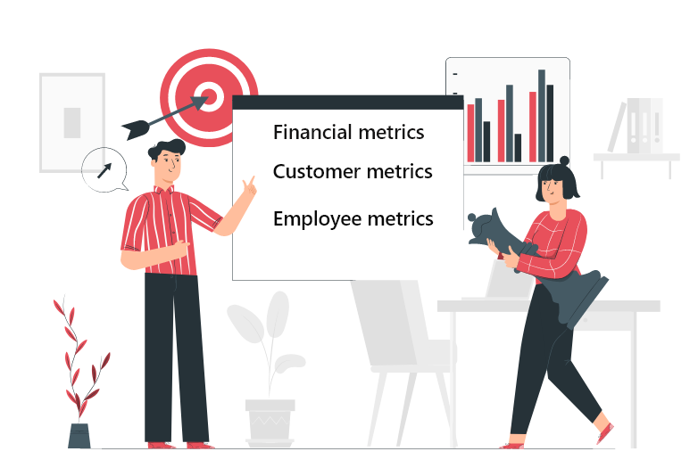

Figure 33:Business Metrics

The common three types of indicators are:

## 1.Financial Metrics

The most widely used performance metrics are financial indicators. These metrics evaluate how well a company is performing. Investment return, net profit, growth rate of sales are financial indicators. Income statement, balance sheet and cash-flow statements are where you begin to evaluate the company’s financial performance.

## 2. Customer Metrics

As the most important key performance metric, customer-focused indicators are increasingly touted. Many metrics of client performance are also evaluated regularly that impact financial measures. A declining customer satisfaction, for instance, would likely impact earnings over period. Time to value (TTV), retention rate, Net promoter score (NPS) are some typical client metrics. To accomplish this understanding, they can apply more innovative approaches to sales and marketing.

## 3. Employee Metrics

Due to the strong correlation between high job satisfaction and business performance, as well as the correlation between employee satisfaction and less employee turnover, companies are increasingly realizing the importance of investing in employee-centered metrics. A significant raise in sick days, for example, may be a key indicator staff turnover.

# Dashboard design principles

**“Visualizations act as a campfire around which we gather to tell stories.** ―Al Shalloway”

You have to take certain things into account when designing dashboards to create an efficient dashboard which actually delivers the correct message to a specific audience. Before actually implementing them, there are several measures that can help create better dashboards. Understand your customers, number one. So, you should think about who this is really about before beginning to create a dashboard. (Kukula 2020) Dashboard is a filtering of various data points, metrics, towards a more limited, basic way to present data. And if you’re designing dashboard for boss, colleague or to explore the data for yourself, you must should think about who this really is for, and are the information I’ve been presenting meaningful to this intended audience? It will allow you to move your dashboard throughout the correct direction and deliver the correct information to the correct audience.

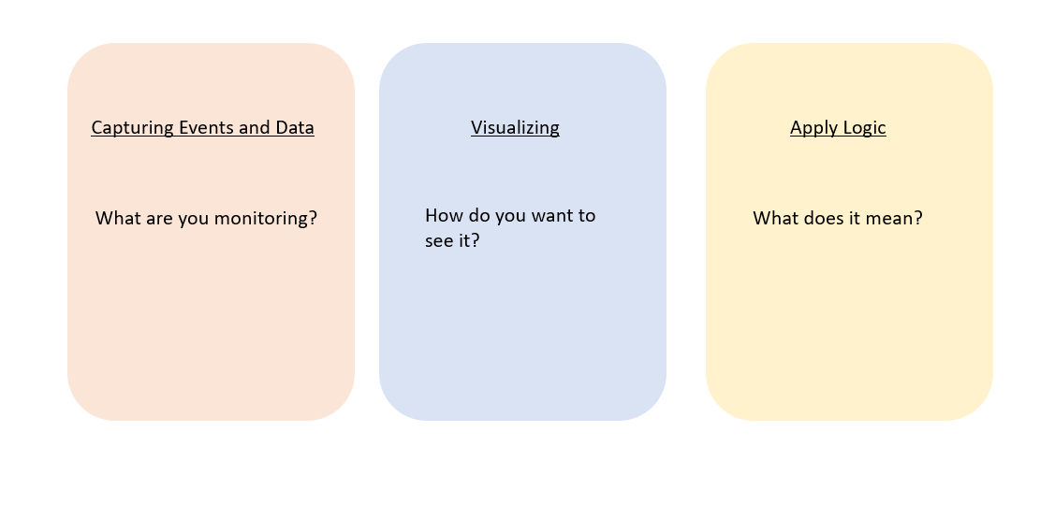

Figure 34:Dashboard design principles

Secondly, get a straight story. Dashboard is obviously there for communications, you would like to convince someone, either you want to advice someone, or to encourage them to analyze the information on their own. A significant aspect of a dashboard is the message that you’d like to covey, and you must know about it first. So, it’s crucial to remain on point, stay with the story, when you communicate your message with a dashboard, you need to include a story that actually tells your information. Step three, get your information/data and your sources of data ready. In this process you should know what data you decide to get for the dashboard. How you clean and prepare the data is something you should think about, because later on it is helpful for the dashboard. (Taras Bakusevych 2018) Step four, that is identifying and visualization. How to organize your information on a visualization, which visualization will you use to effectively communicate your data? You may also begin to look at some other visualization techniques, how some have implemented it. Last and final step, which is getting the resources and then applying it into dashboard. It is crucial that you plan a bit before you start creating a dashboard.

## UX design process

### Understand the user

Designers must consider their users prior to before researching product. Using strategies like customer journey maps, personas allows to visualize what is understood about a specific type of customer. It externalizes information and support decision making to ensure that decisions are taken in the user’s device.(Komninos 2020)

### User research

One we know our users we start investigating the research problem (In development of dashboard). Secondary research is suitable while researching the problems. It includes (system usability sources, expert review, benchmarking against another dashboard). When a designer has a clear understanding of the problem area investigation is performed to evaluate how they engage with dashboard and to understand the issues they face.

### Ideation

As the process of design thinking, several concepts are generated throughout ideation, but they are based on combination of the research. Ideation is an activity of interaction and often includes (user, expert in subject area, main stakeholders for the project).

### Prototyping

You can use paper prototyping to identify the main layout elements when designing dashboard. The level of detail increases as you move through high-fidelity design, covering information such as how data will be displayed.

### Testing and iteration

Testing and iteration are the final steps in this process. By testing prototypes early, before significant time or money are spent, you can find defects and resolve them

# Security

## Scalability

“Scalability of any system refers to the capability of handling the growing amount of work without any disruption. It means system can handle the more total amount of work by adding the resources in the existing architecture.” When developing system, we should always bear in mind that system should be able to carry out additional burden whenever required. Similarly, Automatic Storage Management (ASM) is enabled in this project for system storage scalability where the system data is automatically balanced, and you can easily add the disk whenever you need additional system space. Likewise, Automatic Memory Management (AMM) is allowed which allocates resources automatically to users.

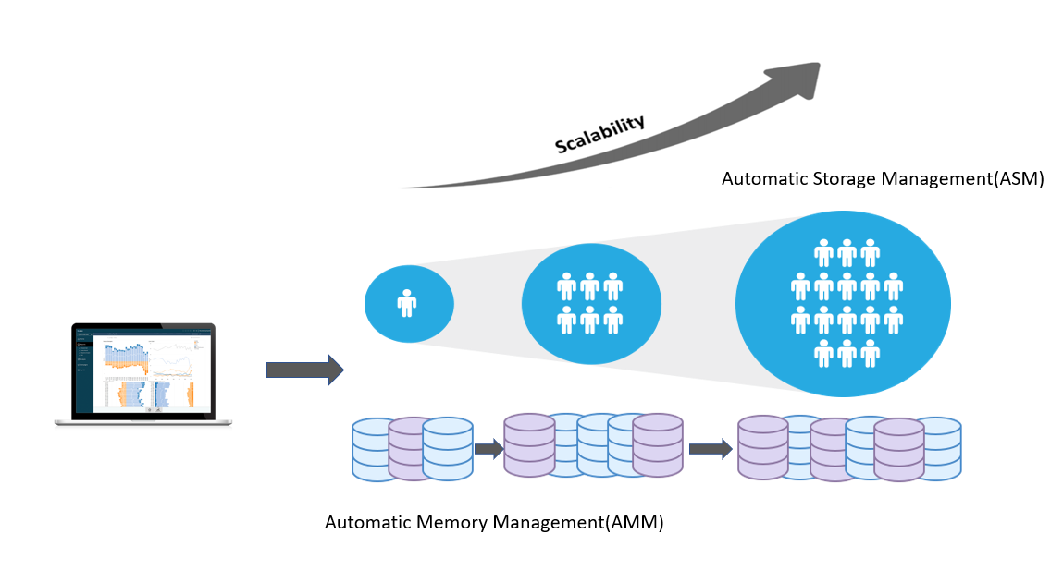

Figure 35:Scalability

## Automatic Storage Management

In the earlier days, If you have multi point datafiles you can store it into the disk again and if you have another set of data files you need to create another disk again you need to set into different disk which was time consuming work and it was difficult to manage all the disk to remove this problem oracle have introduce ASM(Automatic Storage Management). It has created a bunch of discs so because of that only it is really easy to manage all those disk group. ASM disk group is a collection of disks that ASM manages as a unit. To accomplish these things oracle have introduce another instance we call it as an ASM instance. There are two instances if you want to configure ASM the first instance we call it as a database instance and second instance called ASM instance. 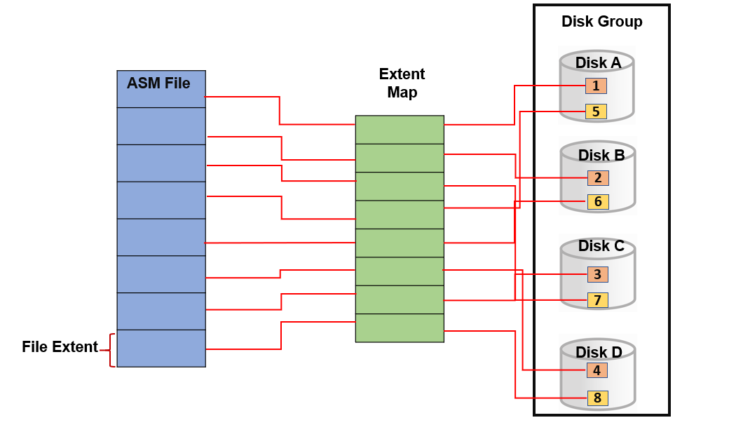

Figure 36:Automatic Storage Management

ASM can be useful for your single database instance as well as for your rack database instances. In rack database instance if we have three node cluster so we can have three host machines on that three machines there will be three instances but there will be a dedicated one database that is shared by the multiple instances. ASM instance will be shared with the multiple database instances on different nodes which mean it can be shared by multiple instances in rack architecture along with that it can be useful for your single database instance. It also like you database instance, but it is smaller as compared to database instance. ASM instance store metadata information about your data like where is your data available in your disk group. One of ASM’s most importance features is adding /removing disk in disk group while database is start and able to access data while running. Automatic reallocation of data through the disk is executed just after disk is added to the disk group. Even if a disk failure occurs, the database will not be down, as the data will be replicated as distributed evenly among the disks, this significantly reduces downtime at the database.

## Automatic Memory Management

Automatic Memory Management allows you to determine maximum memory allocated to the instance. (With PGA and SGA). As needed, the memory usually fixed to the components PGA and SGA. It allows oracle instance to allocate total size of the memory. The key benefits of enabling AMM is DBA doesn’t have to worry about allocating each aspect to both specific mechanisms of memory and background process. It also reduces system administrator overhead pressure. In addition, AMM also allows the memory size advisor to set the initialization parameters at various levels. Likewise, there is additional function called (Automatic Shared Memory Management) that allows you to control (System Global Area) overall. 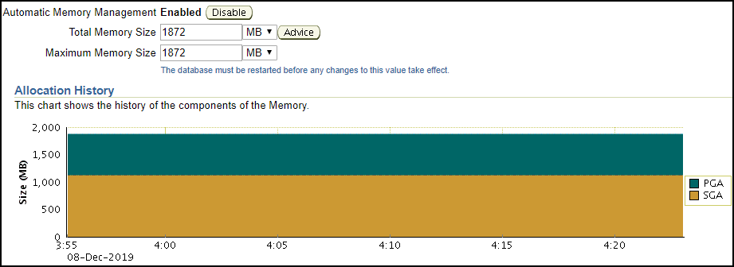

Figure 37:Automatic Memory Management

“SGA is composed of different components and when Automatic Shared Memory Management is enabled then the memory size to the components of SGA is dynamically allocated as needed. Memory management for these components can also be managed manually but for the best performance of system database it is necessary to enable the Automatic Memory Management.”

# Usability

## Dashboard Objects

Dashboard is linked with end-user and are mainly intended to make decision. Every dashboard design choice taken should concentrate on enhancing the end user experience. Avoid adding cool functionality-ensure which will bring benefit to users but not disruption. You can also add many kinds of objects in order to add visual appeal, functionality and meaning to your dashboard.

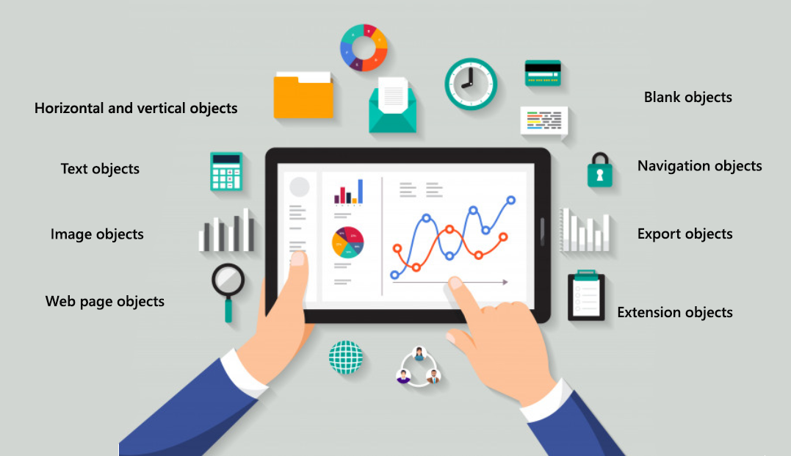

Figure 38:Dashboard Objects

## Adding interactivity

We need to make sure to give dashboard clients the chance to communicate with the dashboard at their own speed and to discover the information and insights. By using one of three dashboard actions, you can add interactivity to the tableau dashboard.

### 1.Highlights

### 2.URLs

### 3.Filters

## Adding and configuring fields

A field in tableau is an aspect of your information. Through all the data field can be displayed, created, calculated, grouped, filtered and combined. When you connect to a data source, fields are initially applied to the data pane. Depending on its format, tableau automatically formats the data. For instance, latitude and longitude values will instantly get identified as geographical data.

## Filtering and sorting data

Including filters at the stage of the dashboard improves your dashboard’s usage (and therefore value) as different audiences can use the same interface. A dashboard containing worldwide data, for example, is only useful to top management at that same tactical level since it offers a bird’s-eye summary of the system. Adding features help user to get information in different level.

## Adding actions

Actions certainly brings value to the dashboard by encouraging users to connect with it. At the level of the dashboard, applying actions is just the same as inserting it to separate graphs.

### Filter Actions

Filters help user concentrate on the information which is most important and reducing the amount of information of data presented on the dashboard. (example choosing a location to see certain shops in a particular area).

### Highlight Actions

With indicators, you can add attention to specific area and fade others. It is especially helpful in the dashboards since key user details can be highlighted.

### URL Actions:

You can add a link to an outer web site, details, or email when adding URLs. If you want to direct the user to something which is hosted outside tableau, and also provide then with a method to seek more data this will be very helpful.

## Performance and Scaling

### Choosing a data connection

You may choose to extract data or connect to a live data source when make a data connection. Live source of information/data can be slower to interact with, depending on the method extracts are normally much quicker. It is always easier to work with an extract when you are exploring information, or prototyping visuals. (Record and Analyze Workbook Performance 2020) But extract is not long-term answer for huge size data if you want to access data that is continuously been updated. The number of columns is one of the key factors affecting the efficiency of data extraction. To increase efficiency, you can use the hide inactive fields choice in the data display to cut down number of fields.

### Reducing data points

Getting a huge amount of data points in a visualization often decreases the visualization benefit by overburdening the audience. To optimize your visualization efficiency and make it much easier to audience to understand you should spread information/data over many sheets and direct the viewers through high-level summary. (David 2020) Eliminate needless dimensions from list of data and present your data in various ways.

### Optimize calculations

The more calculation you create in visual the slower it goes to be. To reduce this, consider switching calculation back to your source of data. “For example: Calculated columns in your database or spreadsheet alternatively. You can look at how you use built-in functions such as MIN, MAX, and AVG.”

## Clean up your workbooks

Getting many workbooks and data sources impact efficiency. Remove the unused worksheets or data sources and duplication enhance the efficiency of the dashboard. (Eldridge 2015)

# Building accessible dashboards

With the help of tableau user can concentrated on enhancing their product. Adding features like keyboard-only navigation, screen readers and braille keyboards helps you to build better dashboard. To boost the accessibility dashboard there are four measures that can be applied.

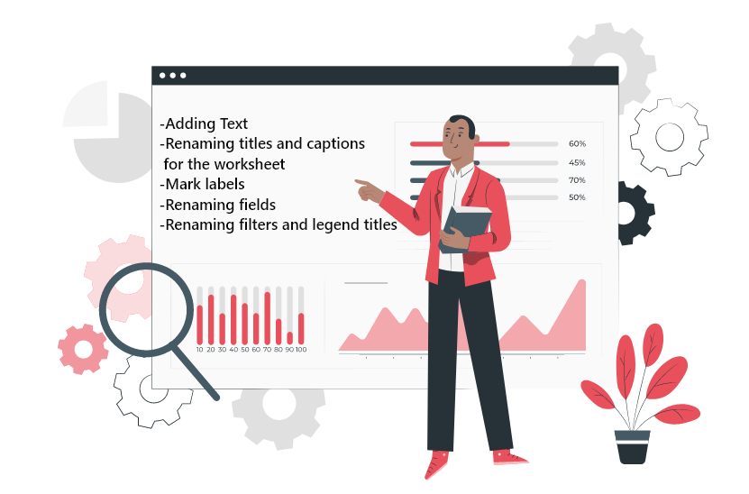

Figure 39:Building accessible dashboards

## Updating color palettes

There are many customizable color patters available in tableau. Considering the Color-Blindness color like blue orange will be easy to view. recommendations on the use of color palettes, WCAG suggests that visualization of text and text images should have contrasting ratio of approximately 4.5:1 or 3:1 for broad text.

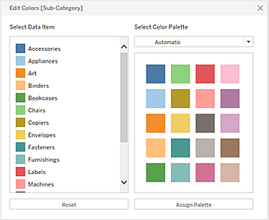

Figure 40:Updating color palettes

## Providing visual cues

Using color is not only sufficient. You may use various visual sign to create a more flexible dashboard, such as adjusting size or shape of logo to convey message.

# User security

In physical location database contains the confidential infromation and data that are essential to every organization. We need to enforce security for the user of the system to protect them form the unauthorized user. And in transportation its more essential as it contains user data like user information, history, location which can be misused. User were created so that user can be get different roles, tablespace, password complexity function, profile. (Oracle Database 11G: Administration Workshop I 2020)

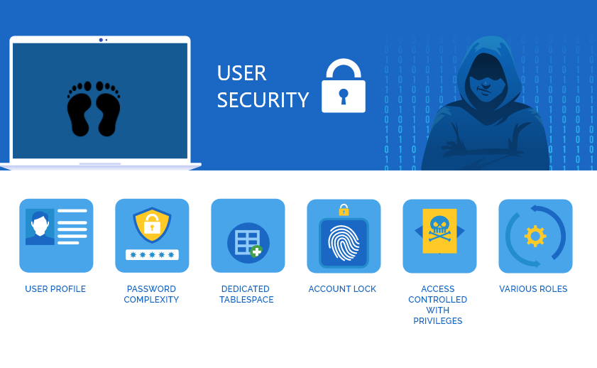

Figure 41:User security

Password Complexity Function: This role helps define the complexity of password which include minimum length of password, number and special characters etc. Additional features like Account locking, failed login attempts, password lock time, password again and expire, password lifetime and password grace time.

Role: A role hold all the rights/privilege which are approved to that role and all the benefits of other roles which are given to it. There are various types of roles formed upon this system so that the user privileges can be easily managed. This permits users to access to the database and make database objects in their given patterns.

Profile**:** Profile means the parameter created for the user by the system administrator to use the tools of that specific boundary. The profile must be created to impose a limitation on the usage of resources and to protect the confidentiality and integrity of the database. “In case of public transportation, the profile can be creating for accountant, dba, data analyst and etc. the specific person has the specific role and responsibilities to the particular task assign to them for the progress of organization.” ‌ (Introducing Enterprise User Security 2020)

Dedicated Tablespace**: “**It is a logical unit storage consists of one or more datafiles and collectively holds all types of database objects.” (Best Practices for Oracle Database Security 2017)In this system, separate tablespace was created so that only the user associated to the tablespace get the privileges to access it.

User**:** Here we create system user and allocate them to their roles and profile. User frequently communicates with the system and performs various tasks. Since the database server is much more vulnerable that other stander servers, the user of the system must be properly managed.

Implementing Password and Security Features**: “**In Oracle 11g the password management and security are implemented during the creation of roles and profiles.”Similarly, the authentication features are already used in profile development for better user password management. Further, the profiles have multiple level of security such as password reuse time, password again and expiring, account locking and resources limitation. This ensures that the device is safe and not accessible outside the database by another person.

# System Security

It is also necessary to secure a system to make sure the security of transportation data. Transportation data is very essential and need to be protected. If person with bad intension have access with data, they may misuse it. (Oracle Database 11G: Administration Workshop I 2020)

## Auditing

Auditing is important that we need to understand so before that let me take one real-time example let's say you're working as team someone drop the database definitely there will be a lot of people simultaneously working on the Oracle database server. So, if someone is dropping the database, we should know that who has dropped the database, or you can take the example like who has dropped the table. (Oracle Database 11G: Administration Workshop I 2020)If nobody admits who has dropped the table now there should be some proof right who has dropped the table who was logging on that time so these are the things which will come when something went wrong on the database product manager who is having the responsibility that everything should be fine. 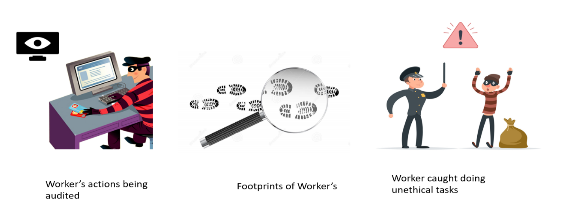

Figure 42:Auditing

Let's say someone drop the database I should know that he has dropped the database and he was if he was logging on that time or someone has dropped the table so how we will come to know about this kind of activities on the database level so this is all possible with helped out by using the auditing on the Oracle database so adding thing is option in Oracle database through which you'll come to know about who is doing what who is doing auditing is something to track what is exactly happening on the overall database that - very easily so the first part the statement level of auditing all the statement which are fired on the database will get audited . Object level auditing we know we have multiple objects in the Oracle database let's say it is about the table it is about the index or something or view because table is contain very important information may be the account or details about the money or transaction everything will be stored so we don't want anyone to see that details because that is secure that is that being privacy terms which is coming over there right so that object level statement or that object layer things also that you can audit it. Overall database we are providing a different kind of privileges to the users so on privileges level also you can enable the auditing.

# Data Security

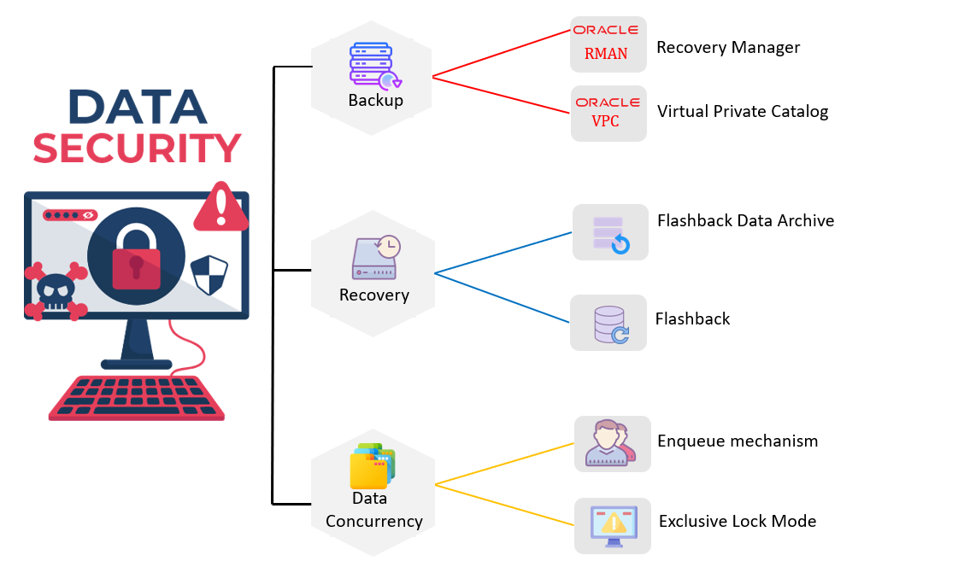

Figure 43:Data Security

## Backup

Data is a really valuable and vital asset of every organization or business. Regardless of how large or small the organization is, data holds the same value. Such data is stored as a database in physical storage. There are several quality features such as security, storage management, auditing, maintenance and data retention. Among these, however the backup of the database is one of the most major importance features. For different purposes, the database may also get corrupted whether it is human error or technological error. (Oracle Database 11G: Administration Workshop I Volume 2 2007)The data may even be removed unintentionally or with poor intentions by individuals. Several backup protections against that kind of human error, no matter what the cause is, this will adversely impact the organization if the database get compromised or if any data/file is lost or removed. The backup of data is very necessary to ensure the availability of the data even when the database gets corrupted.

# Recovery Manager (RMAN):

There is a feature in Oracle known as RMAN which stands for Recovery Manager to ensure the backup and safeguarding of the database. RMAN is already installed and configured during oracle installation. There needs to be a destination database for RMAN to work. In target database RMAN is linked to perform the database backup or recovery actions. All of the metadata for the operation is stored in the file system. RMAN can work with either recovery catalog or Fast Recovery Area (FRA). Both Recovery catalog and Fast Recovery Area (FRA) is used in this project. Recovery catalog is a different database in which the RMAN actions are recorded on one or more database. The benefit of consuming recovery catalog with that is it stores RMAN repository metadata which guarantees recovery even though the control file gets lost or damage. (Oracle Database 11G: Administration Workshop I Volume 2 2007) A database called ‘cat dB’ is built for this project as the recovery repository. A user is then created and given the privileges of the owner of the recovery catalog which permits the user to control the RMAN catalogue. Recovery manager catalog includes a list of the backups as well as other target database information. Also, backup can be classified as:

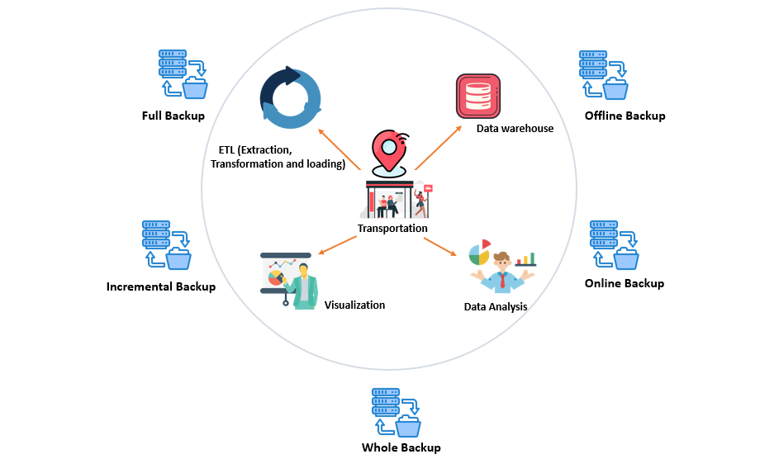

Figure 44:Backup

## 1. Cold or offline backup

Cold backup seems to be the simplest and most secure example of backup. When the database is in offline mode, it takes backup. What does that mean it takes backup when database is shutdown that is not use during the backup process? During cold backup no changes should be made to the database. ‌ (Backup and Recovery 2020)Its advantage is implementing cold backup is easy to handle and is cheaper and need less repair. Some drawback of cold backup is that it does not have the choice for a single database table backup to take. Compared with other backup options it takes more storage space.

## 2. Hot or online backup

Online or hot backup is also recognized as dynamic backup. It is a data backup, whereas the database is still online and open to users. Online backup is the normal way to do most backup in the database. This is done for applications that must be in 24 * 7 * 265 service. Any failure in the network will result in major losses. The benefit of the online backup is that it offers timely recovery and restore which can be done at any time because it allows the database to be kept in online state-run. It permits to take backup of tablespace and datafiles. If database backup is fails point in time recovery is unable be done.

## 3. Full Back up

In this backup it gets a copy from every block of data which contains data, and which is stored in the file. It also known as no archive log mode. Full back up should have included the database-associated parameter files. (RMAN Backup Types 2014) You may take full backup of the database one the database is closed or when the database is opened.

## 4. Whole Backup

This sort of backup is executed when Archive log mode is running in database. Archived redo log backup is performed in collaboration with database. This need redo to get into consistent state.

## 5. Incremental Backup

Since previous backup copy of all block of data is made that have change. Incremental backup supports two level of backup which is cumulative backup and differential backup. Cumulative backup all changed since the last level 0. Differential backup changed since the last incremental backup (0 or 1). It is quicker than full backup. This takes up less available space.

Backup is necessary for any type of business depends on company needs. Different kinds of backup are designed for various purposes with this project. Full backups are scheduled weekly basis and incremental backup is schedule daily. In monthly basis, whole backup is scheduled. All these forms of backup are designed in project to ensure that repair in the event of a failure is possible.

# Virtual Private Catalog:

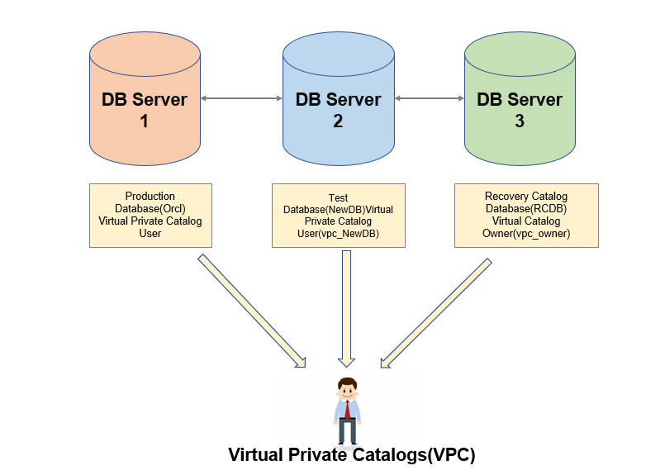

Figure 45:Virtual Private Catalog

The new function provided by oracle from version 11 g is Virtual Private Catalog. This feature allows RMAN. This new functionality allows you to offer limited access to certain users on RMAN catalog so they can access a specific list of application database included in the (recovery catalog). This function is really beneficial if you need to split tasks between different database administrators, or between DBAs and the recovery catalog administrator. VPC includes of database information, where the owner can perform backup and recovery actions. Imagine there are several databases. A new employee joins and new database provided to work with. This is registered in the RMAN to configure the backup on the new database. But it will be difficult for the recovery manager person to handle all the resources in the (recovery catalog). So VPC is used to prevent this. Owner split tasks between different database administrators, or between DBAs and the recovery catalog administrator. (Oracle Database 11G: Administration Workshop I Volume 2 2007)Then new user can login into RMAN and make virtual catalog and can perform backup and recovery actions. This will also reduce the burden and workload on the user / owner of the recovery manager, this will also perform restore and quick backup when necessary.

# FDA (Flashback data archives)

Flashback data archives is also referred to as Total Recall this enables us to place a table in archiving mode which we can track all changes whether their DDL or DML against that table based off a series of once a table is placed in archiving mode that table cannot be dropped all changes made to that table will be tracked and retained for a series of years. (Flashback Data Archive (FDA) Tips 2015) I have used the flashback data archive (FDA) to preserve the retention period of data for 5 years under the data protection act.

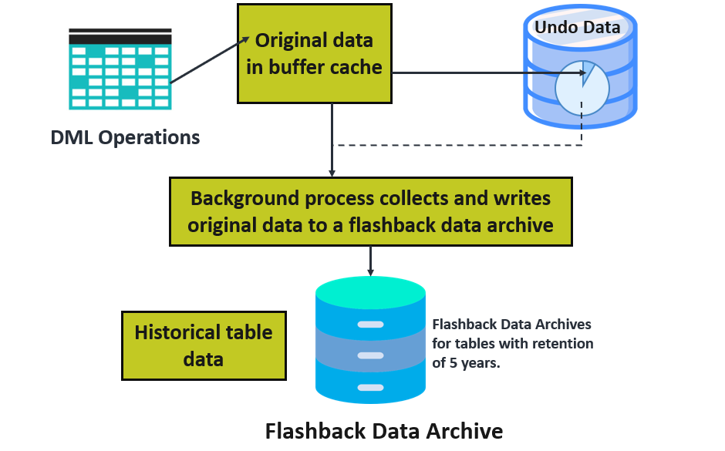

Figure 46:FDA (Flashback data archives)

# Concurrency Control

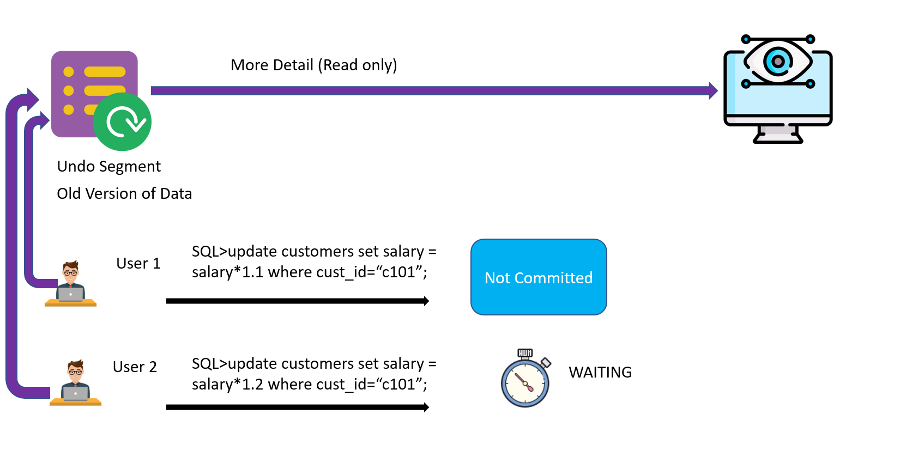

Figure 47:Concurrency Control

(Concurrency Control) means that multiple user accessing the same data at the similar time. Where data is the important aspect that must be taken into account for any type of system. There are two types of database on amount of user accessing the database at a single time: Multi-user database and single user database. In single-user only one user has access to database perform task on same data which do not cause any problems. Where in Multi-user database user can do multiple activities in database at the same time. (Data Concurrency and Consistency 2020) When the user makes DML query in data then automatically the row/table is locked so transaction can’t change the data until it is committed. Now another user tries to do DML action then at same time have to wait until the first user commits transaction. if anytime user want data then get it from undo segment older version of (read only). For Organization Data is significant assets and it became more crucial when it comes to transportation sector, so any form of valuable(multi-user) DBMS (Database Management System) regardless it is e-commers or healthcare. In order to sustain the integrity of data and protect/prevent undesired modification we need to do concurrency control. By default, oracle provides different sort of concurrency control. There is exclusive lock, DML lock, share lock and transaction lock mechanism where row level lock is automatically enabled by oracle which gives basic level of controls where user cannot change/modify the similar row at similar period. Any type of locking mechanism can be enabled at any time suitable to the system.

Enqueue Mechanism: Oracle have the mechanism that automatically monitors the direction of the lock request and sessions waiting for lock which is called enqueue mechanism. Enqueue Mechanism retains way of request lock mode, keep order in which sessions request lock and sessions waiting for locks. Locks request are automatically placing in queue. After hold transaction is complete the next on-line session obtains the lock. It monitors the direction in which locks are demanded and mode requested. (Nitish Srivastava 2019) It ensures data integrity, since one single user can carry out data transactions at a period. For example, there are many scenarios where users lock the session and forget to commit and following another user must wait and might not get (accessed privilege) to similar data where we must detect the lock dispute and sort out them. Further Note, there have been two types of enqueue waiters one who wait with no shared ownership and with ownership which is shared who choose to intensify the (lock level). Second category waiters have higher priority and must wait less over ordinary waiters.

Exclusive Lock Mode: Lock conflicts is another locking mechanism of oracle. Under this mode, one user locks the entire table and other users cannot do any activities onto this table. It is often done during analysis on table or when handling table data. (IBM Knowledge Center 2018)The DBA or the users with administrative privileges do exclusive lock mode.

# Database Maintenance

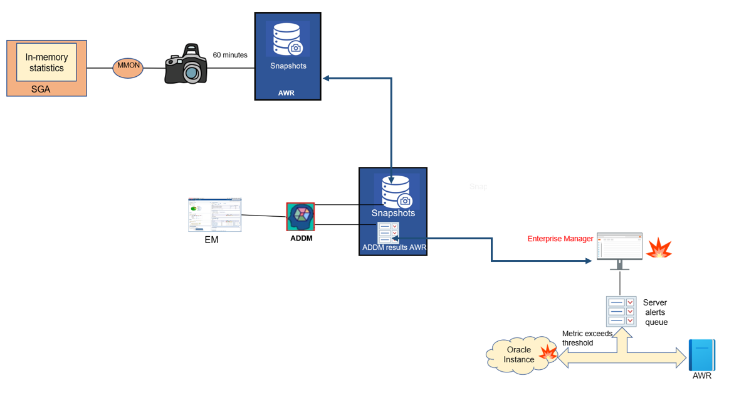

Figure 48:Database Maintenance

The word database maintenance defines a set of tasks to be performed in improve database performance. There are plenty of tasks like updating internal statistics, free storage space, checking data error, inspection fault in hardware and several other duties are plus the maintenance of the database. The objectives of Database maintenance are using automated tasks, setting alert thresholds, manage optimizer statistics, use the Automatic database Diagnostic Monitor (ADDM), describe and use the advisory framework and Manage the Automatic Workload Repository (AWR). (Naveen 2020)The oracle has introduced three type of maintaining database which is reactive, automatic and proactive. Each one of them are different maintenance modes, but its main objective is verifying whether or not the database performs well. At the daily time, automatic database maintenance activities are automatically performed on the database. It run in system when the system database has minimum workload at prespecify time set and we can also build our specify manual maintenance windows. Automatic SQL Tuning Advisor, Automatic Segment Advisor and Automatic Optimizer Statistics collection are one of common examples. Likewise, (proactive maintenance) requires a continuous checking of activities in the database and identifies any issues until they become the system’s major problem. AWR (Automatic Work Repository) is classified as the database warehouse that gathers output information, all transactions, and system processes. Automatic Work Repository gathers the information in each and every 1 hour (60 minutes) (Managing Automated Database Maintenance Tasks 2020) Then ADDM analyzes the statistics collected and provides the database report and alert and by default that include guideline for solving the current problems in certain cases, solve the problem automatically itself. (Reactive database) maintenance means responding to the essential error occurs in database. If database cannot fix this problem (Database Administration) needs to address the problem manually, like running out of storage. Based on AWR Database server generates the crucial alert if it is unable to fix these problems so they suggest the solutions to that specific problem and the administration/admin has to make the choice for it.

## Automatic Diagnostic Workflow (ADW)

Oracle include Automatic Diagnostic workflow for detecting, diagnosing, preventing and to resolve critical problems. These are caused by customer data corruption, code bugs and metadata. If there is any critical error, then alter in EM (Enterprise Manager). DBA can view the problem details for example (file #9, block #11). Then DBA gather additional diagnostic information and create a server request. (Managing Diagnostic Data 2020) Then packaged and upload diagnostic data to oracle support track the server request and implement any repairs. Its advantage is problem prevention, reducing problem diagnostic time, simplifying customer interaction with oracle, reducing problem resolution time and limiting damage and interruption after a problem is detected. 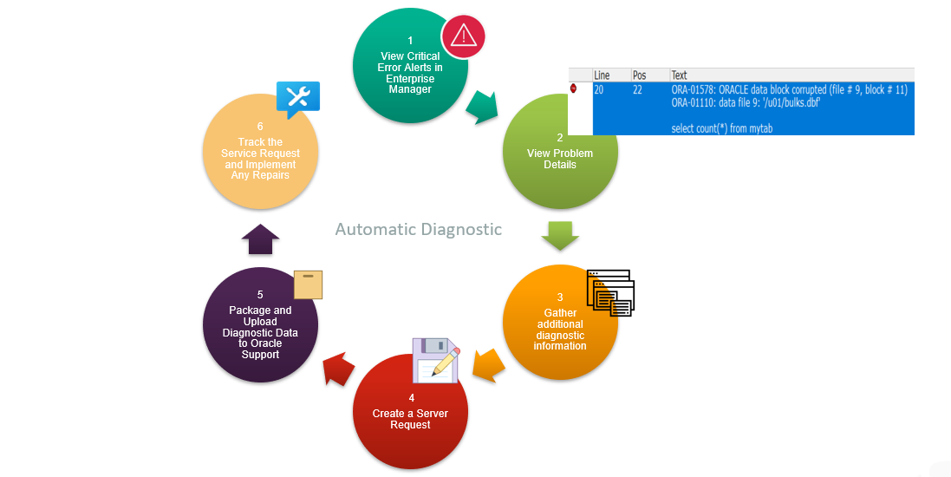

Figure 49:Automatic Diagnostic Workflow (ADW)

# Automation

Automation actually allows the system to carry out tasks without human intervention being required. Automation was also enabled in this system using the work scheduler of the oracle.

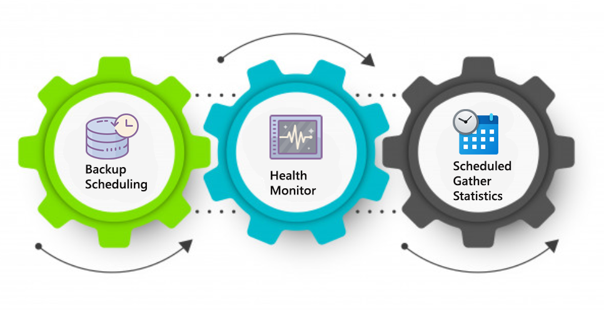

Figure 50:Automation

## Scheduling

This is the feature in oracle that allows task automation and it is known as ‘work scheduling’. The activities are referred to as jobs and are scheduled to operate at an interval at the designated time. With support of scheduling, activities such as backup can be done daily, or any time, and collected stats can be scheduled to run at daily basis or hourly basis. In order to ensure the proper functioning of the system, I have use scheduling to automate the collected stat on a regular basis. Likewise, I have scheduled full backup weekly, whole backup monthly, cumulative and differential backup on daily basis. This is intended to make sure that the information is backed up at frequent intervals and system can be recovered in case of any occurrence that leads to data loss.

Health Monitor**:**

Health Monitor is one of the features of oracle database it is used for executive diagnostic checks on several database components. It checks inspect at different mechanisms/components of database like process usage, file, metadata, transaction integrity and memory. All these checks produce information on their result and further suggestions for solving problems. It can be run by enterprise manager interface or otherwise using DBHM_HM SQL package. Look on CHECK V$HM for full explanation of possible examine/checks that health monitor can carry out. It come into one of two types. DB-online where checks can be executed while database is in OPEN mode. (Running Health Checks with Health Monitor 2020) Another is DB-offline which is runnable while database is open and can carried out checks at the time when instance is present and database itself is in NOMOUNT mode. After it run, including preferences critical, high and low it produces a report info on the outcome of checker describe of the result and their effects and basic facts about information.

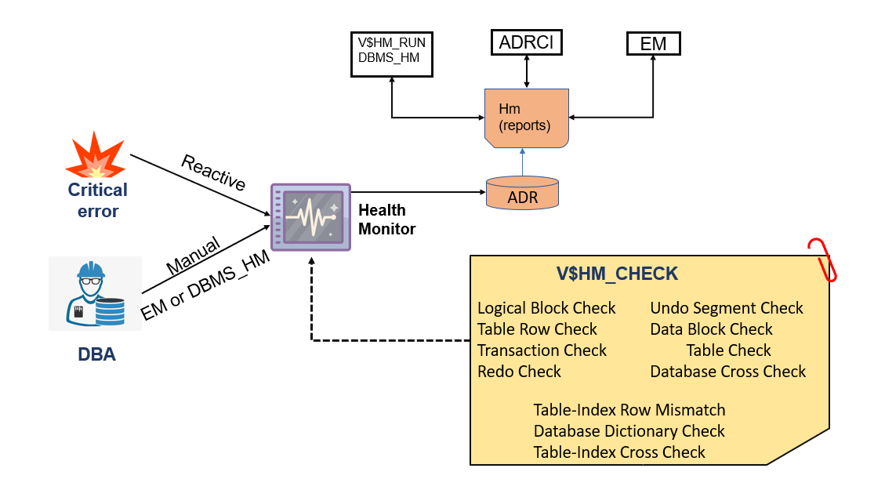

Figure 51:Health Monitor

# Deferred segment

Defer segment is making a partitioned table permits indexes and tables to be form despite of actual segments that can be (double-edged sword) as it allows creation of object even though there is no room available for such object in define tablespace. (Llanos 2020)

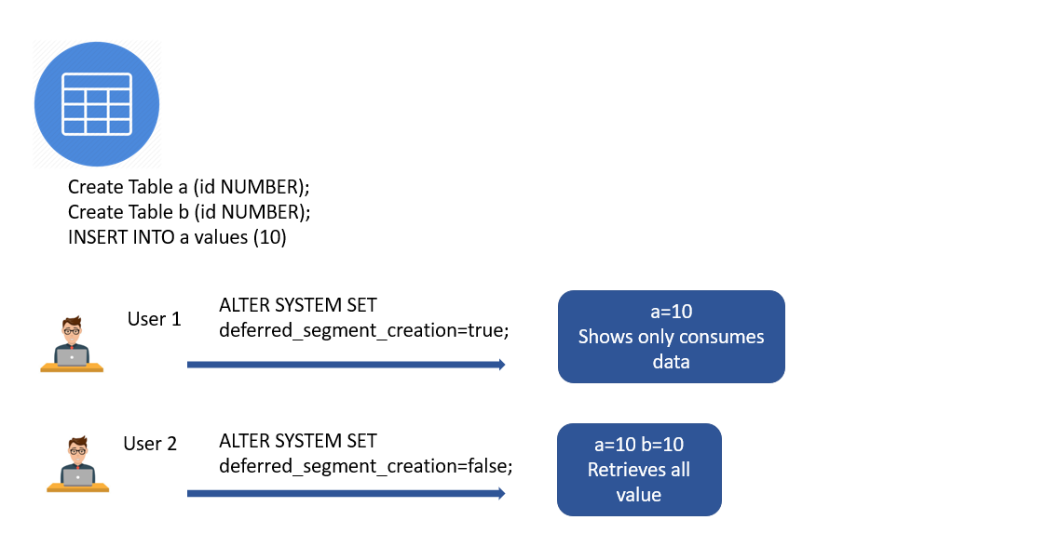

Figure 52:Deferred segment

Inthis figure, two table is created named a and b. Value is insert in table a. In user 1 deferred segment is created (ALTER SYSTEM SET deferred_segment_creation=true;) where only (a table) have consumed space. It shows table which only consumes data. In another user deferred segment is false (ALTER SYSTEM SET deferred_segment_creation=false;) where both a and b table have consumed data where all value is retrieved.

# Materialized view

Materialized view is simply a database object that contains the result of query. It is a physical copy of an original database tables just like a snapshot and picture. It is also known as precomputed and these are stored on a disk like an object. They are not updated each time they are used. It has to updated manually with the help of triggers. (Materialized Views in Oracle 2018) It response faster compare to view. It doesn’t waste time for resolving queries. It referenced based on trigger as query expression. Reference decides to update materialized view and trigger decides when to update materialized view. It is used for fast processing.

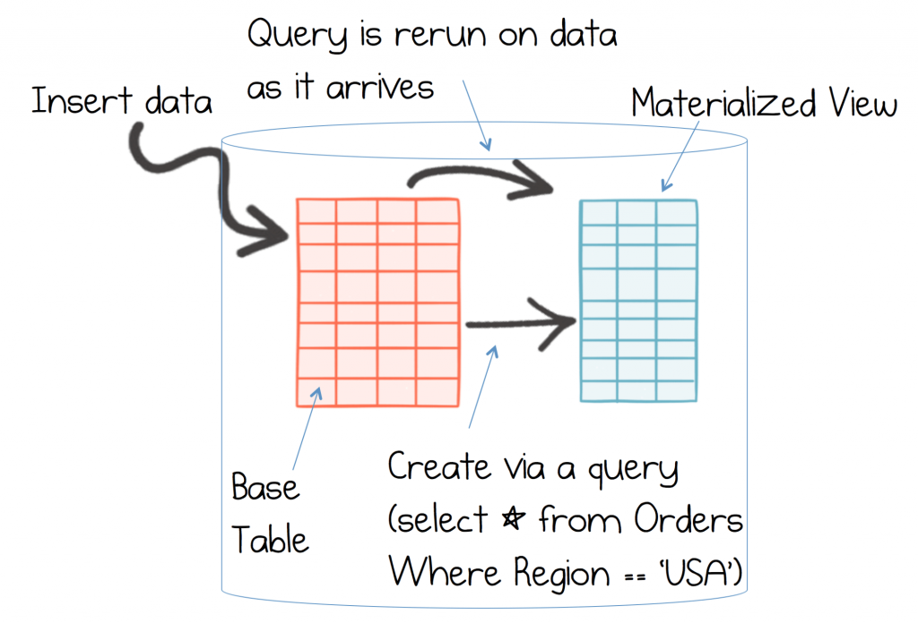

Figure 53:Materialized view

# Extract Transform and Load (ETL)

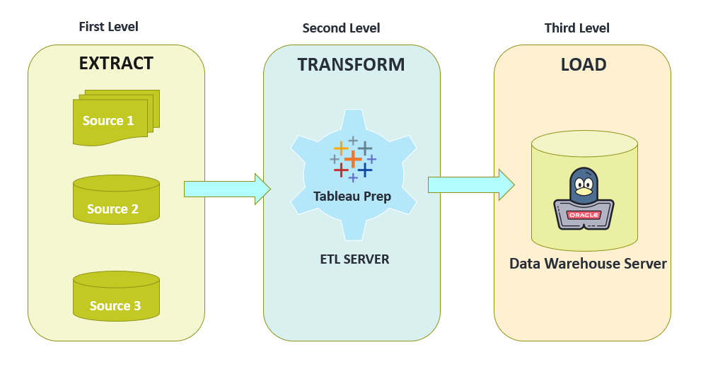

Figure 54:Extract Transform and Load (ETL)

One of the most important aspects of data warehousing which is ETL.

“The complete process of extracting the data transforming the data and loading the data into warehouse is called extract transform and load it.” (Rungta 2020) ETL has three phases first is the extraction path second is the transformation and third is the loading of the extractor and the transform data into the warehouse.

As a first step in data warehousing, the data from the various sources has been extracted into the staging area, some of extraction techniques are offline extraction, online extraction, incremental extraction, logical and full extraction. we need to remember while extracting the data from so system is that it must be structured in a way that does not negatively impact the performance of the system. For my project I have extract data from online source like (Git-hub and Open-data)

Let's move on to the next phase which is transformation phase where tableau prep has been used. we cannot use that data as it is it needed to be in raw format. It has to be cleaned up as to the necessity and changed before it is finally ready for loading into a data warehouse. At the basic transformation tasks first is the selection the data which is essential to be loaded into. And the data from more than one source system is collected so that it has to be normalized or standardized, so we clean and enrich the data and consolidate and summarize at last. The data from the source system because we do not want to load same data. we calculate and derive new columns from the existing columns we split, and merge fields split it from a single field so multiple fields and then we combine some fields as well and this all happens based on the requirements we convert units because so system may have a different way of storing it a particular measurement but we convert into a standard format for example we can work the date/time we can word the units of measurements into a standard format to summarization aggregation of data and consolidation deduplication is also done as a part of transformation in which we delete the duplicate data.

Hence, we (consolidate, summarize and aggregate) the data from so system intake cross solution. (What Is ETL - Extract, Transform, Load? 2020)

Data need to be standardized before loading into warehouse. The entire data set is normally taken after transform of data and leaded further into database system. Next is incremental load so this is when we apply all the ongoing changes. Oracle is main data warehouse server for this project. I have used the flashback data archive (FDA) to preserve the retention period of data for 5 years under the data protection act.

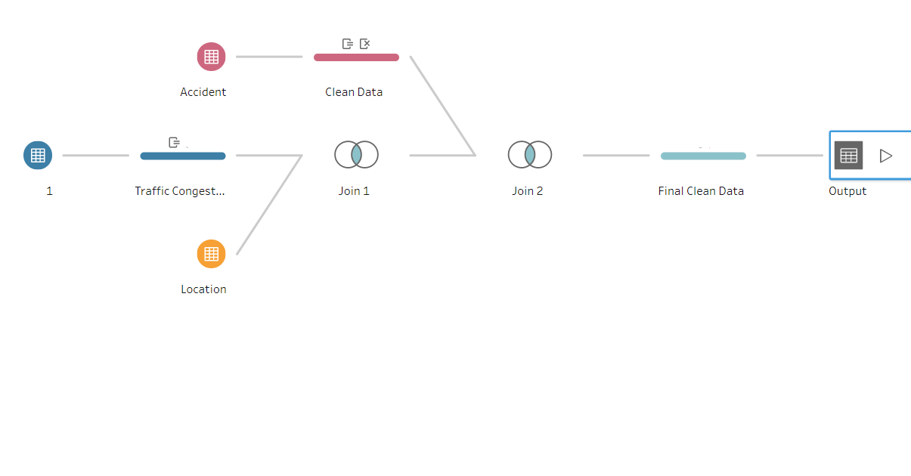

Figure 55:ETL Process

# Data warehouse

In order to provide useful business insights, Data warehouse method is useful to collect and handle data from different sources. Using SQL tools and other data analysis tools the data obtained on the warehouse is accessed by the decision makers, business analyst and data scientist. Information and data are a necessary aspect of business in order to remain competitive*.* (Data Warehousing 2020) So, they use analytical and dashboard reports to track performance of their business generated by business analyst. In addition, Data warehouse makes use of numerous methods to improve performance of the system and therefore decreases the cost of execution. Similarly, Data warehouse is the method used to turn information into useful information. (Rouse 2017)

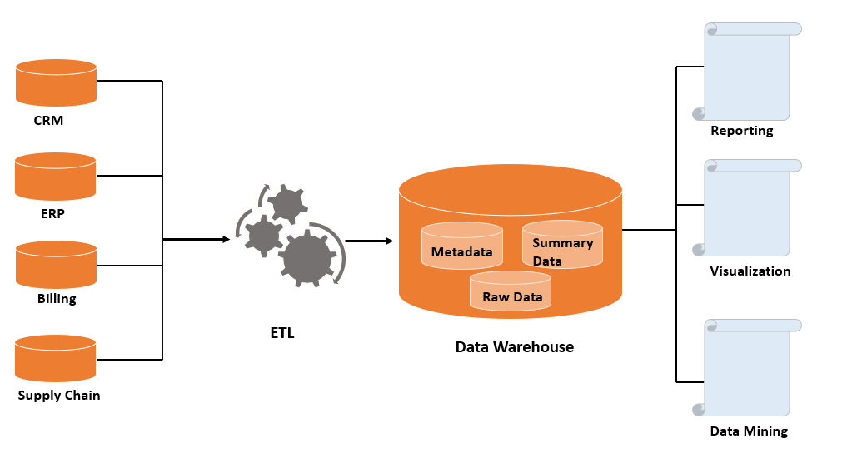

Figure 56:Data warehouse

# Indexes

Easy data structure methods for faster retrieval of data are and only viewing the row types of an index files. Index is formed using more than one column that stores all the data in structure format and it first access the index when query the results, then collect the result of the question from table. Benefit of index formation decreases the expense of scanning the entire table per (row by row) and returns the results faster. (Partitioned Tables and Indexes 2020) Bitmap and B-tree are two types of indexes. We usually use bitmap index in the warehouse because it reduces duplicates.

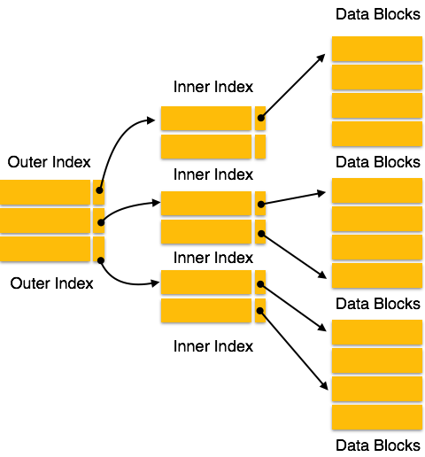

Figure 57:Indexes

# Partition

“It is powerful technique used in data warehouse that allows the tables, indexes to be sub-divided into the smaller parts so that the database objects can be easily managed and accessed”. Likewise, oracle includes different partition levels to satisfy each business needs. In addition, the implementation of this function has many benefits, such as enhancing device efficiency by operating on actual data. (Partitioning Overview 2018) It also enhances the access of data through the independent partition and reduces cost by processing the data in the proper form. Oracle support various type of partition that are list, hash and range partition.

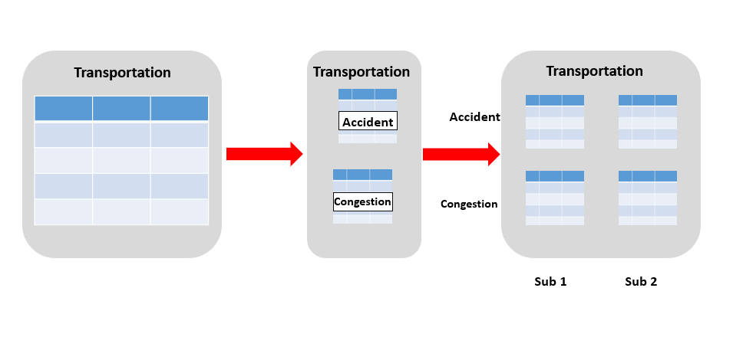

Figure 58:Partition

# PL/SQL

“It is Procedural extension language that enables the power to combine the SQL with the procedural statements.” (Rungta 2020) PL/SQL instruct compiler about ‘What to do’ and ‘how to do’ in structural way. Likewise, there are many benefits using PLSQL, such as the numbers of queries in a single block can be executed and it offers the ability to construct function, triggers and procedures that are stored for future reuse in the database. (PL/SQL for Developers 2018) In addition, it can be used for outstanding management and cost error verification.

# Dashboard design process

We expect dashboards which consider the customers into account, that are built to resolve their issues and that allows them to make better decision. Customer will not use the dashboard if they just don’t see any benefits. Take the time to understand the dashboard and before choosing the right one, the issue we are trying to solve offers us time to explore solutions. (Smith 2019) This approach hep to ensure that the dashboard is designed for a clear objective. The four steps of dashboard design process are:

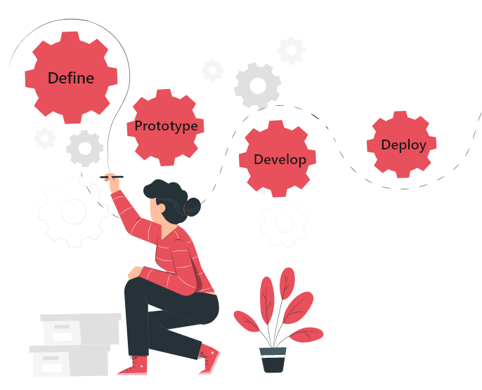

Figure 59:Dashboard design process

## Define

The first important step is to know who are those stakeholders? What choices are they expected to make? Determine the details that will help inform certain decisions (metrics and visualizations). It is important that you design dashboard with your audience in mind which help in decision making. It is important to define the users and to create a dashboard which is meaningful and relevant. The next step is to determine which metrics that help them take decisions once you have defined your audience and explained what they care about or need to make decisions on. With input from the appointed individual or the general public, these should be chosen.

## Prototype

Once you understand which metrics on the dashboard will be reported, it’s necessary to consider how properly to present them. You’ll test possible dashboard in this process, get comments, and refine it. Then you’ll check that the objectives are met by a prototype. Always start with what you’d like to clarify when choosing a visualization and let that direct decisions.

## Develop

Access to the data would be necessary for everyone where will it be kept? How is it clean?To ensure that you can access the data you need, collaborate with your data team. You shove get actual data/information to build the dashboard. If your data is prepared, then use queries to make formula and send the data. (David 2020) Develop charts as well as the other metrics you’ve developed during prototyping once it’s ready.

## Deploy

After completing the dashboard, it is time to share to viewers. Strategies should be built to ensure the dashboard is retained as use and data source develop. Sharing a dashboard, collect more tweak and feedback as required. If the source data is changed then dashboard need to keep changing accordingly. Over time, audience preference can also change. So, planning dashboard analysis times so they remain relevant and usable. Also include form for audiences to provide input so that you can updated with the requirements for maintenance.

# Process

## Developing Dashboards

Design of the dashboard starts with a source of data. Data source of my project is in excel spreadsheet. Identifying your source of data, the type of information, or whether it is dynamic, or static is essential and whether it is unchanging or live. After getting your data ready, you need to link it to dashboard. For advance method of connecting data software like Tableau has been used to link to source data. Next step in development is filtering. Filtering enable you to exclude unwanted information from dashboard. (PLANNING YOUR DASHBOARD PROJECT " n.d.) At the data source stage, additional data manipulation helps to fix the data imbalance between different data sources and combine data in one place. After completing dashboard, it is essential to consider about how to distribute it. Dashboard need to host if you want to provide access to multiple users and ability to communicate with data. It can be hosted on company server or website.

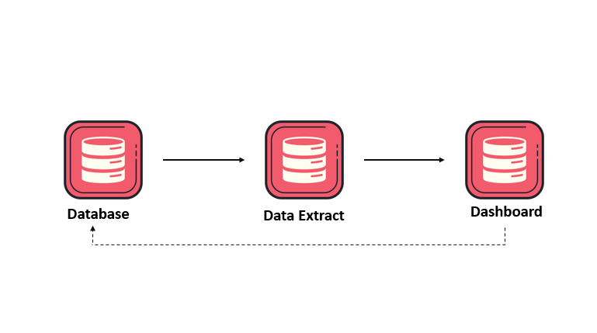

Figure 60:Developing Dashboards

# Challenges

## User’s concerns

It’s time to carry it out into your organization once you’ve planned, created and tested your dashboard. We need to think about end users and how they would feel about a new dashboard being integrated into their workflow before we look at any strategies for promoting dashboard adoption. What and why user have question over a dashboard and how could these issues be addressed? (Build Dashboards for Accessibility 2020)

## Strategies for driving dashboard adoption

You are in a prime role as an observer to assist the company in creating a culture guided by data and enhancing organization decision-making. Driving user adoption is a crucial way to succeed in this field. Some of the strategies for driving dashboard adoption is faster all your customers engaged in the easier you can optimize the benefit from the dashboard. You can’t persuade people that new approach is better you need to show them how this is better. Everybody needs to do their job to make dashboard usable. Ensure your customers know how to navigate the details that they really need. Interaction between user and team makes dashboard fun. (Wright 2014)

# Devices

Developed Dashboards of this project is accessible in devices like tablet and mobile phone.

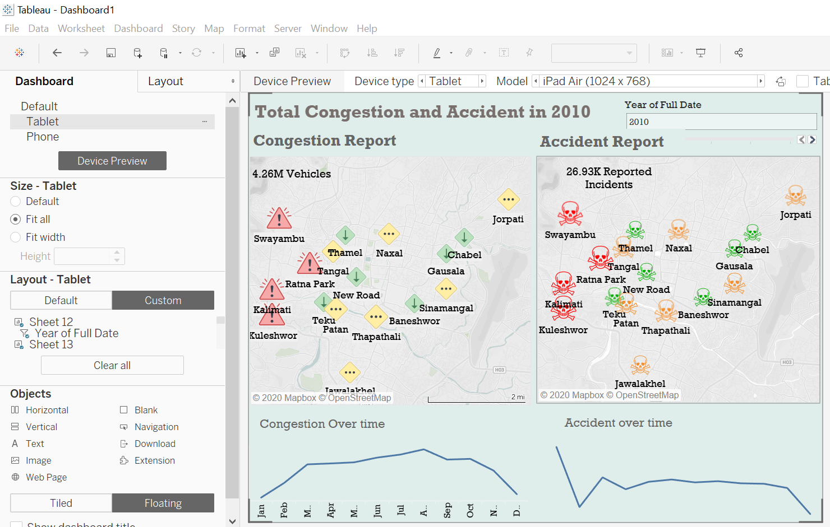

Figure 61:Dashboard 1 Tablet Testing

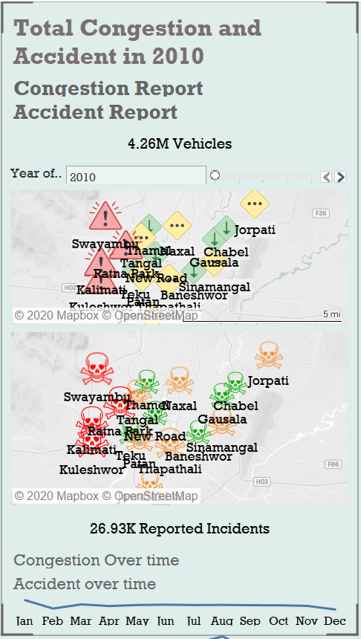

Figure 62: Dashboard 1 Phone testing

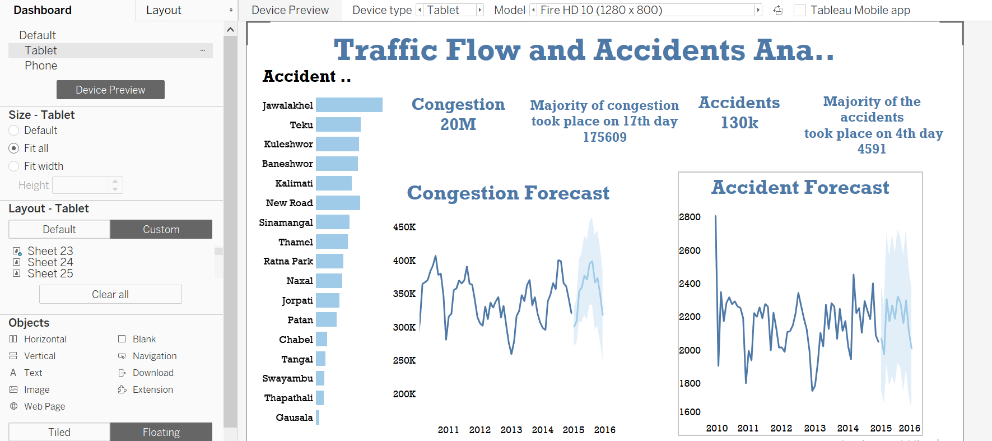

Figure 63:Dashboard 2 Tablet Testing

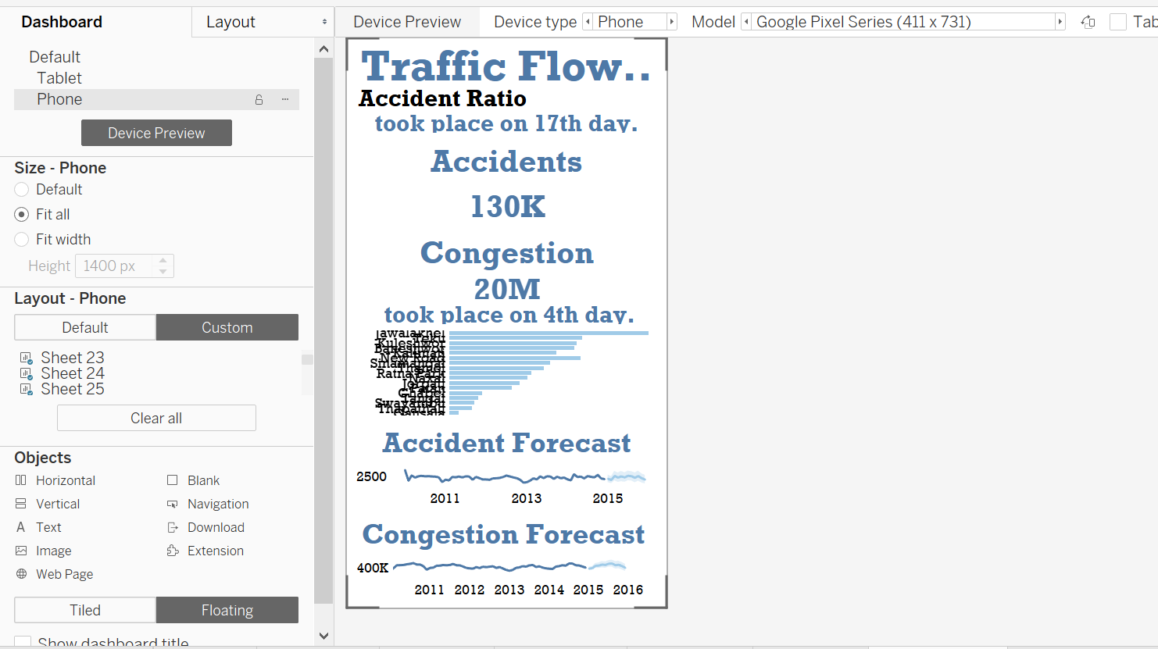

Figure 64:Dashboard 2 Phone testing

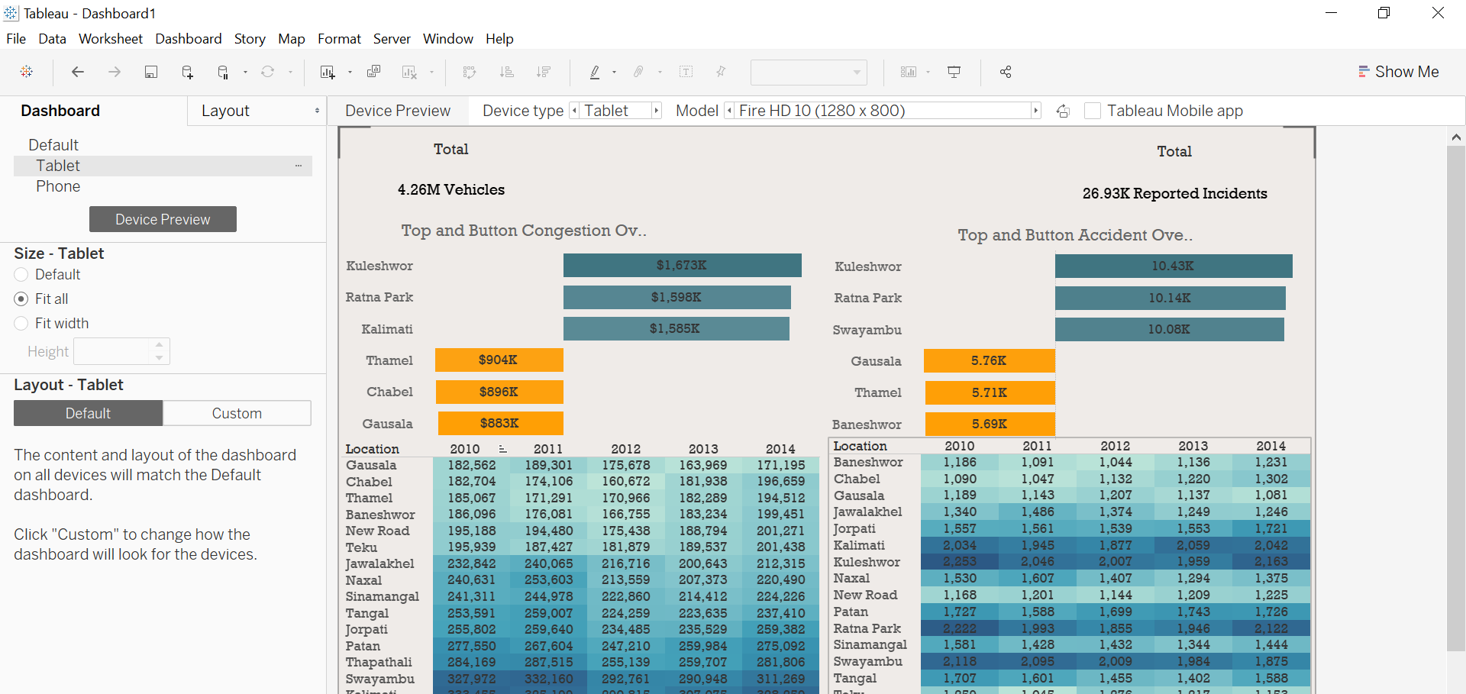

Figure 65:Dashboard 3 Tablet Testing

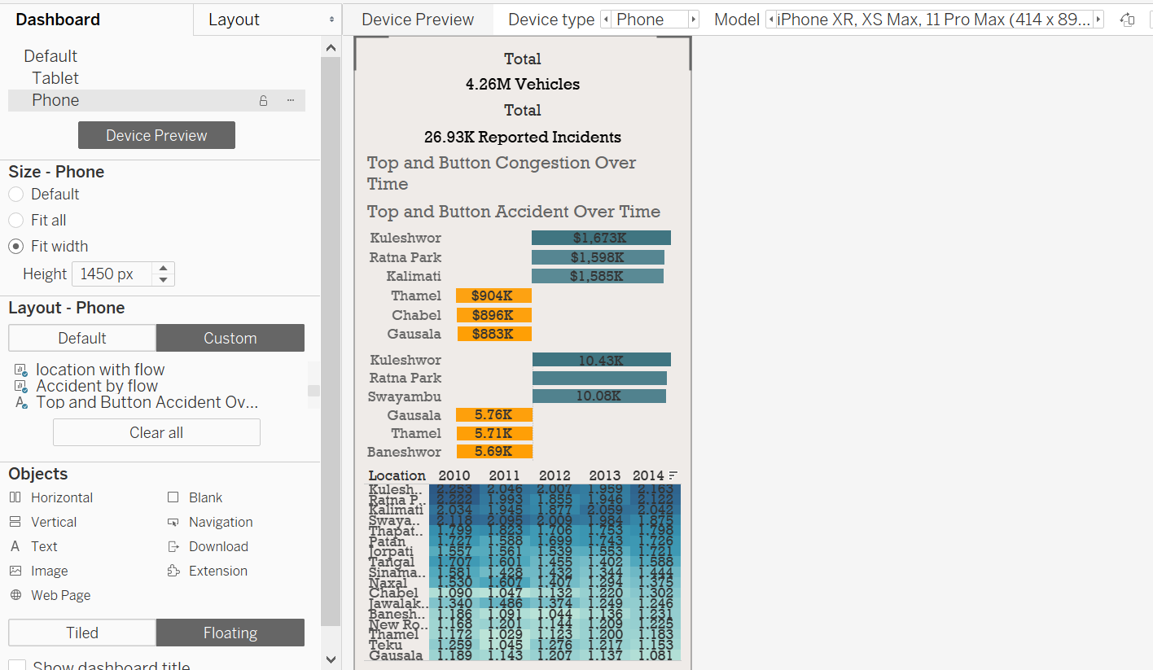

Figure 66:Dashboard 3 Phone testing

# Effectiveness

The main six element to remember while presenting information/data are: 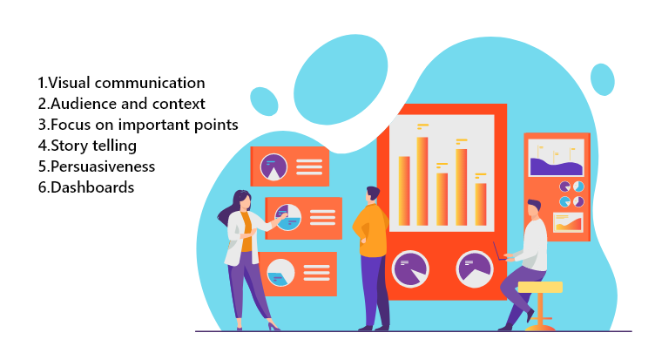

Figure 67:Effectiveness

1.Visual Communication:

Getting all the platform as well as visual aids like image, graphs and charts you can plan to use it for the presentation of your data. (Best Practices for Effective Dashboards 2020)

2. Audience and context: Target your specific (internal and external) audiences. To these audience have clear objectives for access to your data.

3. Focus on important points:

Match the data presentation to answer issues and to know business requirements. Priorities and explain the communication of your points.

4. Story telling:

Communicate ideas from data as a story.

5. Persuasiveness:

Explain your answer clearly and accurately. Ask yourself the question, ‘what next?’ and ‘what then?’ to check how convincing the presentation is.

6.Dashboards:

Dashboard is a perfect way to integrate two or more data analysis project to provide a more comprehensive view of business concern or a market target.

# Testing Dashboards

After a dashboard is developed, to know it really works testing provide the clarification. Building beautiful, accessible dashboard is not enough it should be usable and fast updateable. (Tableau Community Forums 2020) Some of the testing are:

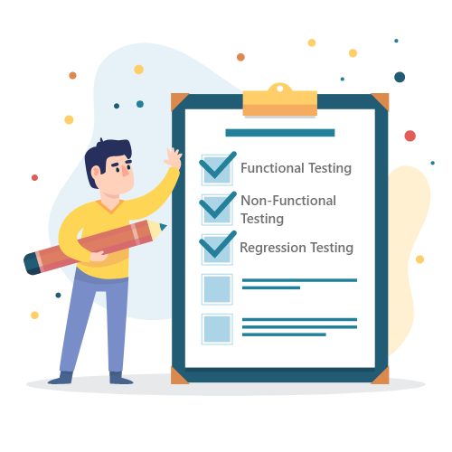

Figure 68:Testing Dashboards

1.Functional Testing

Functional testing guarantees that the dashboard performs what it should and satisfies the requirement of business. Main things we should check while doing functional testing are (Data validation, Interactivity and Navigation)

2.Non-Functional Testing

Non-Functional Testing targets on (scalability, accessibility, compatibility and usability). It is not included as specification during the scope of the project, but any solution is always expected from it. Earlier in this module, we looked at accessibility, so we can concentrate on other components later. (Leach 2019)

3.Regression Testing

Regression testing is the process of re-running test after you make adjustment. This test ensured that when you update existing once’s, or new functionality you do not unintentionally introduce new bugs.

# Best case and work case scenario

Scenario analysis explores the consequences of changing several factors simultaneously. It helps to identify overall effect of undesirable and beneficial changes. What can result, such as a financial crash, in a “perfect storm”. It allows to assess the robustness of possible decisions in order to consider the possible effect of unforeseen impacts and to recognize potential possibilities and risks. we need to know (potential threats and opportunities, evaluate all potential outcomes and understand the potential impact of external influences) in scenario analysis. The main steps we need to perform in scenario analysis are (Evaluate options, define the problem, run a what if analysis and create a list of variables).

Best case scenario: In best-case scenario it assumes what if anything follows the pattern of the organization. The best-case scenario in transportation could be no traffic congestion and accident. It answers the question such as what the benefit are if there will be no congestion and what impact that will have in economy over the time.

Worst case scenario: In worst-case scenario each variable is expected to shift negatively such as economic crisis, financial crash. Worst case scenario in transportation can be high traffic jam, accident, economic loss, pollution. What if analysis is done in worst case scenario. Example: What if there is lock-down what impact that have in transportation over the time.

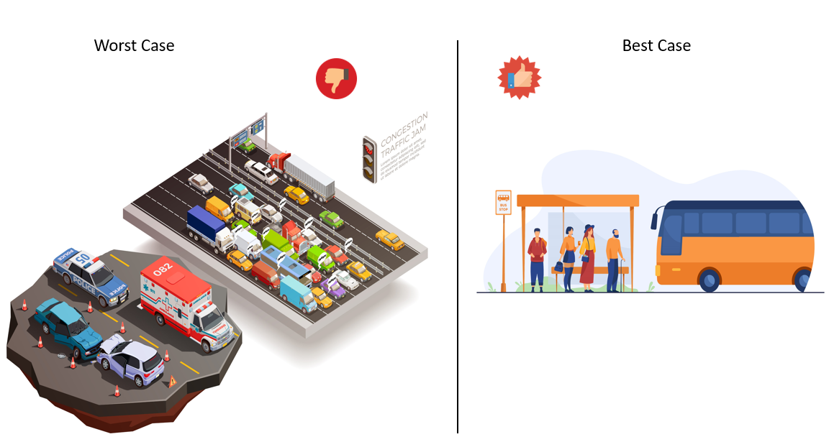

Figure 69:Best case and work case scenario

# Findings

Three level of dashboard has been developed. High level dashboard for executive, midlevel dashboard for analyst and low-level dashboard for employee.

## High level Dashboard

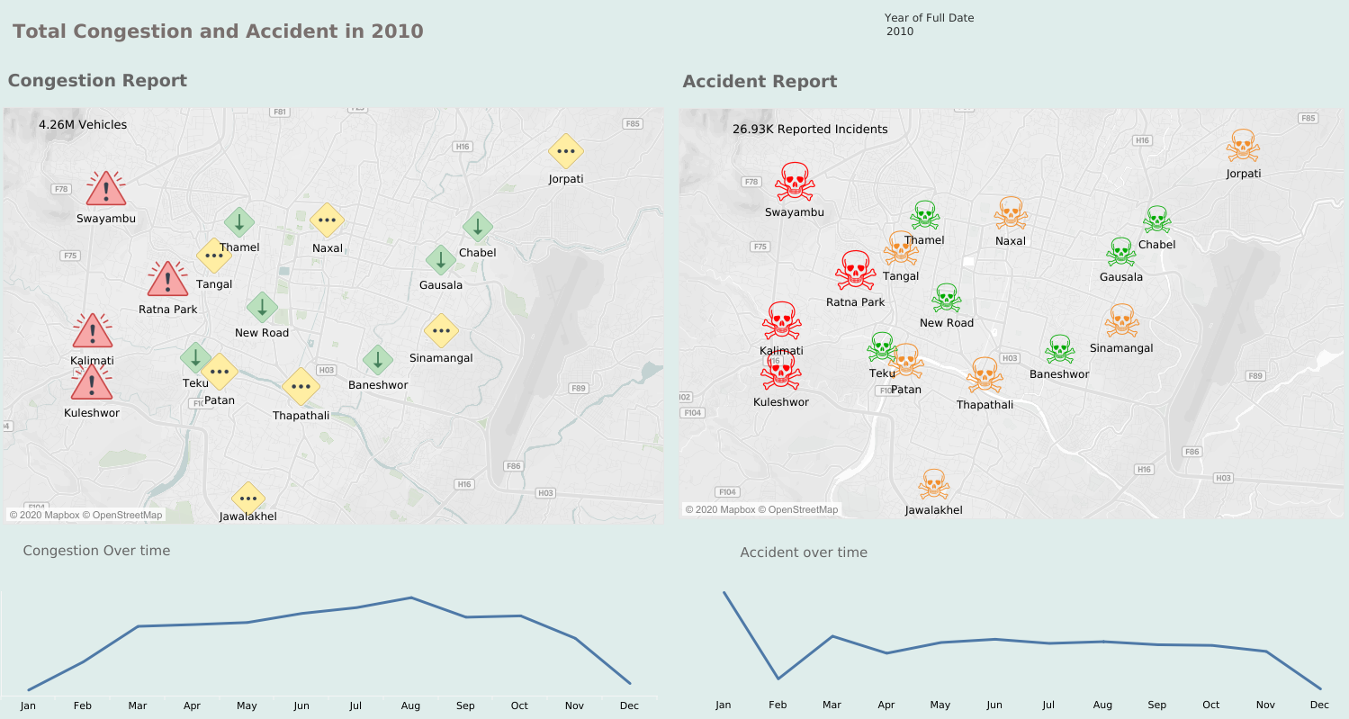

Figure 70:High level Dashboard

This dashboard is for executive level. In Congestion Report Red color shows the high-level congestion, yellow represent medium and green show low level. In Accident Report Red color symbol ugly , orange worst and green bad. It was found that Swayambu is most congested and accident place since it is heritage site on the other hand least congested and accident place is thamel because limited vehicles are allowed there. In bottom left and right it shows the monthly congestion and accident over the time.

## Mid-level Dashboard

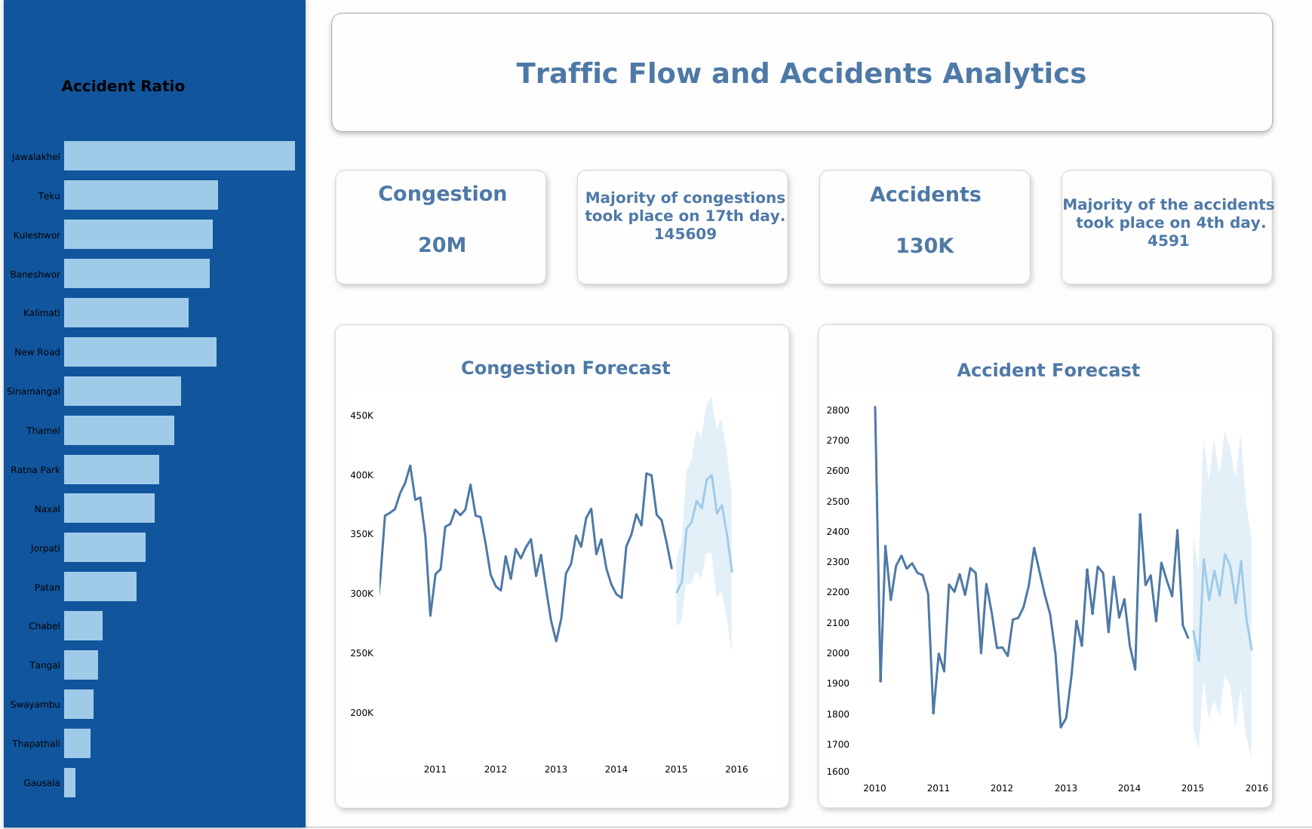

Figure 71:Mid-level Dashboard

Mid-level dashboard is for high level manager and data analyst. In left side of dashboard, it shows the accident ration. It shows that jaulakel of most frequently accident occurring place and gaushala is least. Both congestion and accident forecasting are done from 2015 to 2016. Forecasting of congestion is almost similar compare to 2014- 2015. But in worst case scenario it can goes up to 450k and in best case scenario it can decrease up to 250k. Forecasting accident from 2015-2016 shows that it might decrease next year. But in worst case scenario it can goes up to 27 thousand and in best case scenario it can decrease up to 17 thousand.

## Low-level Dashboard

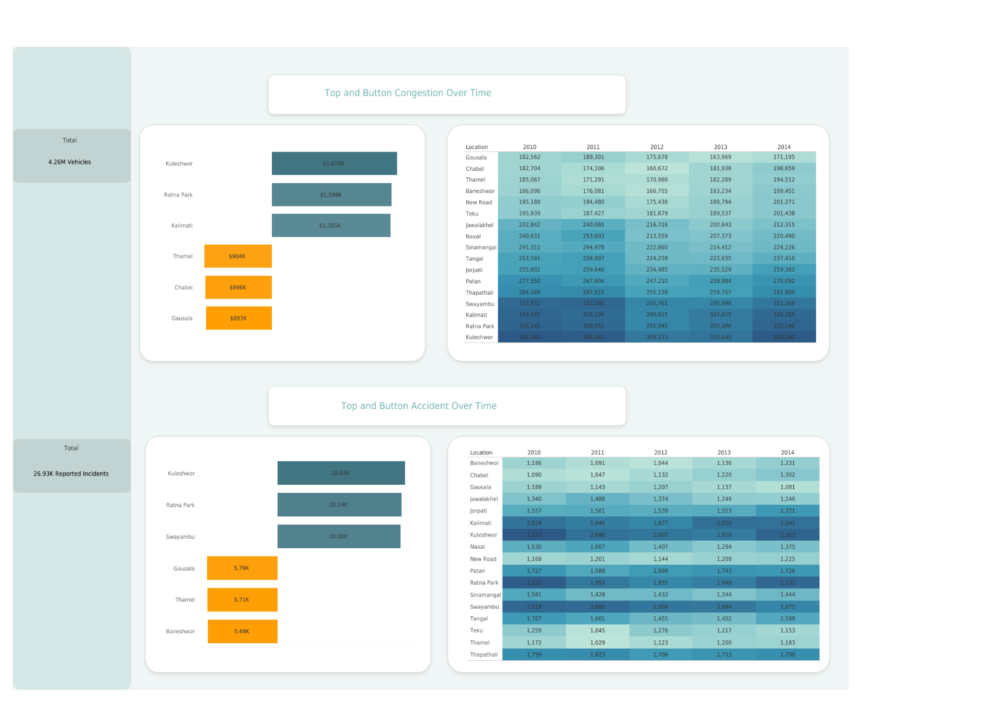

Figure 72:Low-level Dashboard

Low-level dashboard is for employee. More information is needed in low level dashboard. Top and Button analysis is done in this dashboard. Top three congested places are kuleshwor, Ratna park and kalimati. Least three congested places are thamel, chabel, gausala. Likewise, top three accident places are Kuleshwor, Ratna Park and Swayambu. Least accident place is gausala, thamel and baneshow.

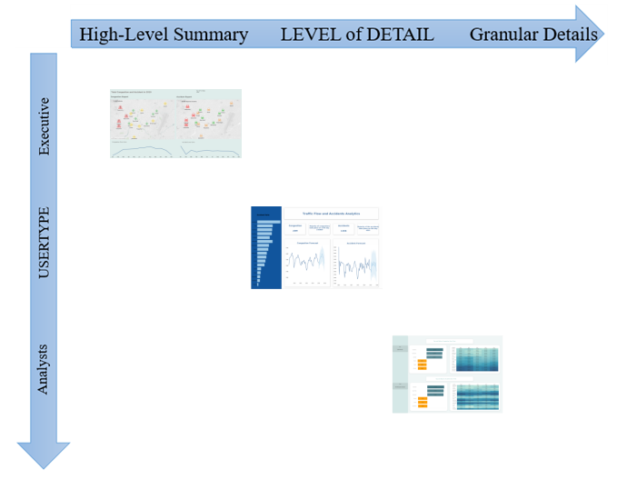

Figure 73:Summary Dashboard

In summary, I have made three level of dashboard. High level dashboard for executive where I have made one-week dashboard. Another one is for business analyst or high-level manager where forecasting of congestion and accident is done. Last one is Low level dashboard for employee or users where top and button analysis is done.

Project Plan**:**

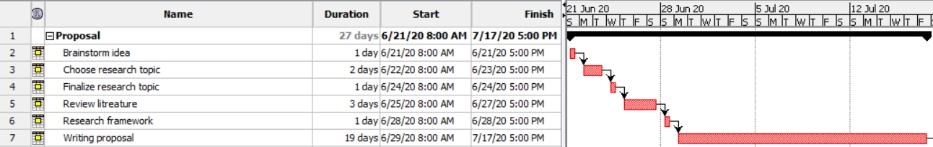

Figure 74:Proposal Project Plan

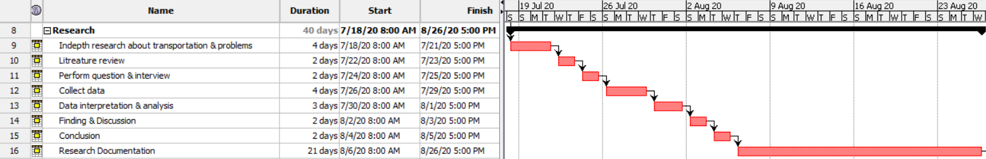

Figure 75:Research Project Plan

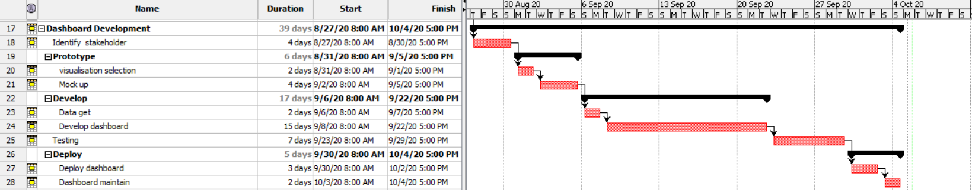

Figure 76:Dashboard Development Project Plan

Future work**:**

Each sector has a position for improvement, and the research results carried out can also be improved in a number of ways. The project has several improvements, one of the most significant being is to deliver better dashboard. Project focuses on technology and seeks to improve and expand implementation between various platforms to provide data into tableau. Diving more deeply into analytics and introducing more model of prediction. Learning about data analytics in an effort to advance its expertise and generate more market value with advanced analytical applications.

Maintaining the security in dashboard is another challenge. To make system more effective dashboard needed to be more accurate and up-to date. Dashboard must be interactive. Separate dedicated oracle database, because for research oracle was built in the VM box which take more resources and created some difficulties including overheating of the system and reaction time was slow. In the future, it is possible to create a smartphone application to conveniently and rapidly access the maps. Implementing oracle data guard for achieving consistent accessibility, recovery and data security

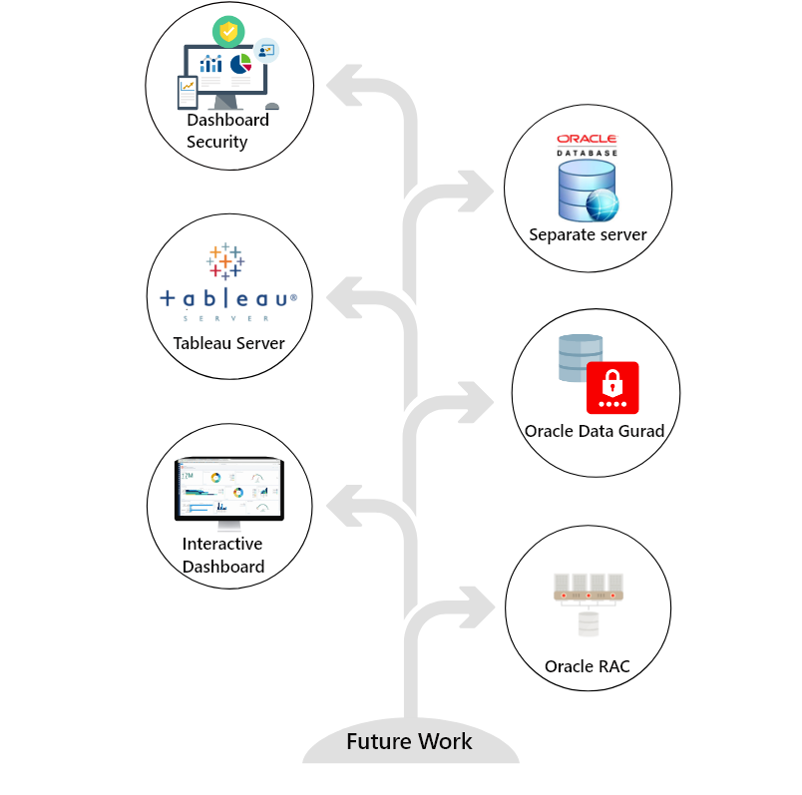

Figure 77:Future work

# Conclusion

Visualization of data has the ability to support the study of transportation data as a way of presenting various data types in an understandable form. Each visualization has a specific purpose and revels various stories that can be discussed and analyzed. The visualization that have been built makes the analysis, the method of data analysis and interpretation is simpler and allows to gain insight into transportation system which helps data easier to understand and clearable. The importance of visualization and data warehouse has been recognized in the transportation sector. To improve database efficiency and help fast decision making was the key reason for using data warehouse and visualization. Thus, this study was carried out to analyze different visualization and techniques of data warehouse that are appropriate to transportation.

This project was carried out keeping in mind ethical considerations (GDPR and 12 principle of data ethics). All the goals were accomplished, and the project was successful. This research was carried out to examine how the transportation data would be impacted by the implementation of visualization and Datawarehouse. In this research, numerous current techniques have been discussed to define the most suitable transportation strategies. Numerous case studies and relevant to this study were researched. Different business analysis was used to identify needs and proposing strategies that provide value to the stakeholders. For research desk base methodology was used and agile for development.

Using various techniques of Oracle data warehouse of transportation system was formed.

In order to implement user protection, unique password complexity features, roles and profiles were formed, and access right was controlled through the object and system privileges. To ensure a level of security a dedicated tablespace was specified for users. Different level of auditing was allowed for system protection and the tasks performed by the employee was registered to assure that they did not perform any unauthorized activities. Five different backup Stargate was made (whole backup on monthly basis, full back up in weekly basis and cumulative and differential backup in daily basis) to ensure data security. RMAN was designed to ensure data recovery in case of data failure or data loss. Virtual private catalog (VPC) was implemented to support certain users to access and maintain database in order to minimize the burden of the system administrator. Health checkup was scheduled on monthly basis to fix issue. Retention of transportation data for a minimum duration of 5 years was carried out. FDA (Flashback Data Archive).

The most suitable charts to express the data were decided and developed through tableau. It was found that the visual representation of data relays information much quicker rather that going through one by one data. For preparation of the data tableau prep was most suitable tool which helps to automate the cleaning process to shape the data in visually form. Different visualization like (bar chart, forecasting, map clustering etc.) has been used in this project. To show the must congestion and accident areas map clustering have been used. Forecasting has been used to predict what might happen next year based on current data to know the general trend. As observed, it come to the conclusion that (oracle as a most suitable data warehouse and tableau for visualization and analysis.)

# Bibliography

Faiz Siddiqui (2019) *Tesla Floats Fully Self-Driving Cars as Soon as This Year. Many Are Worried about What That Will Unleash.* [online] available from <https://www.washingtonpost.com/technology/2019/07/17/tesla-floats-fully-self-driving-cars-soon-this-year-many-are-worried-about-what-that-will-unleash/> [21 July 2020]

O’Kane, S. (2018) *Tesla vs. Waymo: Who’s Winning the Race for Self-Driving Cars* [online] available from <https://www.theverge.com/transportation/2018/4/19/17204044/tesla-waymo-self-driving-car-data-simulation> [5 July 2020]

WTF1 (2019) “The Unusual History Of F1 Teams”. in *YouTube* [online] available from <https://www.youtube.com/watch?v=uA4xcZYVFTg&t=262s> [6 July 2020]

Meet the Boss (2015) “Williams F1: How Formula 1 Is Using Data Analytics to Improve Performance”. in *YouTube* [online] available from <https://www.youtube.com/watch?v=3kNX3jWehQY&t=58s> [1 August 2020]

Larry Ellison (2020) *Forbes* [online] available from <https://www.forbes.com/profile/larry-ellison/#1bccbf9224c2> [1 August 2020]

Why Oracle - Students and Graduates *| Careers | Oracle India* (2020) available from <https://www.oracle.com/in/corporate/careers/students-grads/whyoracle.html> [23 September 2020]

Rungta, K. (2020) *What Is Tableau? Uses and Applications* [online] available from <https://www.guru99.com/what-is-tableau.html> [23 September 2020]

Rodrigues, I. (2020) *CRISP-DM Methodology Leader in Data Mining and Big Data* [online] available from <https://towardsdatascience.com/crisp-dm-methodology-leader-in-data-mining-and-big-data-467efd3d3781> [3 June 2020]

Crisp DM Methodology *- Smart Vision Europe* (2020) available from <https://www.sv-europe.com/crisp-dm-methodology/> [3 June 2020]

‌

Creating Future Wealth (2019) “The Law of Large Numbers - Trading like a Casino - Investing 101”. in *YouTube* [online] available from <https://www.youtube.com/watch?v=wRmyCegH82Q> [23 September 2020]

Webb, B. (2019) *Law of Large Numbers* [online] available from <https://www.bestcasinosites.net/blog/law-of-large-numbers.php> [23 September 2020]

Shashank Gupta (2018) *Sentiment Analysis: Concept, Analysis and Applications* [online] available from <https://towardsdatascience.com/sentiment-analysis-concept-analysis-and-applications-6c94d6f58c17> [23 September 2020]

Gwynn Guilford (2015) *Facebook Data Know You Better than Your Own Mother* [online] available from <https://qz.com/325129/facebook-data-know-you-better-than-your-own-mother/> [7 April 2020]

The Telegraph (2018) “What Facebook Knows about You and How It Uses Your Personal Data”. in *YouTube* [online] available from <https://www.youtube.com/watch?v=N70W36RKRn8&t=91s> [28 August 2020]

Micheál Heffernan (2017) *The Power of Storytelling and How It Affects Your Brain* [online] available from <https://talesfortadpoles.ie/blogs/news/the-power-of-storytelling-and-how-it-affects-your-brain#:~:text=Your%20brain’s%20auditory%20cortex%20becomes,engagement%20with%20what%20is%20happening.> [15 August 2020]

Martinez-Conde, S., Alexander, R.G., Blum, D., Britton, N., Lipska, B.K., Quirk, G.J., Swiss, J.I., Willems, R.M., and Macknik, S.L. (2019) “The Storytelling Brain: How Neuroscience Stories Help Bridge the Gap between Research and Society”. *The Journal of Neuroscience* [online] 39 (42), 8285–8290. available from <https://www.jneurosci.org/content/39/42/8285> [2 June 2020]

Heitzman, A. (2019) *Data Visualization: What It Is, Why It’s Important & How to Use It for SEO* [online] available from <https://www.searchenginejournal.com/what-is-data-visualization-why-important-seo/288127/#close> [23 September 2020]

‌

Unwin, A. (2020) “Why Is Data Visualization Important? What Is Important in Data Visualization?” *2.1* [online] available from <https://hdsr.mitpress.mit.edu/pub/zok97i7p/release/2> [23 September 2020]

Rouse, M. (2017) *Data Visualization* [online] available from <https://searchbusinessanalytics.techtarget.com/definition/data-visualization> [23 September 2020]

Visualizations That Really Work (2016) available from <https://hbr.org/2016/06/visualizations-that-really-work> [23 September 2020]

EU Data Protection Rules (2020) available from <https://ec.europa.eu/info/law/law-topic/data-protection/eu-data-protection-rules_en> [23 September 2020]

Kukula, L. (2020) *9 Dashboard Design Principles: See Them in Action with Real Examples* [online] available from <https://www.geckoboard.com/blog/9-dashboard-design-principles-see-them-in-action-with-real-examples/> [1 October 2020]

Taras Bakusevych (2018) *10 Rules for Better Dashboard Design - UX Planet* [online] available from <https://uxplanet.org/10-rules-for-better-dashboard-design-ef68189d734c?gi=2cea65d9f71f> [1 October 2020]

Smith, K. (2019) *Dashboard Design Process* [online] available from <https://www.logic2020.com/dashboard-design-process> [1 October 2020]

David, M. (2020) *Design Thinking Process for Dashboards* [online] available from <https://dataschool.com/how-to-design-a-dashboard/dashboard-design-process/> [1 October 2020]

PLANNING YOUR DASHBOARD PROJECT *"* (n.d.) available from <https://www.idashboards.com/wp-content/themes/idashboards/pdf/whitepaper/Planning%20Your%20Dashboard%20Project.pdf>

Record and Analyze Workbook Performance (2020) available from <https://help.tableau.com/current/pro/desktop/en-us/perf_record_create_desktop.htm> [1 October 2020]

David, M. (2020) *Scaling Dashboards to the Company* [online] available from <https://dataschool.com/how-to-design-a-dashboard/scaling-dashboards/> [1 October 2020]

Eldridge, A. (2015) *Best Practices for Designing Efficient Tableau Workbooks Third Edition* [online] available from <https://www.tableau.com/sites/default/files/media/designing_efficient_workbooks_9.0.1.pdf> [1 October 2020]

Build Dashboards for Accessibility (2020) available from <https://help.tableau.com/current/pro/desktop/en-us/accessibility_dashboards.htm> [1 October 2020]

Wright, J. (2014) *10 Ways to Drive End-User Adoption of Tableau - Part 1 | InterWorks* [online] available from <https://interworks.com/blog/jwright/2014/05/29/10-ways-drive-end-user-adoption-tableau-part-1/> [1 October 2020]

Best Practices for Effective Dashboards (2020) available from <https://help.tableau.com/current/pro/desktop/en-us/dashboards_best_practices.htm> [1 October 2020]

Tableau Community Forums (2020) available from <https://community.tableau.com/s/question/0D54T00000C5qBO/what-is-the-best-way-to-test-tableau-dashboards-> [1 October 2020]

Leach, N. (2019) *Tableau Best Practises Put to the Test - Wellcome Data Labs - Medium* [online] available from <https://medium.com/wellcome-data-labs/tableau-best-practises-put-to-the-test-f62f5380ba0b> [1 October 2020]

Rungta, K. (2020) *What Is PL/SQL? Introduction & Architecture* [online] available from <https://www.guru99.com/introduction-pl-sql.html> [1 October 2020]

PL/SQL for Developers (2018) available from <https://www.oracle.com/database/technologies/appdev/plsql.html> [1 October 2020]

Partitioning Overview (2018) available from <https://www.oracle.com/database/technologies/partitioning.html> [1 October 2020]

Partitioned Tables and Indexes (2020) available from <https://docs.oracle.com/cd/B19306_01/server.102/b14220/partconc.htm> [1 October 2020]

Data Warehousing*:* Understanding Electronic Storage (2020) available from <https://www.investopedia.com/terms/d/data-warehousing.asp> [1 October 2020]

Rouse, M. (2017) *Data Warehouse* [online] available from <https://searchdatamanagement.techtarget.com/definition/data-warehouse> [1 October 2020]

Rungta, K. (2020) *ETL (Extract, Transform, and Load) Process* [online] available from <https://www.guru99.com/etl-extract-load-process.html> [1 October 2020]

What Is ETL - Extract, Transform, Load? Webopedia Definition (2020) available from <https://www.webopedia.com/TERM/E/ETL.html> [1 October 2020]

Materialized Views in Oracle (2018) available from <https://oracle-base.com/articles/misc/materialized-views> [1 October 2020]

Running Health Checks with Health Monitor (2020) available from <https://docs.oracle.com/cd/B28359_01/server.111/b28310/diag007.htm#ADMIN11269> [1 October 2020]

Oracle Database 11g: Administration Workshop II (2020) available from <https://learn.oracle.com/ols/course/oracle-database-11g-administration-workshop-ii/38560/57861> [2 October 2020]

Oracle Database 11G: Administration Workshop I (2020) 2nd edn. 2009. available from <http://indexof.co.uk/Database/Oracle%20Database/Oracle%20Database%2011g%20Administration%20Workshop%20I%20vol%20II.pdf> [2 October 2020]

Oracle Database 11G: Administration Workshop I (2020) 2nd edn. 2009. available from <http://indexof.co.uk/Database/Oracle%20Database/Oracle%20Database%2011g%20Administration%20Workshop%20I%20vol%20II.pdf> [2 October 2020]

Oracle Database 11G: Administration Workshop I (2020) 2nd edn. 2009. available from <http://indexof.co.uk/Database/Oracle%20Database/Oracle%20Database%2011g%20Administration%20Workshop%20I%20vol%20II.pdf> [2 October 2020]

Oracle Database 11G: Administration Workshop I Volume 2 (2007) 1st edn. Oracle. available from <http://index-of.co.uk/Database/Oracle%20Database/Oracle%20Database%2011g%20Administration%20Workshop%20I%20vol%20II.pdf> [2 October 2020]

Oracle Database 11G: Administration Workshop I Volume 2 (2007) 1st edn. Oracle. available from <http://index-of.co.uk/Database/Oracle%20Database/Oracle%20Database%2011g%20Administration%20Workshop%20I%20vol%20II.pdf> [2 October 2020]

Oracle Database 11G: Administration Workshop I Volume 2 (2007) 1st edn. Oracle. available from <http://index-of.co.uk/Database/Oracle%20Database/Oracle%20Database%2011g%20Administration%20Workshop%20I%20vol%20II.pdf> [2 October 2020]

Llanos, V. (2020) *Oracle Database 11g SQL Fundamentals I Volume II Student Guide* [online] available from <https://www.academia.edu/17564698/Oracle_Database_11g_SQL_Fundamentals_I_Volume_II_Student_Guide> [2 October 2020]

Flashback Data Archive (FDA) Tips (2015) available from <http://www.dba-oracle.com/t_flashback_data_archive_fda.htm> [2 October 2020]

Data Concurrency and Consistency (2020) available from <https://docs.oracle.com/cd/B19306_01/server.102/b14220/consist.htm> [2 October 2020]

Nitish Srivastava (2019) *Oracle Locking Mechanism – Latches & Enqueues* [online] available from <https://databaseinternalmechanism.com/2019/01/23/oracle-locking-mechanism-latches-enqueues/> [2 October 2020]

IBM Knowledge Center (2018) available from <https://www.ibm.com/support/knowledgecenter/SSGMCP_4.2.0/com.ibm.cics.ts.applicationprogramming.doc/topics/dfhp39o.html> [2 October 2020]

Naveen (2020) *Database Maintenance* [online] available from <https://intellipaat.com/blog/tutorial/oracle-dba-tutorial/database-maintenance/> [2 October 2020]

‌Managing Automated Database Maintenance Tasks (2020) available from <https://docs.oracle.com/cd/B28359_01/server.111/b28310/tasks.htm#BABJIJFC> [2 October 2020]

‌Managing Diagnostic Data (2020) available from <https://docs.oracle.com/database/121/ADMIN/diag.htm> [2 October 2020]

‌Banafsheh Hajinasab, Davidsson, P., Löwgren, J., and Persson, J.A. (2013) *Visualization of Data from Transportation Simulation Systems* [online] available from <https://www.researchgate.net/publication/262068782_Visualization_of_data_from_transportation_simulation_systems> [2 October 2020]

‌Meng, I., Sari, C., and Kartika, D. (n.d.) *Fakultät Für Bauingenieur-Und Vermessungswesen Lehrstuhl Für Kartographie Visual Exploration of Spatial-Temporal Traffic Congestion Patterns Using Floating Car Data* [online] available from <https://cartographymaster.eu/wp-content/theses/2015_Kartika_Thesis.pdf?fbclid=IwAR3yTUVb9A_pUAS8ILXVv3mXaeoCiMqA6mGrk24Vek0GiJ6VIAJnhkoIegQ> [2 October 2020]

‌Tanzina Afrin and Yodo, N. (2020) *A Survey of Road Traffic Congestion Measures towards a Sustainable and Resilient Transportation System* [online] available from <https://www.researchgate.net/publication/342043387_A_Survey_of_Road_Traffic_Congestion_Measures_towards_a_Sustainable_and_Resilient_Transportation_System> [2 October 2020]

‌Brosi, P. and Bast, H. (2014) *Real-Time Movement Visualization of Public Transit Data* [online] available from <https://ad-publications.cs.uni-freiburg.de/theses/Master_Patrick_Brosi_2014.pdf>

O’Toole, J. and Matherne, B. (2017) *Uber: Aggressive Management for Growth* [online] available from <https://www.researchgate.net/publication/314196711_Uber_Aggressive_management_for_growth> [2 October 2020]

“Uber Founder Travis Kalanick Resigns as C.E.O.” (2017) *The New York Times* [online] 21 June. available from <https://www.nytimes.com/2017/06/21/technology/uber-ceo-travis-kalanick.html> [2 October 2020]

Uber Revenue and Usage Statistics (2017) available from <https://www.businessofapps.com/data/uber-statistics/> [2 October 2020]

Big Data in Practice (2016) available from <https://www.goodreads.com/book/show/29909820-big-data-in-practice> [2 October 2020]

Delaney, I. (2016) *New Data Visualisation Shows the Beating Heart of London* [online] available from <https://360.here.com/2016/08/24/new-data-visualisation-shows-the-beating-heart-of-london/> [2 October 2020]

How TfL Uses ‘Big Data’ to Plan Transport Services (2019) available from <https://www.intelligenttransport.com/transport-articles/19635/tfl-big-data-transport-services/> [2 October 2020]

Introducing Enterprise User Security (2020) available from <https://docs.oracle.com/cd/B28359_01/network.111/b28528/concepts.htm> [2 October 2020]

Best Practices for Oracle Database Security (2017) available from <https://www.datasunrise.com/blog/professional-info/oracle_database_security_best_practices/> [2 October 2020]

‌

Backup and Recovery (2020) available from <https://docs.oracle.com/cd/B19306_01/server.102/b14220/backrec.htm#:~:text=There%20are%20two%20types%20of,control%20file%2C%20or%20archived%20log.> [2 October 2020]

RMAN Backup Types (2014) available from <https://web.stanford.edu/dept/itss/docs/oracle/10gR2/backup.102/b14191/rcmconc1005.htm> [2 October 2020]

‌

Anushka Mehta (2017) *Analytics Insight* [online] available from <https://www.analyticsinsight.net/four-types-of-business-analytics-to-know/#:~:text=For%20different%20stages%20of%20business,%2C%20diagnostic%2C%20predictive%20and%20prescriptive.> [2 October 2020]

‌

Team ASM IBMR (2020) *Business Analytics (BA): Everything You Need To...* [online] available from <https://www.asmibmr.edu.in/blog/business-analytics-ba-everything-you-need-to-know/> [2 October 2020]

‌

Komninos, A. (2020) *7 UX Deliverables: What Will I Be Making as a UX Designer?* [online] available from <https://www.interaction-design.org/literature/article/7-ux-deliverables-what-will-i-be-making-as-a-ux-designer> [11 October 2020]

# Appendix I

## 

## 

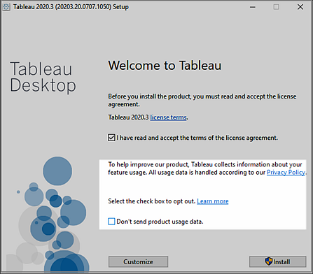

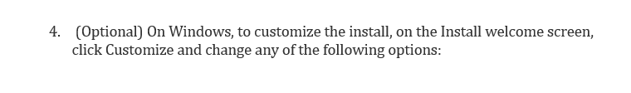

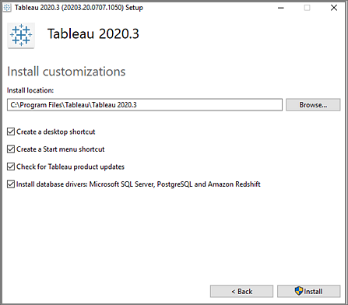

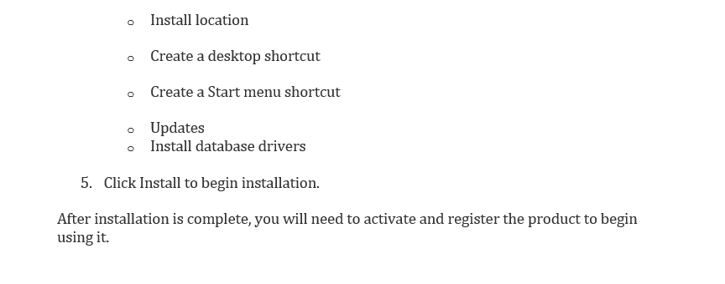

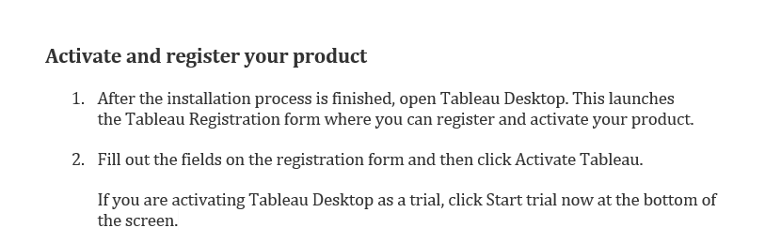

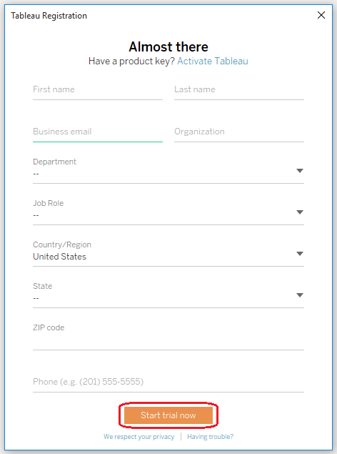

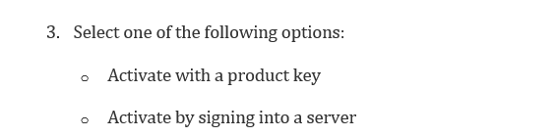

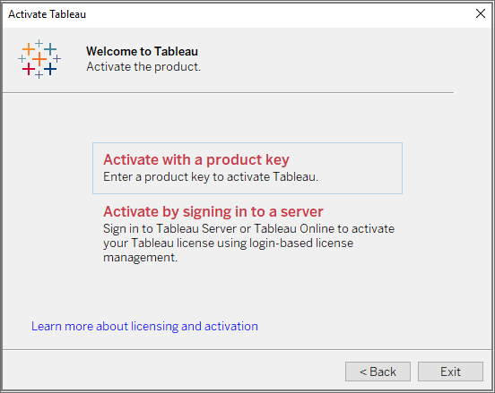

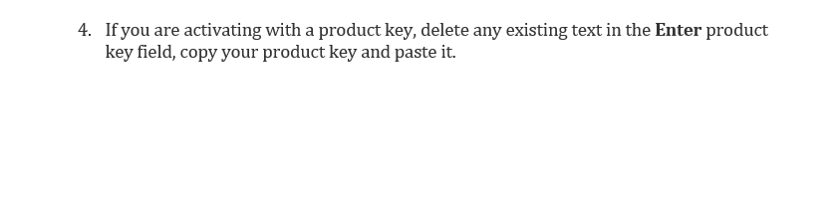

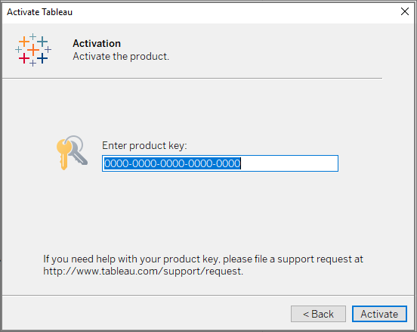

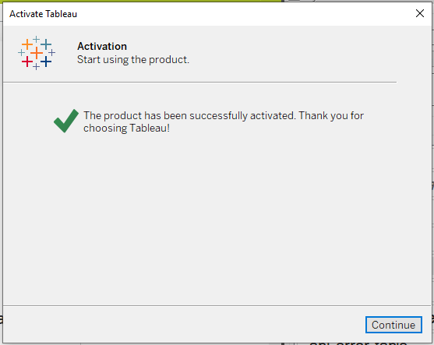

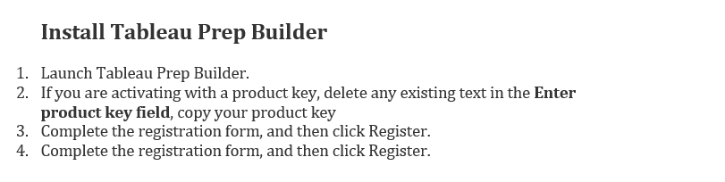

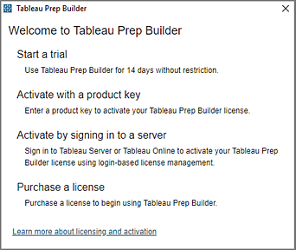

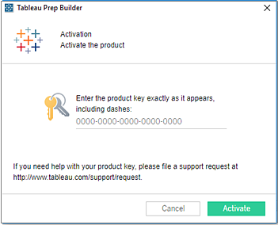

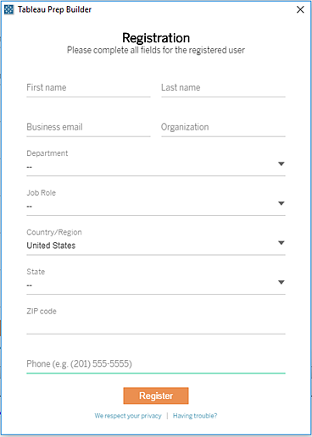

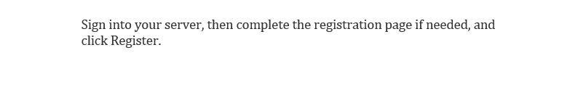







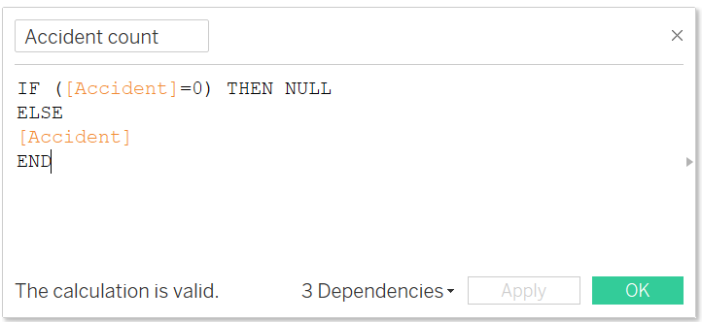

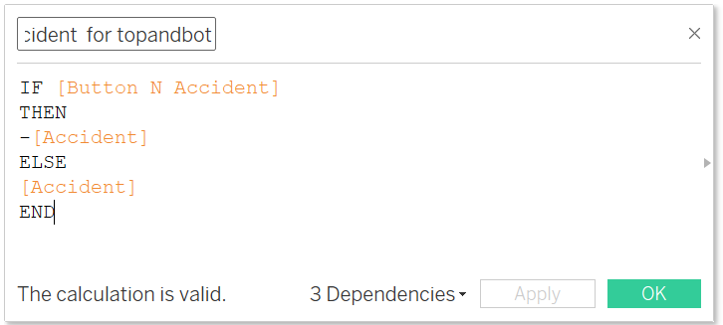

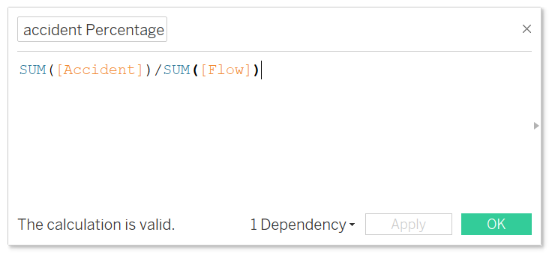

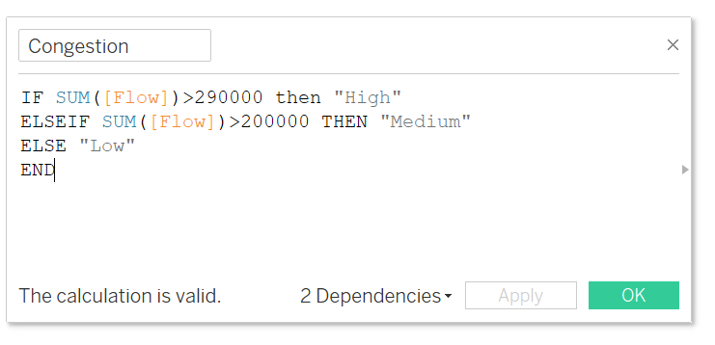

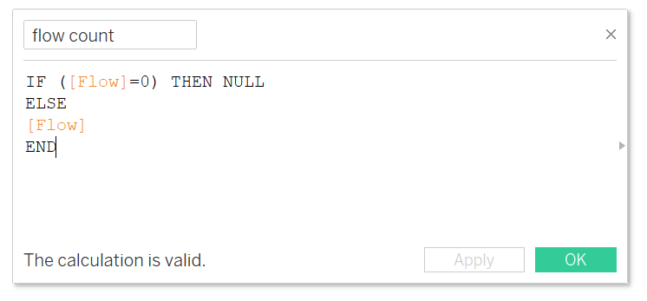

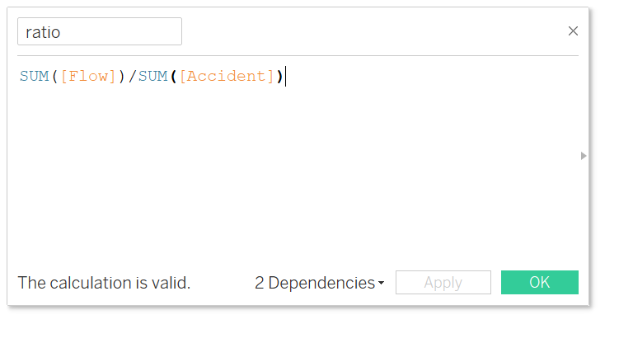



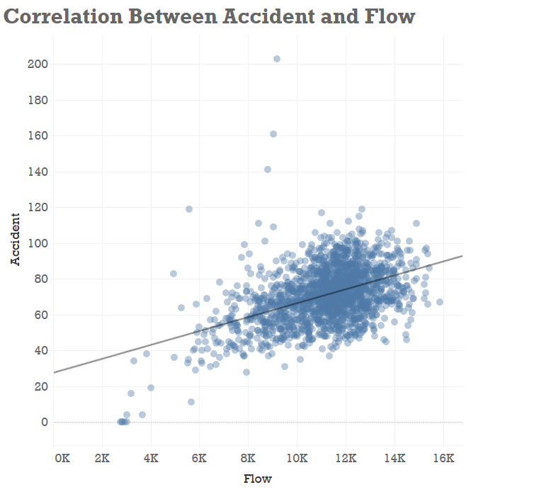

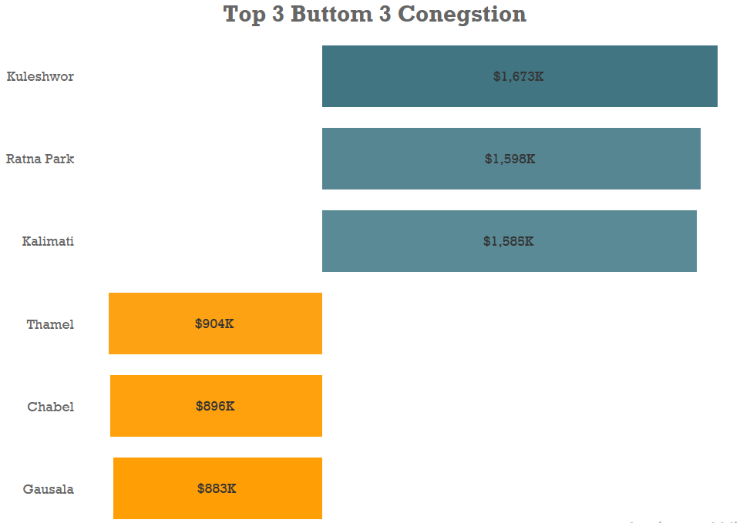

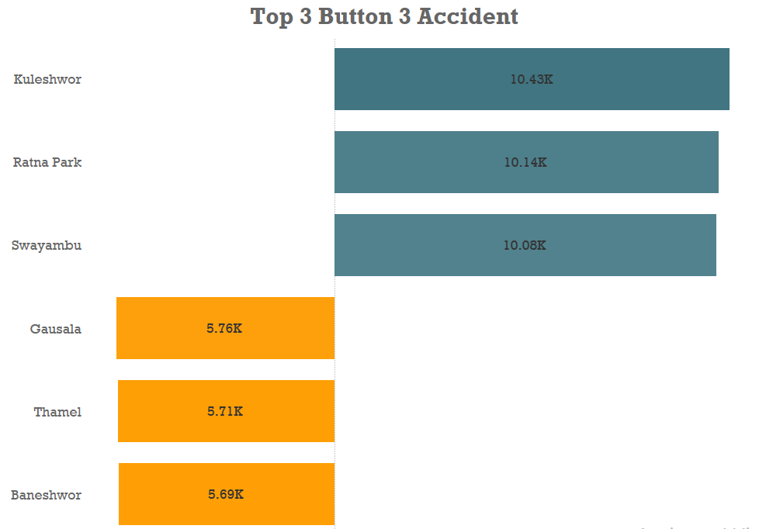

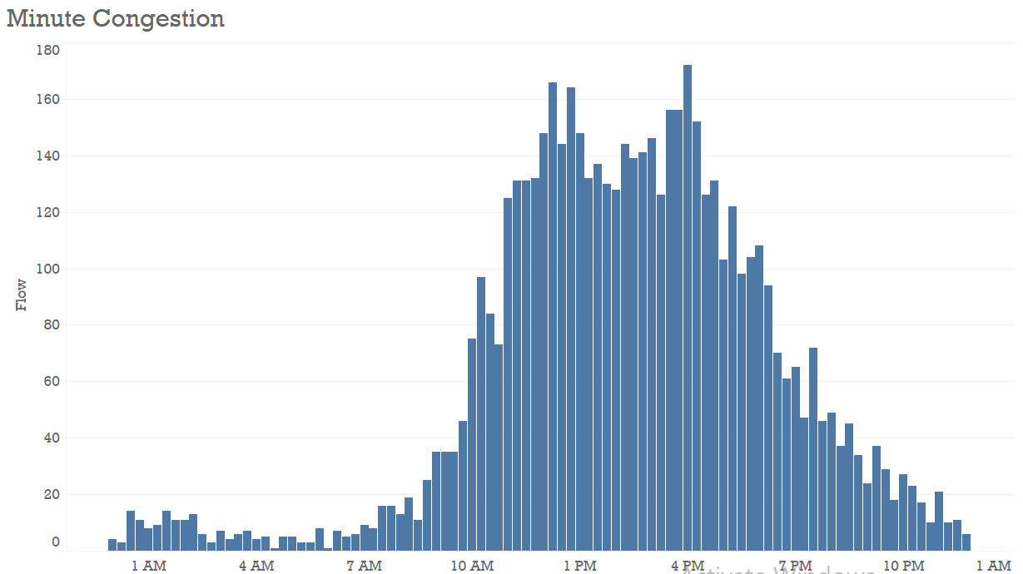

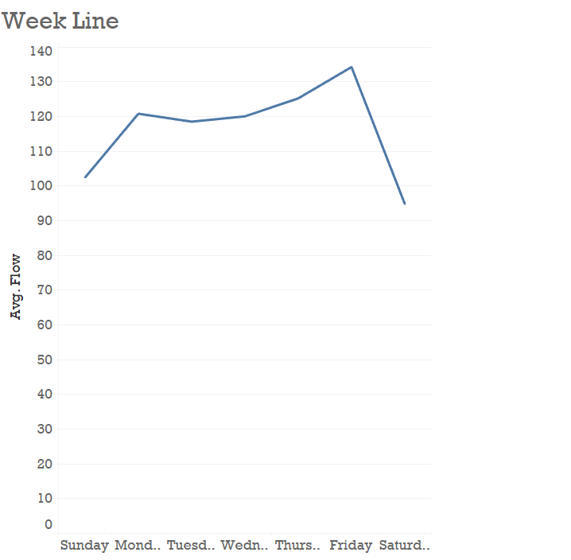

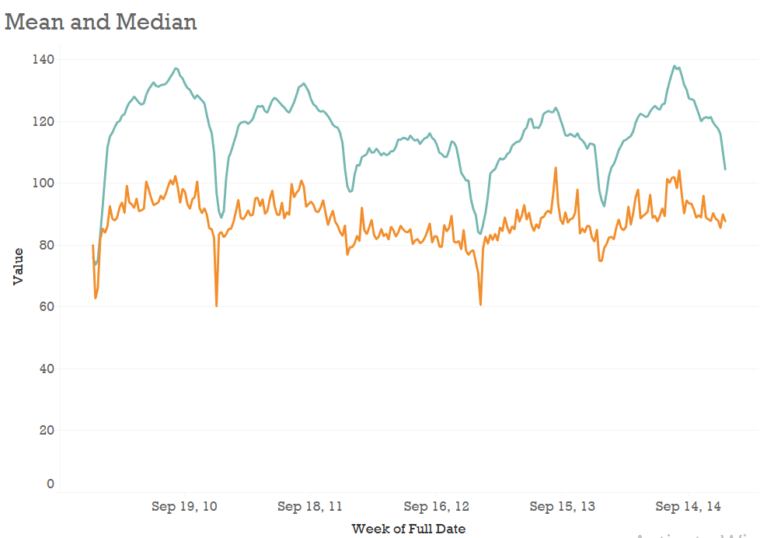

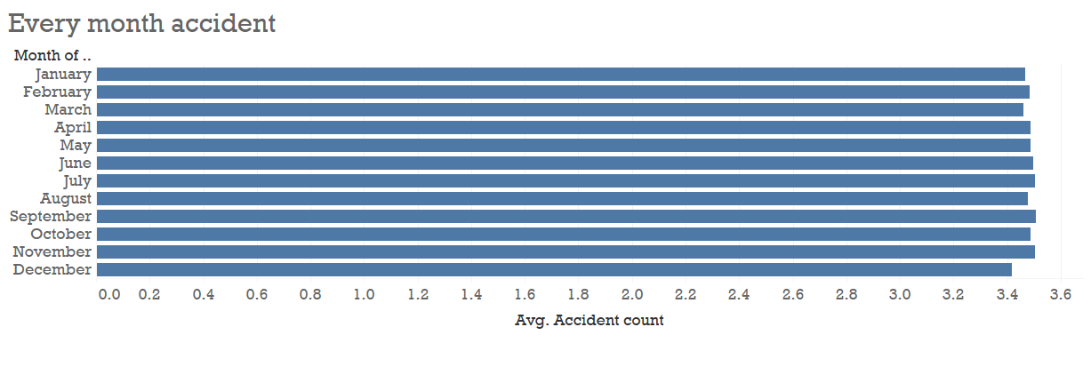

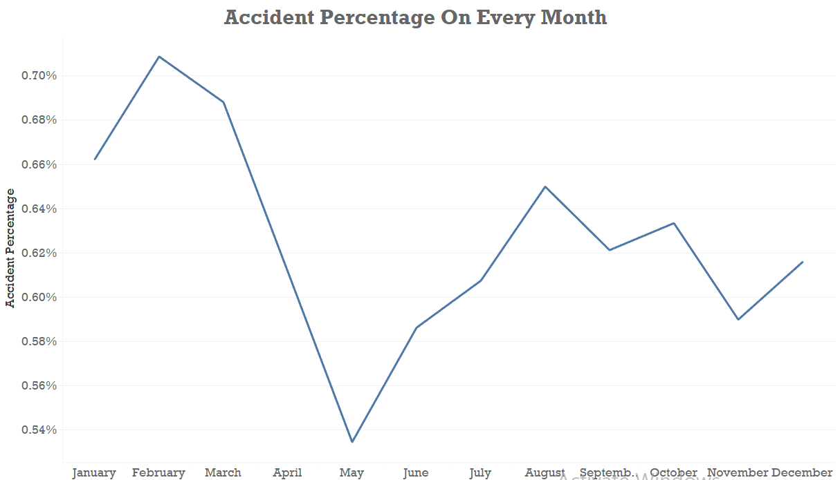

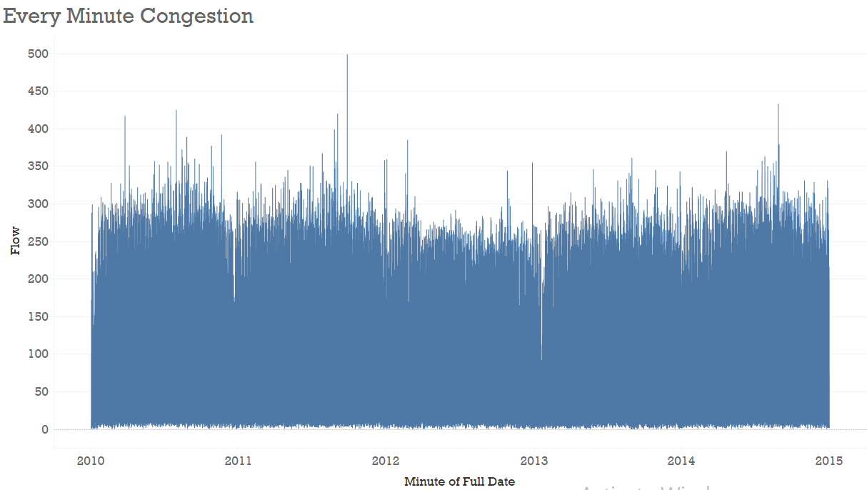

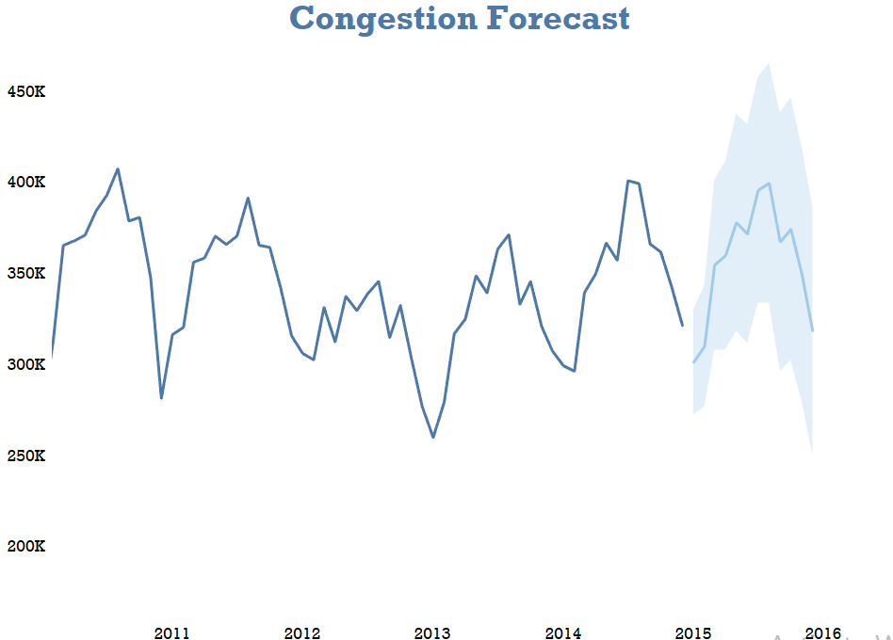

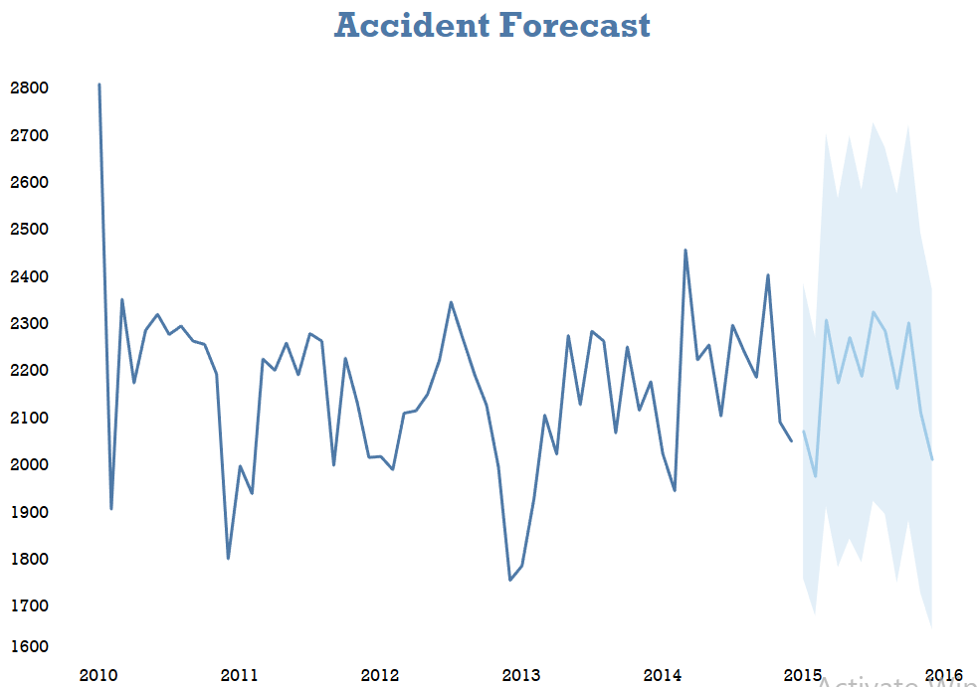

# Appendix II

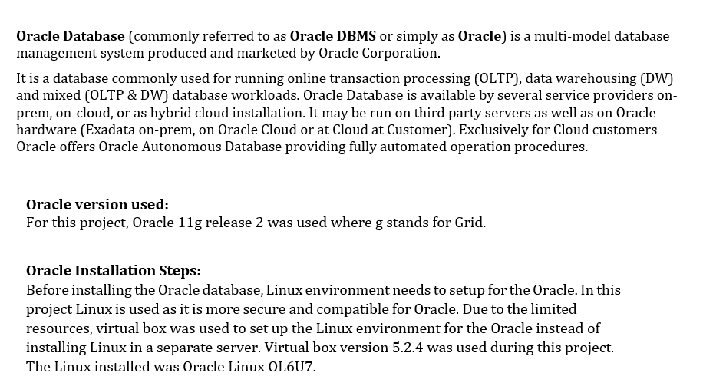

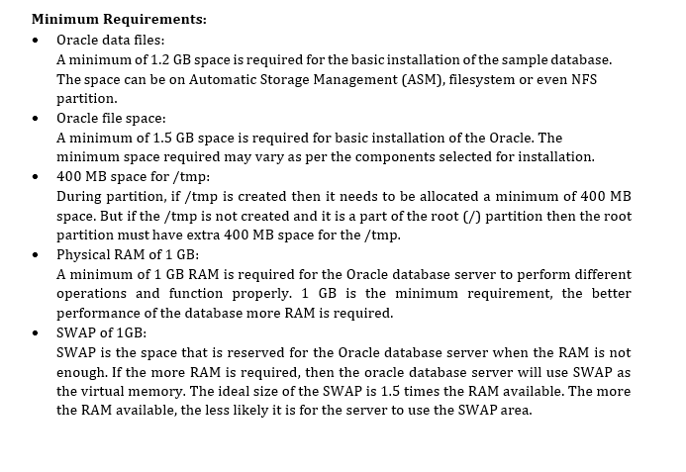

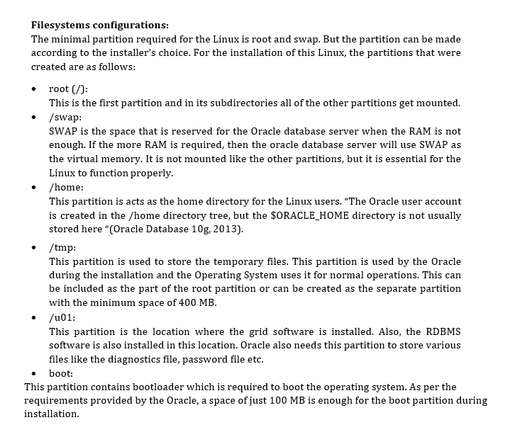

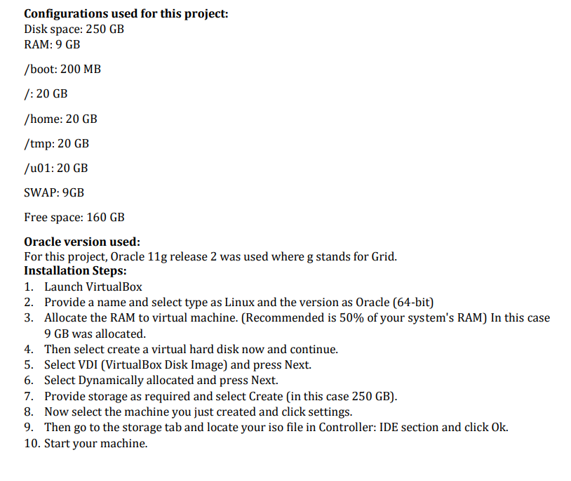



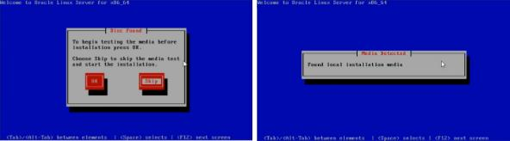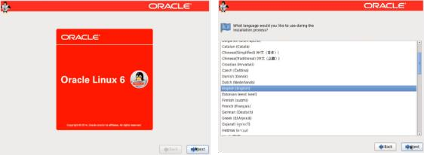

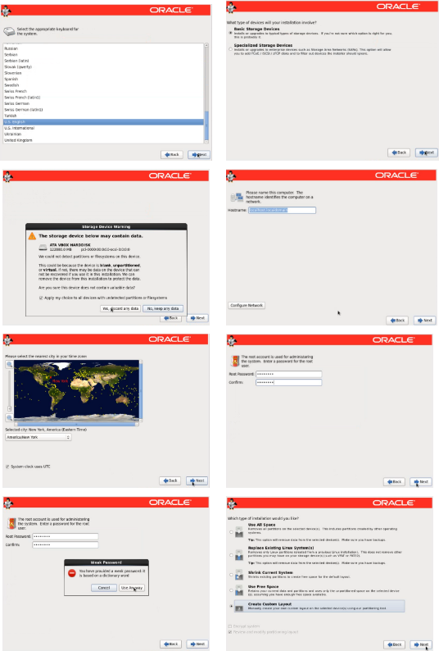

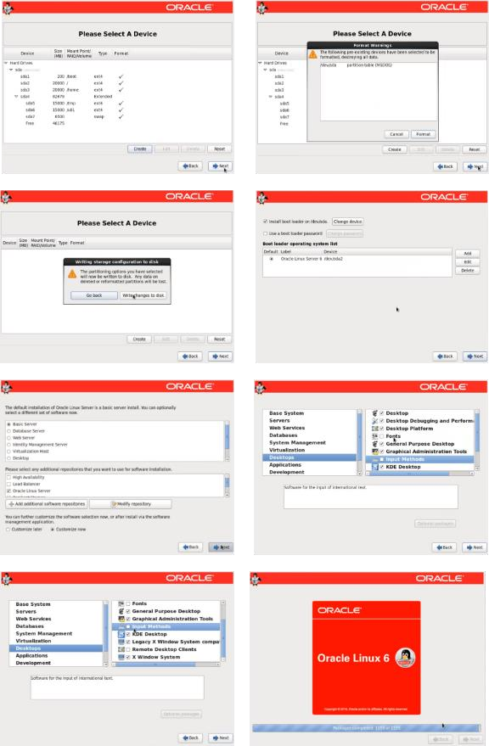

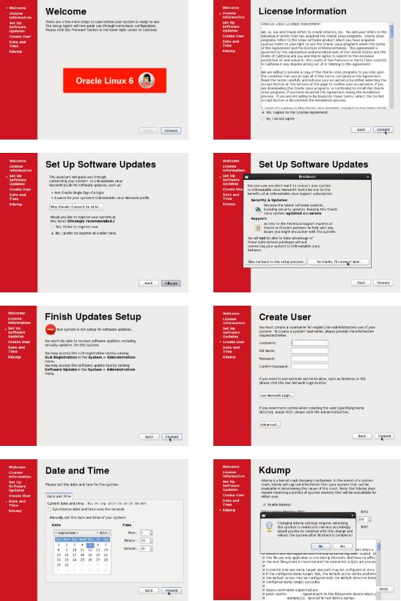

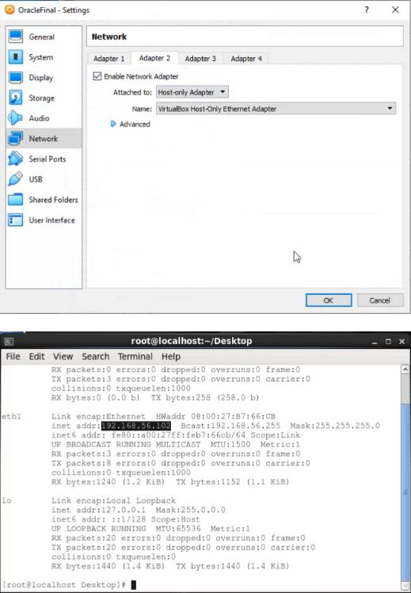

**Yum Configuration**

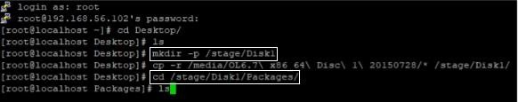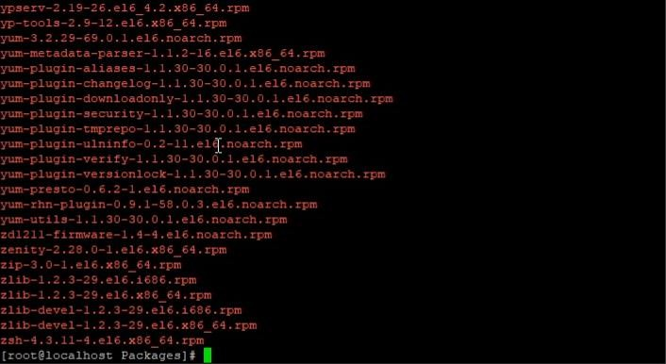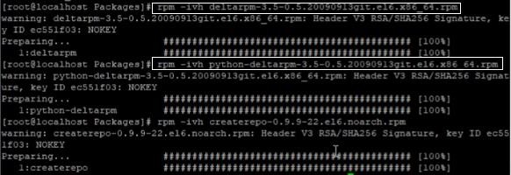



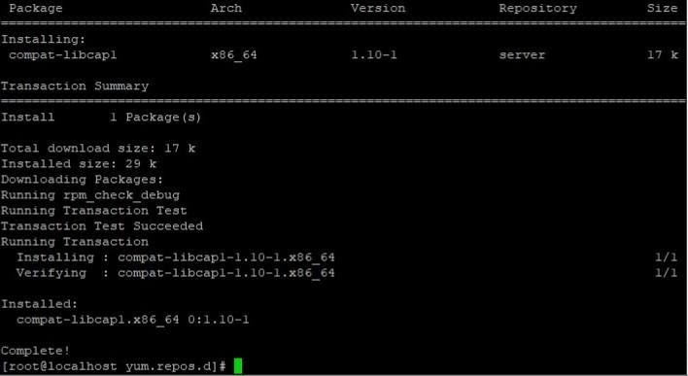

**Kernel Modification**

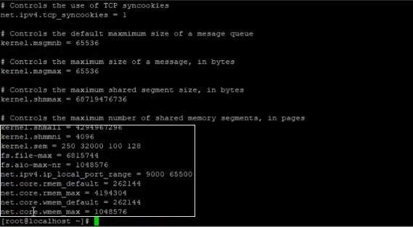

Configuring Shell Limits for the Oracle User

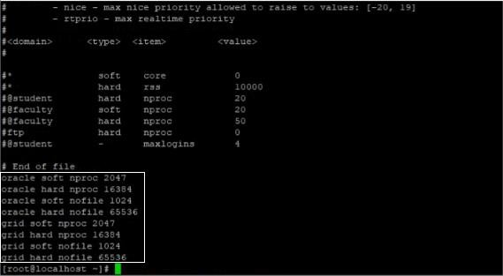

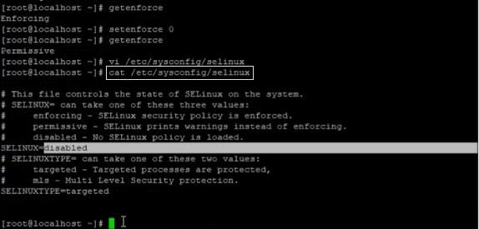



Adding User and Groups

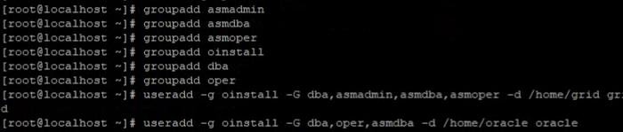

Creating a necessary Directory



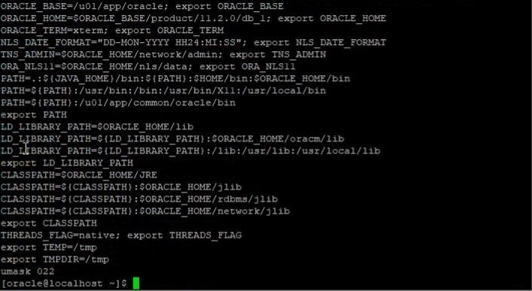

Setting up the Grid Environment

